Public Employment Service Office San Julian
Management Information System

DEPARTMENT OF INFORMATION TECHNOLOGY
College of Computer Studies
Eastern Samar State University
Borongan City, Eastern Samar

In Partial Fulfillment of the Course Requirement for the Degree
BACHELOR OF INFORMATION TECHNOLOGY

Lisaca, Tirso Jr
Docel, Benidic G
Villones, Jake

Chapter I
INTRODUCTION
Background and Rationale
The Municipality of San Julian, located in the province of Eastern Samar, continues to strengthen its commitment to improving the welfare and opportunities of its constituents through education, employment, and digital innovation. Two key initiatives that contribute significantly to this goal are the Public Employment Service Office (PESO) and the local scholarship program. It serves as a bridge between job seekers and employment opportunities by offering job matching, referrals, labor market information, and skills training support. Meanwhile, the local government’s scholarship program offers financial assistance to deserving students, especially those from low-income families, as part of its efforts to promote access to higher education and uplift the socio-economic status of the youth.
However, both programs currently face limitations, The PESO relies heavily on paper-based records and face-to-face transactions, which often lead to delays in service delivery, difficulty in tracking beneficiaries, and inefficient reporting. Similarly, the scholarship program's manual application and evaluation process can result in bottlenecks, inconsistencies, and limited reach, particularly for students in remote barangays. These issues affect the responsiveness of the local government and hinder the full realization of its inclusive development goals. To address these challenges, the municipality proposes the development and implementation of a PESO Management Information System (MIS). This digital platform aims to transform how the local government delivers education and employment services by automating key processes, improving data management, and making services more accessible to the public. The PESO MIS component will streamline functions such as client registration, job matching, employer profiling, event coordination, and real-time report generation. It will also improve coordination with national agencies like DOLE and TESDA and enable the office to make evidence-based decisions based on updated labor market data.
On the other hand, the Scholarship will digitize the entire scholarship lifecycle from online applications and beneficiary tracking and report generation. This will enhance transparency, minimize errors or duplication, and ensure that educational assistance reaches the most qualified and deserving students efficiently. By making the system accessible through mobile and online platforms, the local government can ensure wider coverage, particularly for those in geographically isolated areas.
Local scholarship programs, which are intended to promote access to higher education for underprivileged youth, are often hampered by unclear guidelines, manual processes, and weak documentation systems. This makes it difficult to track beneficiary performance, monitor fund utilization, and assess the long-term impact of such programs on employment outcomes (De Vera, 2020). Moreover, there is a lack of integration between education support services and employment facilitation mechanisms. As a result, valuable data that could guide policy such as the educational backgrounds of student , their employment outcomes
Despite the mandates and efforts of local government units (LGUs) to promote inclusive access to employment and education, municipalities of San Julian continue to rely on manual, paper-based systems and the student cant track their status in the management of public employment and scholarship programs. This outdated approach results in inefficient data handling, delayed service delivery, and limited monitoring and evaluation capabilities (Aguinaldo, 2021). While the Public Employment Service Office (PESO) is required under Republic Act No. 10691 to institutionalize labor market information systems at the local level, many PESOs across the Philippines still lack the technological infrastructure and capacity to fully implement these requirements (Department of Labor and Employment [DOLE], 2020).

Objectives of the Study
The main objective of this study is to design and develop a comprehensive, web-based PESO San Julian MIS that enhances the accessibility, efficiency, and transparency of the scholarship application and management process for the Local Government Unit of San Julian.
The study aims to:
- Provide a notification system that informs applicants about the status of their application and important updates.

- Enable scholarship administrators to review, approve, and manage applications digitally

- Create an administrator dashboard where authorized personnel can review, filter, and manage applications efficiently.

- Design an online platform that allows students to easily submit scholarship applications

- Enable the system to generate comprehensive reports on application statistics, including the number of applicants, approval and rejection rates

- Allow document uploads for students to attach necessary files such as IDs, academic records, and certificates as part of their application.

- To evaluate the developed system in terms of functionality, usability, efficiency, and maintainability based on ISO 25010 standards

Scope and Limitations
This study focuses on the design, development, and implementation of the PESO Julian MIS for the Local Government Unit (LGU) of San Julian, with the goal of improving the scholarship application and management process through the use of digital technology.
Scope:
- The system will be accessible online,
- LGU administrators can review, approve, reject applications
- The system includes a notification and alert feature to inform applicants about: Application status updates (Approved, Rejected)
- The platform will prioritize security, ensuring that all applicant data is stored securely
- The system will have different access levels for users, including students (applicants) and administrators,
- The system will support scholarship/summer job (Tulong Dunong Program, Transportation allowance, special program for employment of student SPES)
- The system will include a document upload feature, allowing applicants to submit required files such as identification documents, certificates, or recommendation letters during the application process.
Limitations:
- The system requires an internet connection for users to access the platform.
- Students and administrators will need a basic understanding of using web-based systems and devices (computers, smartphones) to access the platform.
- The system will not handle other administrative functions such as student enrollment, academic record keeping
- System will not allow the automatically verify validity of the application
- Users (students or administrators) will not be able to customize the platform interface or add functionalities without developer support.
Significance of study
This study lies in its potential to transform the scholarship application and management process in San Julian, making it more efficient, accessible, and transparent. the benefits of this system extend to administrators, students, and the community as a whole,
Local Government Unit (LGU) of San Julian
This study PESO San Julian MIS offers the LGU an effective tool for managing and overseeing scholarship applications digitally, the system will minimize administrative burdens, reduce the chance for errors. The ability to track and manage applications efficiently will help the municipality ensure the fair distribution of scholarship resources. Additionally, the system will generate valuable reports and insights, allowing the LGU to make informed decisions and improve future scholarship initiatives. This digital transformation aligns with the municipality’s broader goals of promoting good governance and fostering transparency in public service.
Student
This study PESO San Julian MIS will provide students, especially those from remote or underserved areas, with a convenient, accessible, and transparent way to apply for scholarships.
Researchers
This study provides a significant contribution to the field of digital governance and educational support systems. The findings from this study can serve as a valuable resource for understanding how digital tools can be leveraged to solve challenges in public sector management, specifically in scholarship distribution.
Future Researchers
This study will serve as a foundational resource for future researchers interested in the application of digital platforms in the public sector, particularly in education and scholarship management. Future researchers can build upon this study by evaluating the long-term impact of the PESO MIS in San Julian,
Definition of terms
Beneficiary An individual who receives services or assistance from a government program. In this context, it refers to job seekers served by PESO and students supported by the local scholarship program.

Beneficiary Tracking The ongoing monitoring of individuals who are receiving services or aid, such as employment assistance or scholarship funds, to ensure they meet requirements and achieve intended outcomes.

Client Profiling The process of collecting and analyzing information about clients to provide personalized and targeted services. In PESO, profiling includes skills, education, employment history, and job preferences

Data are values of qualitative or quantitative variable, belonging to a set of items

Database an organize collection of data. The data are typically organized to model relevant aspects of reality in a way that supports processes requiring this information

Digital Governance The use of information and communication technology (ICT) by government institutions to improve service delivery, transparency, and citizen engagement. The proposed system is an example of digital governance in local administration.

Government is the system by which state or community is governed
(LGU) Refers to a political subdivision in the Philippines such as a province, city, municipality, or barangay. In this study, LGU pertains to the Municipality of San Julian, which is responsible for implementing the proposed system.
Management Information System (MIS) A computerized system designed to collect, store, manage, and analyze data to support decision-making and improve the efficiency of organizational operations. In this study, it refers to a digital platform for automating PESO processes in San Julian.

Monitoring and Evaluation A systematic process used to assess the performance and outcomes of a program. The MIS and Scholarship system can track usage, success rates, and compliance.

Online Dashboard A visual interface within a system that shows key data, statistics, or trends in real-time. The PESO or scholarship coordinator can use this to make fast, informed decisions.

PESO (Public Employment Service Office) A non-fee charging multi-employment service facility or office established in local government units (LGUs) to provide employment services such as job matching, skills training, and labor market information. It operates under the supervision of the Department of Labor and Employment (DOLE).

Report to give detailed information about research or an investigation

User Authentication The process of verifying a user’s identity before granting access to a system or account. It ensures that only authorized users can access as sensitive data in the PESO MIS or Scholarship platform.

Chapter II
Review of Related Systems
This chapter primarily presents various studies, both foreign and local, which are significant to the variables included in this research. The literature reviewed in this study comes from books, journals, articles, and electronic sources such as (PDFs). These sources are believed to enhance understanding and awareness concerning the focus of this study.
Public Employment Service Offices (PESOs) play a crucial role in implementing labor market programs and promoting employment (Bachita & Bayoneta, 2021). While these services have shown high levels of implementation, there is a need for local laws to enhance employment facilitation (Bachita & Bayoneta, 2021). Management Information Systems (MIS) are essential for improving the effectiveness and efficiency of employment support systems, particularly for individuals with disabilities (Migliore et al., 2021). The implementation of digital-based systems in government services can lead to increased efficiency, fairness, and accountability (Khairati & Putra, 2024; Government Information Quarterly, 2022).However, the adoption of website-based MIS for public services has shown mixed results, with some studies indicating that while it may improve employee work effectiveness, it may not fully meet public needs (Sultan, 2023). Overall, the integration of MIS in public employment services presents both opportunities and challenges for enhancing service delivery and employment outcomes.
In Davao City, the Educational Benefit System Unit (EBSU) was developed to automate the city’s scholarship processes. This system included key functions such as applicant tracking, document verification, and approval workflows, effectively reducing manual workload for administrators (IJETT, 2024). Likewise, a Scholarship Management System with SMS Notification, proposed by researchers in 2022, emphasized the importance of real-time communication between scholarship coordinators and applicants.
The system proved effective in improving transparency and engagement (IJEI, 2022). Meanwhile, in the Municipality of Rosario, Batangas, a PESO Job Portal was developed to digitize job postings, applicant profiles, and employer coordination. The portal helped minimize walk-in traffic and manual processing, and served as a valuable digital hub for employment services at the municipal level (IJARP, 2021).
the, developed by the Department of Labor and Employment (DOLE), serves as a centralized database of active manpower supply. It contains profiles of job seekers and employers, facilitating efficient job matching and providing labor market information. The PEIS is maintained largely by LGUs and is linked to DOLE's regional and central offices, constituting a national employment service network (Department of Labor and Employment, 2020).
Another system that highlights digital innovation in employment services is the Baguio City PESO Digital Employment Services, launched in 2022. This system integrates job matching, training registration, and employer profiling into a single platform accessible to constituents via a web and mobile app. It also allows PESO staff to generate reports for monitoring employment trends and program effectiveness. This approach supports the city’s commitment to delivering responsive and efficient public employment services (Baguio City Government, 2022).
The Quezon City PESO Management System, launched in 2021, provides an integrated platform for job seeker registration, employer profiling, and job matching. It allows the city’s PESO staff to track employment referrals and training programs digitally, significantly improving turnaround times and reducing paperwork (Quezon City Government, 2021). This system also integrates labor market data from the Department of Labor and Employment (DOLE), enabling local PESO staff to make evidence-based decisions and provide timely labor market information.
According to Ranjitha V, & Swamydoss D. (2022), a job portal is used for job seekers to find available job vacancies according to their Education Qualification, skill, experience, and location. Companies can identify eligible job seekers and it is the best way to select the best-qualified candidate-job portal is the solution for recruiters as well as job seekers to fulfill their requirements. Job seekers can register the application and update their profile, skills, and experience, Job seekers can search the available jobs and apply for their desired positions
Similarly, the (2022) improved client profiling and employer engagement by allowing online job postings and automated matching features, reducing delays in job referrals and facilitating remote access for clients in geographically isolated areas (Zamboanga City Government, 2022).
Various digital systems have been developed to address the challenges of manual scholarship management. Cruz and Reyes (2022) created an E-Scholarship System that digitizes submission, approval, and monitoring processes for local government units. Bautista and Flores (2021) designed the Online Scholarship Application and Record Management System for AYZ City, offering secure data handling and status update features to reduce administrative workload. Bagaporo and Espinosa (2025) designed an online scholarship management system for Camarines Sur Polytechnic Colleges, which centralizes application processing, user-status updates, and administrative tasks.focused on real-time monitoring and transparency of scholarship disbursement for marginalized students in the region. Additionally, Edukasyon.ph (Springer, 2021) offers a Philippine-based online portal that connects students with universities, scholarships, and career pathways, promoting informed decision-making through digital access
Locally, there have also been smaller-scale scholarship management systems implemented in some municipalities and universities. The Iskolar ng Bayan or Dr. Pio Valenzuela Scholarship Program introduced by the City Government of Valenzuela aims to simplify the application process through an online platform, helping to minimize manual paperwork and improve accessibility for students (Valenzuela City Official Website, 2022; Manila Bulletin, 2022).
the Bacolod City PESO Job Portal (2023) integrates features like career counseling scheduling, employer profiling, and training referrals, providing a comprehensive platform that supports employment facilitation and labor market information dissemination within the local community (Bacolod City Government, 2023).
Internationally, various employment information systems serve as benchmarks for the development of the PESO MIS in the Philippines. Development of a Comprehensive Scholarship and Grants Management System (SchoGMS) (Remegio & Casquejo, 2025) A system for State Universities/Colleges in the Philippines; automates workflows, aligns with CHED reporting, improves security and efficiency.
Scholarship Management System with CMS for Lyceum of the Philippines Cavite (Mendez et al., 2025) A system with content management, application status tracking, web access, digitization of manual processes. Furthermore, as a result of this program, the participants are making attempts to stay, and the graduating students keep continuing and going. The participants’ families are also delighted that the program can give their children with a free and high- quality education.
These programs are part of the national agenda to promote social mobility and economic growth by building a skilled workforce. However, the rising costs of educationincluding tuition, books, and other necessities continue to pose challenges for many families (Kaufman & Phan, 2025).despite the importance of these scholarships, the manual processing methods still in use hinder the timely distribution of benefits and present obstacles for applicants, particularly those in remote areas. shifting to digital platforms can address these issues by improving efficiency, minimizing errors, and expanding access to scholarship opportunities.
According to Internet has become the means for conducting growing numbers of transactions because of the speed, flexibility, and efficiency that it offers. this Technology is required by every organization if it does want to reach out to its customers in this age of globalization. the term “scholarship” is a form of financial assistance that does not require repayment or employment and which is usually offered to students who show potential for distinction, or who possess certain characteristics important to the scholarship provider (such as religious beliefs, hobbies, ethnicity, etc.).
As technological innovation rapidly grows in technology and education, scholarship offices manage educational assistance that helps students continue their studies. most admin and scholarship officers of various scholarship programs use traditional ways of managing scholarship programs. Traditional keeping records of documents and requirements can be misplaced, and finding records is also a tedious job. therefore, (Albert V. Paytaren Hazel G. Gonzales Rhannel D. Dinlasan) came up with making a web application for managing educational assistance, which helps scholarship officers in collecting and managing information of scholars as well as for scholars to easily apply and submit requirements.
A scholarship Is a form of financial aid that is specifically geared towards students who are attending college. It is used as a way of financing their education, and it may pay a part of their education, or it may pay the entire cost of a student’s tuition. As point out, scholarships will require students to meet certain requirements, both before and after they’ve obtained It. most of these scholarships will require students to have a minimum GPA, and they may also require them to take a certain number of credit hours within the first 12 months of Their the importance of digital transformation in scholarship application and management systems, Bisen and Sahu (2021) designed an Advanced Application System for Student Scholarship using content-based filtering technique, aiming to automate and personalize scholarship matching based on applicant qualifications. Similarly, Dhal and Panda (2024) discussed the integration of Natural language Processing (NLP) I nto E-Scholarship platforms to help reduce manual errors and speed up application reviews. lastly, research by Jibrin et al. (2020) analyzed the ongoing struggles of Filipino students, noting the importance of digital tools in bridging scholarship opportunities to marginalized sectors.
In this paper. Isbudeen Noor Mohamed, Ahmad Tasnim Siddiqui, Syed Ajaz, S. Mohamed Idhris, “Student Information Report System with (SIRS), in proc. 2020 system has come up with many advantages for educational institutions to track the student development and administration attendance.
Manual processes further disadvantage students with mobility issues or those living far from institutions, making timely submission of applications difficult. Bicol University, for instance, has recognized the importance of addressing these lmitations by partnering with organizations like the Tzu Chi Foundation to enhance access to scholarships through digital means. these efforts reflect a growing need for online scholarship management systems to improve efficiency, security, and accessibility for both administrators and students in the region (Bicol University, 2023; Commission on Higher Education, 2022).
Several studies have explored the development of e-scholarship systems to improve how students apply for and receive scholarships. These systems are designed to make the process faster, more accurate, and easier for both students and administrators. Karthikeyan and Suganthi (2024) introduced a student students application system integrating NLP with e scholarship platform that uses Natural Language Processing (NLP) to help match students with scholarships based on their qualifications and needs. Their system reduces the time students spend searching for opportunities and also helps administrators by automatically sorting and filtering data, making the review process more efficient.
The study of (Gonzales et al., 2020) utilizes the design and development of the website since it focuses on online application and detection of the scholarship granted to the scholars. The respondents of the study are the regular users of the scholarship office. It provides all the information that the scholarship office can give to scholars regarding the status of scholarship grants and how they will apply online.
Fajardo et al. (2024) implemented a machine learning-based approach to predict scholarship grants for the Davao City Educational Benefit System Unit (EBSU). By utilizing algorithms such as Logistic Regression, Support Vector Machine, Multilayer Perceptron, Naïve Bayes, and Random Forest, the system effectively matched applicants with suitable scholarship programs based on their backgrounds and qualifications.
Santos and Mendoza (2021) developed an Educational Assistance Management System for Batangas State University to improve the accuracy and security of student scholarship records through automation, highlighting how moving from manual to digital systems allows educational institutions to improve efficiency, fairness, and accessibility for students, especially in remote areas.
Valenzuela Scholarship Program in Valenzuela City offers an online application process for incoming first-year college students, helping reduce barriers associated with manual form submission (Manila Bulletin, 2022).
An online scholarship application and record management system for an agency to eliminate the manual process of managing and profiling the scholars’ information, scholarship approval, and notification. the main focus of the system is to improve the manual method that the said client uses, and for rapid processing of transactions. there is also a module provided for the administrator where the administrator can easily approve and disapprove applicant scholars and can effortlessly set schedule. (Malipol et al., 2020).
scholarship management systems reveals that many existing platforms, such as those studied by Paytaren, Gonzales & Dinlasan (2023) and Alvaro & Gabayan Jr. (2022), primarily focus on facilitating online application submissions and basic administrative review. These systems often include essential features such as digital application forms and centralized record-keeping. However, they tend to vary in terms of user accessibility, notification systems, predictive or decision-support features, and data security protocols.
Some advanced systems, such as the Scholarship Predictor framework by Kanwal et al. (2024), explore the integration of machine learning techniques to predict eligibility based on multiple criteria (e.g. academic achievement, parental income). While these features enhance fairness and automation, they may demand significant computational resources and technical infrastructure requirements that may be challenging for rural municipality-based LGU programs.
The PESO San Julian Management Information System (MIS). Many existing scholarship management systems in the literature either lack accessibility for applicants in remote and underserved areas or offer it only partially. This gap often forces such applicants and administrators to rely on manual processes, thereby exposing them to the risks. The absence of real-time notifications in most related systems also contributes to delays in processing and increases the likelihood of misplaced or overlooked documents. while several systems mention administrative dashboards, these are often basic and not optimized for diverse users, leaving management oversight limited and dependent on manual tracking.

The PESO San Julian MIS responds to these issues by replacing manual, paper-based workflows with a centralized, digital platform. This transition addresses the Method and Material causes by eliminating the need for fragile physical files and introducing a structured, searchable database. Automated workflows and real-time alerts to both students and administrators minimize errors, ensuring timely actions and reducing oversights. Management inefficiencies are resolved through role-based dashboards that offer clear task visibility and control, while automated reporting tools provide timely trend analysis and fund allocation data features often missing in other systems. the system’s mobile friendly design it improves accessibility for remote users, reducing dependence on outdated machines and minimizing the environmental risks associated with storing physical documents

Chapter III
Software Development Model
The System Development Life Cycle (SDLC), also referred to as the application development life cycle, is a term used in system engineering information systems and software engineering to described a process for planning, creating, testing and deploying an information system (Elliott & Strachan & Radford). Is a structured process that is used to design, develop, and test good-quality software. SDLC, or software development life cycle, is a methodology that defines the entire procedure of software development step by step. The goal of the SDLC life cycle model is to deliver high-quality, maintainable software that meets the user’s requirements. SDLC in software engineering models outlines the plan for each stage so that each stage of the software development model can perform its task efficiently to deliver the software at a low cost within a given time frame that meets users requirements. In this article we will see Software Development Life Cycle (SDLC) in detail.
The Agile model Is a project management approach that prioritizes flexibility and feedback throughout the development process, making it a good choice when these factors are high priorities. It’s an iterative method that focuses on continuous improvement and rapid delivery of incremental value. Unlike traditional methods, Agile focuses on delivering incremental value through iterative development, allowing researcher to adapt quickly to changes and incorporate customer feedback.
The researchers use Agile Model as their software development model because they meet the requirements needed and the following functions iterative development, continuous feedback, and adaptability to change. Agile promotes close collaboration between developers and the scholarship of the municipality of San Julian, enabling the researcher to respond quickly to evolving user needs and technical challenges. Through short development cycles called sprints, Agile allows for incremental progress and regular testing, ensuring that each feature is functional and aligned with the user expectations.

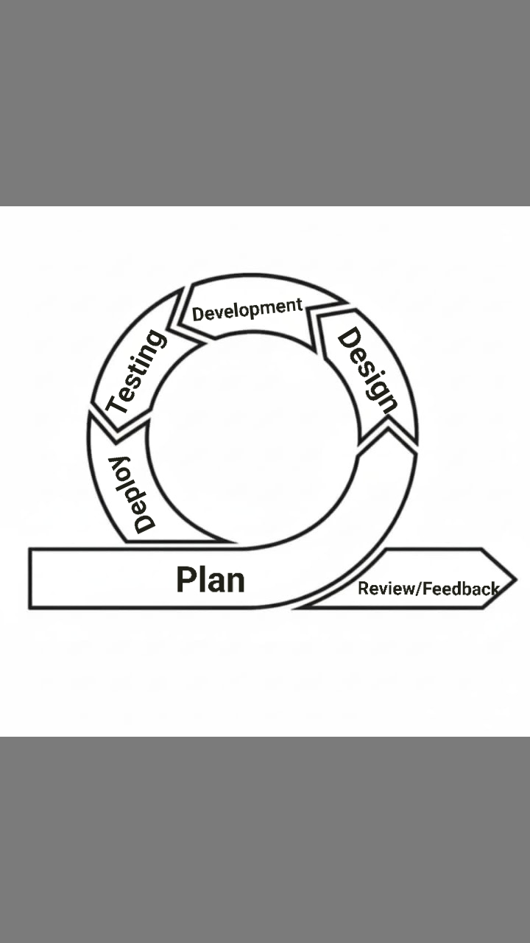
Figure 1.0: Agile model
Agile model is a flexible and iterative approach to software development. It breaks the project into small, manageable units called iterations or sprints, usually lasting 1–4 weeks. Each sprint delivers a working product increment, allowing for continuous feedback and improvements. Agile encourages close collaboration between developers and stakeholders, and it adapts quickly to changing requirements. This model focuses on delivering value early and often.

Planning phase
In this phase, the researchers They looked at all the user stories, talked through what was most important, and decided which features should be tackled early on based on how valuable and complex they were. They also took time to estimate how much effort, time, and budget each part of the project might require. For the PESO San Julian MIS, the researchers chose to start with the basics, before diving into more complicated parts like application reviews and document verification. The planning phase served as the blueprint for the entire project, ensuring that all activities were aligned with the system’s goals.
Design phase
In this phase where we focused on creating the structure and look of the system. For the PESO San Julian MIS, this meant sketching out simple, user-friendly layouts for key parts of the system for the login page, dashboard, and scholarship application form. We kept the designs clean and flexible on purpose, knowing that things might change in the upcoming phase. the team took time to review them, making sure they not only worked well but also looked good and made sense to users.
Develop phase
In this phase where coding and integration happen. Developers start building the features as planned in the sprint backlog. they work collaboratively and attend daily stand-up meetings to share updates, discuss any challenges, and ensure that stays on track. during the development of the PESO San Julian MIS, the researcher would code the registration process, create backend services for user authentication, and connect the database to the login form.
Testing phase
In the Testing phase, the PESO San Julian MIS is systematically evaluated to ensure it meets all specified requirements. the researcher verifies that individual components, such as user authentication modules or database connections, function correctly in isolation. The researcher evaluates the complete, PESO San Julian MIS to confirm it meets the overall functional and non-functional requirements.
Deploy phase
In this Phase, the system is prepared for installation and operational use by the intended users. all necessary configurations, documentation, and training materials have been completed to ensure a seamless transition from development to deployment. the system has undergone rigorous testing
The Feedback and Review phase
This phase, the staff of PESO in charge review the new functionalities and provide feedback. the researcher also reflects internally on what went well, what challenges were faced, and how to improve future phase. after reviewing the first release of the PESO San Julian MIS, the scholarship administrators might request the addition of a Forgot Password feature, and the researcher would include it in the planning for the next sprint.
Requirements Specifications
The requirements gathering phase aimed to identify both functional and non-functional needs. Functional requirements focused on the core capabilities of the system such as enabling students to register, apply for scholarships, upload documents, track application status, and receive notifications. administrators and scholarship committees, the system needed to support tasks such as reviewing applications, verifying eligibility, managing scholarship data, Before the system development, it was essential to gather and analyze all the requirements needed to build an efficient PESO San Julian MIS. This process included identifying the needs of students, administrators, scholarship committees, and other stakeholders.
User registration and login (students, administrators, evaluators)
Scholarship posting and application management
Document upload and verification
Status tracking (application submitted, approved, rejected)

Operational Feasibility
An Ishikawa diagram is a diagram that shows the causes of an event and is often used in manufacturing and product development to outline the different steps in a process, demonstrate where quality control issues might arise, and determine which resources are required at specific times. (A. Hayes, 2019).
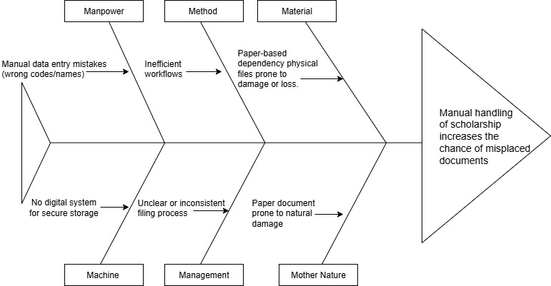

Figure 2.0 Fishbone Diagram
Figure 2: illustrates the focus of the researchers on a prevalent issue within the scholarship application of San Julian E Samar
The researchers used Ishikawa diagram in identifying the possible root of the problem faced by the Municipality of San Julian. This technique is used to be able to identify possible solutions to the problem that will be identified

Technical Feasibility
This section discusses the necessary hardware and software specifications needed in the development and implementation of the system.
Table 1. Software Specification (Development)
Software | System Minimum Requirements
Visual Studio Code | v1.97.2.0  HTML, CSS, JavaScript, & PHP
XAMPP | XAMPP v7.1.1-0 (PHP to 7.1.1, Apache 2.4.25, SSL 1.0.2j, MariaDB 10.1.21)
Database | XAMPP v7.1.1-0 (PHP to 7.1.1, Apache 2.4.25, SSL 1.0.2j, MariaDB 10.1.21
Web Browser | Google Chrome on Windows Version 135.0.7049.115 (Official Build) (64-bit)
Table 1.0: Software Specification; the researchers used Visual studio code for the codes and Xampp for the database for the development of their study
Table 2.0 Software Specification
Software | System Minimum Requirement | Organization/Client  Technical Specification | Compatibility  (Yes or no) | Solution
Web Browser | Google Chrome on Windows version 135.0.7049.115 | Google Chrome on Windows version 78.0.3904.87 | Yes

Table 2.0 Software Specification; the researchers used web browser for the connection of the end user to the server for implementation of their study
Schedule Feasibility
Schedule feasibility is defined as the study that assesses how likely a project is to be completed within its proposed timeframe
Gantt chart
A Gantt chart is a graphical depiction of the project schedule. It’s a type of bar chart shows the start and finish dates of several elements of a project that include resources, milestones, tasks, dependencies. Henry Gantt, an American mechanical engineer, designed the Gantt chart.
Figure Definition
Symbol Description

Indicates the start and finish dates of the finished task.
Shaded Box

Indicates the start and finish dates of the unfinished task.
Unshaded Box
Represents the number of months for the completion of the project. It starts from January up to December. Each month corresponds to the duration of activity.
Vertical Line
Represents the series of activities to be done in the system improvement schema.
Horizontal Line

Task | Month  Mar Apr May June July Aug Sep Oct Nov Dec
Planning
Designing
Development
Testing
Deploying
Review/
Feedback

Figure 3 Gantt chart
In figure 4 is the Gantt chart which represents the phases of the Agile Model as a basis to show each activity needed by the proponent to take up in order to come up with organized project estimated task duration in fulfilling the whole proposed study. The figure shows when the proponent did started each activity and when will the activity end. It doesn’t only represent task duration but it also serve as the proponent’s guide in conducting the proposed enrollment and scheduling system. The phase is named into six categories namely the planning ,system design, develop, system testing, deploy review, launch. At the start of the study, the proponent taken up the first phase which is the requirement analysis where the proponent gathered information’s related to PESO San Julian MIS of San Julian better understand and learn relevant issues arises within their respective office. Several interviews and thorough investigation was conducted by the proponent which leads it to be establish in the statement of the problem which totally mold its objectives to continue the study of PESO San Julian MIS.

Output and User Interface
The system provides outputs such as application status updates, notifications, while offering a user-friendly interface designed for students, administrators, and, featuring dashboards, application forms, tracking their status of application, and document management options.
Home Page
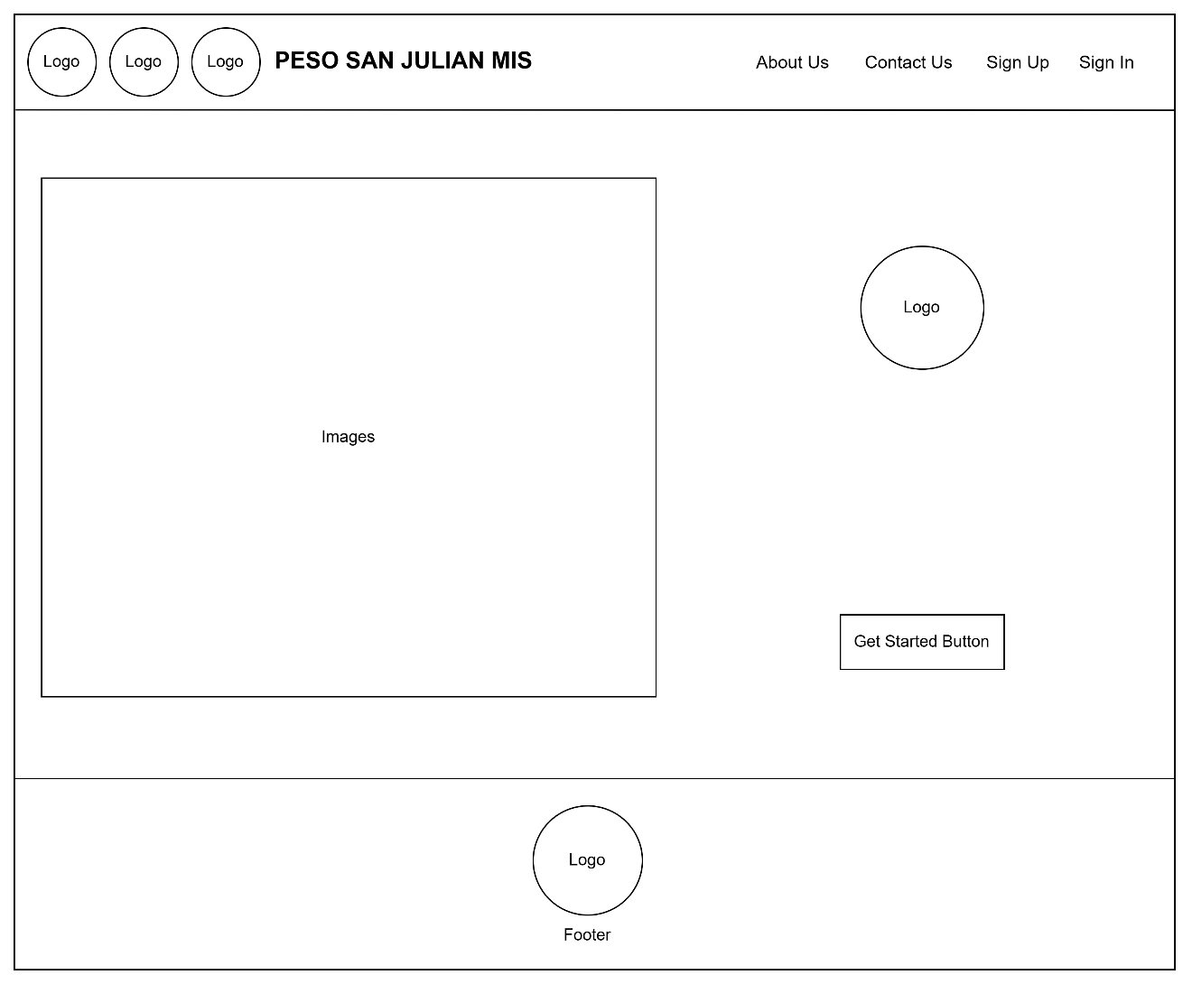
Figure 4: Home page
The PESO San Julian MIS homepage with a simple layout, including navigation links and a prominent "Get Started" button. Key elements the logo and image area highlight branding and user focus.

Sign In Page
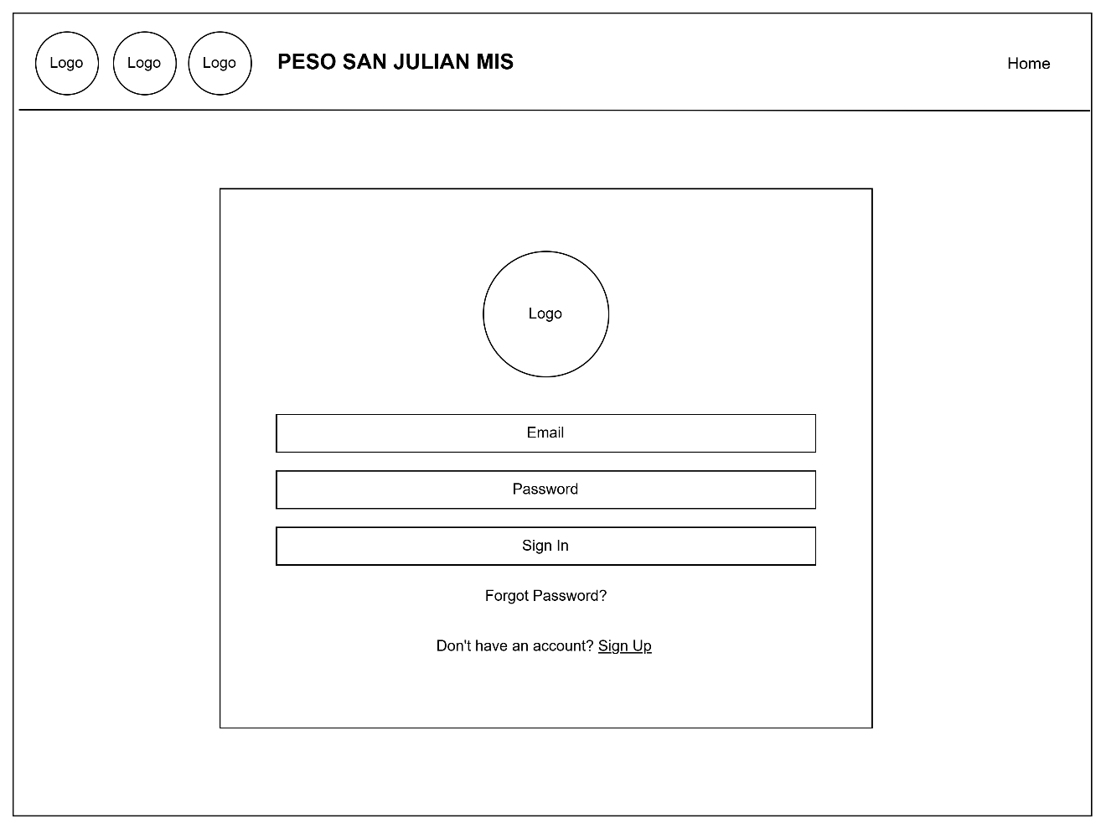
Figure 5: Sign in page
The login page for the PESO San Julian MIS, designed with simple and clarity in mind. It features input fields for email and password, a Sign In button, and links for password recovery and account registration, making easy to navigate.

Sign Up Page
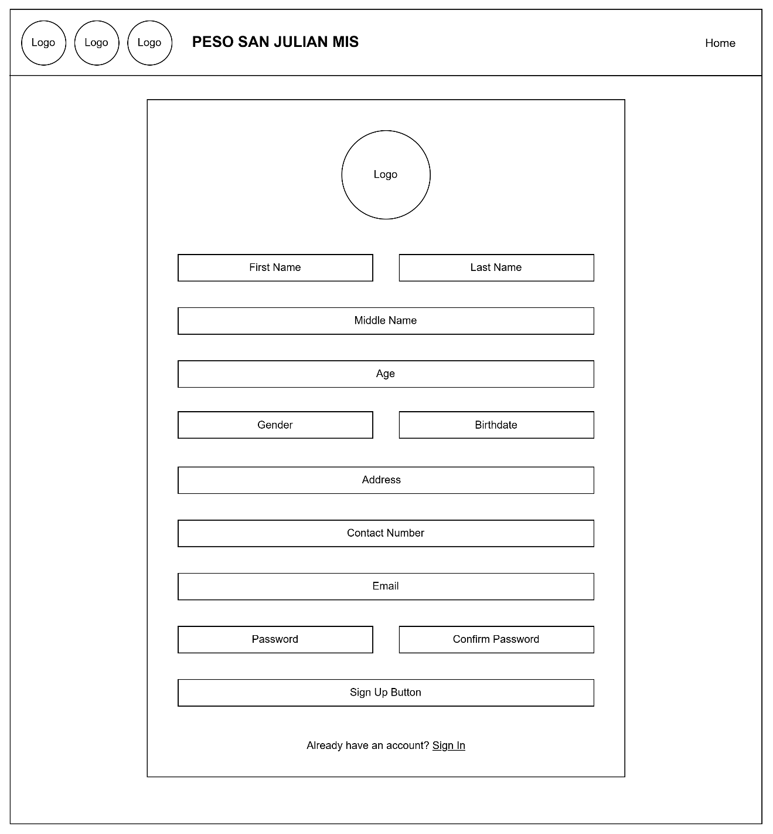
Figure 6: Sign up page
the Sign-Up Page of the PESO San Julian MIS, designed to collect user information for account creation. The form includes fields for personal details ( full name, age, gender, and birthdate), contact information (address, contact number, and email), and login credentials (password and confirm password). A Sign Up button allows users to submit the form, while a link below the form provides easy navigation for those who already have an account to sign in.
Forgot Password Page
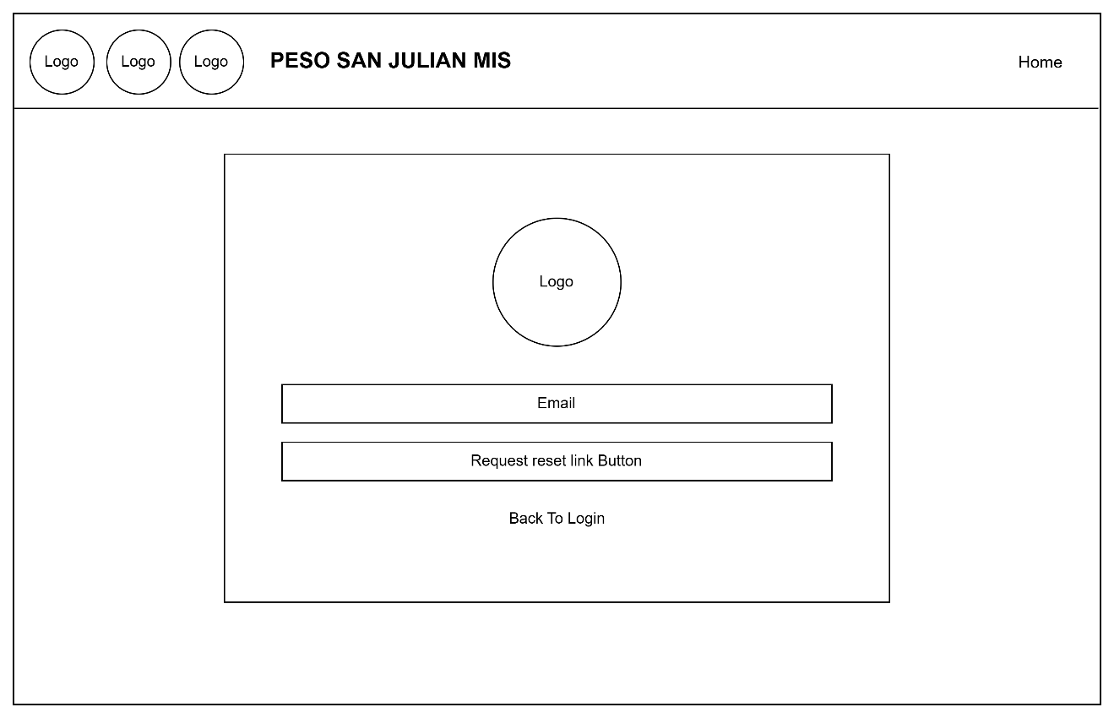
Figure 7: Forgot Password page
the Password Reset Page of the PESO San Julian MIS, featuring a field for the user's email, a request reset link button, and a back to login option

Authentication Code Page
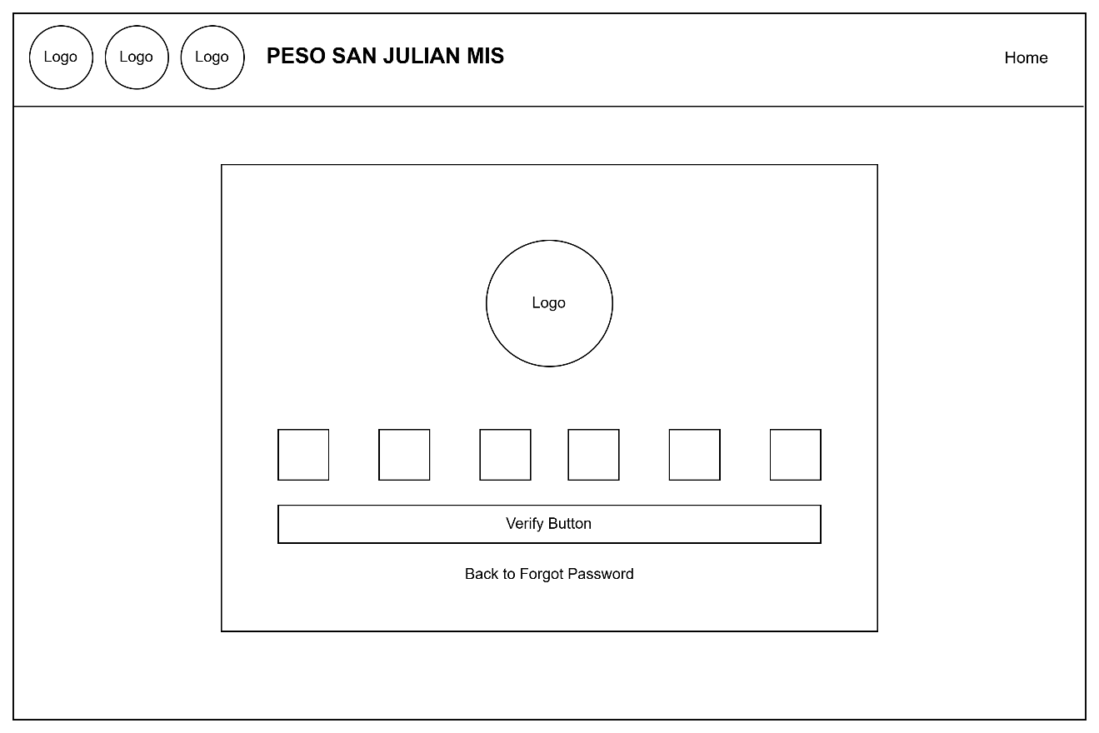
Figure 8: Authentication code page
The Authentication code page of the PESO San Julian MIS, where users enter a 6-digit code sent to their email. It includes input boxes, a Verify button, and a link to return to the Forgot Password page, keeping the process simple and secure.

Reset Password Page
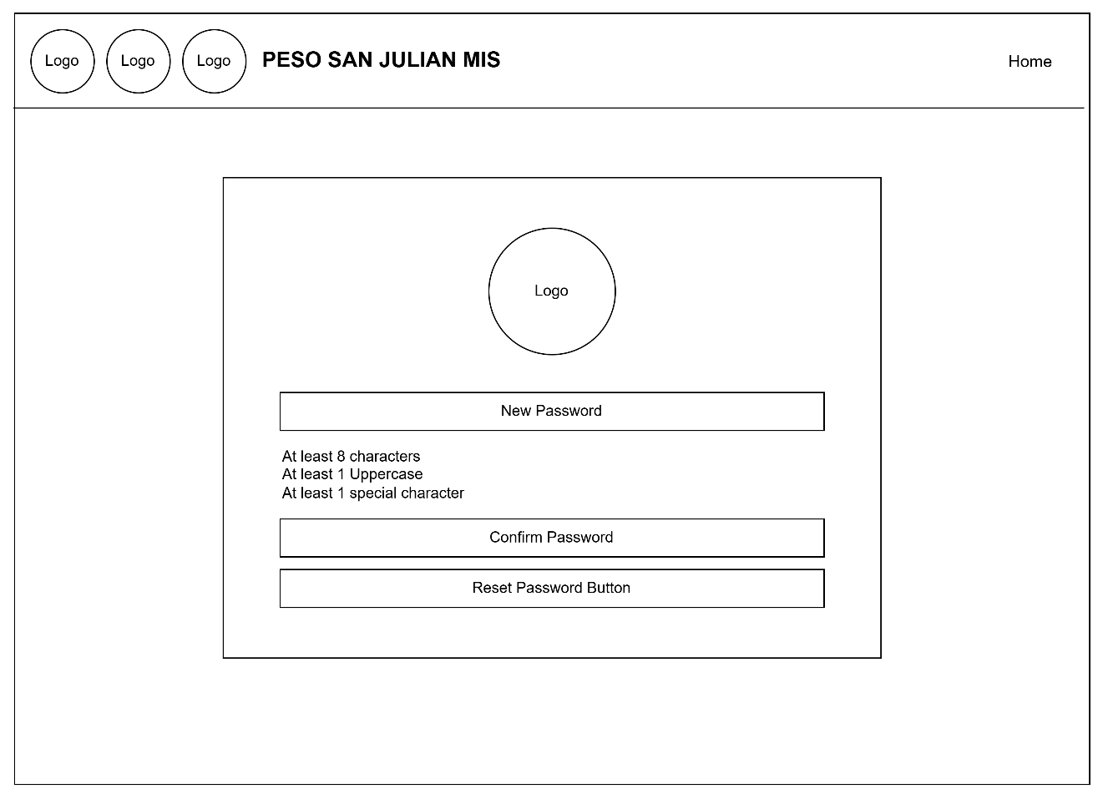
Figure 9: Reset password page
The Reset Password Page of the PESO San Julian MIS, where users can set a new password by meeting specific criteria. It includes fields for the new password, confirm password, and a Reset Password button, promoting both security and ease of use.

User Dashboard Home Page
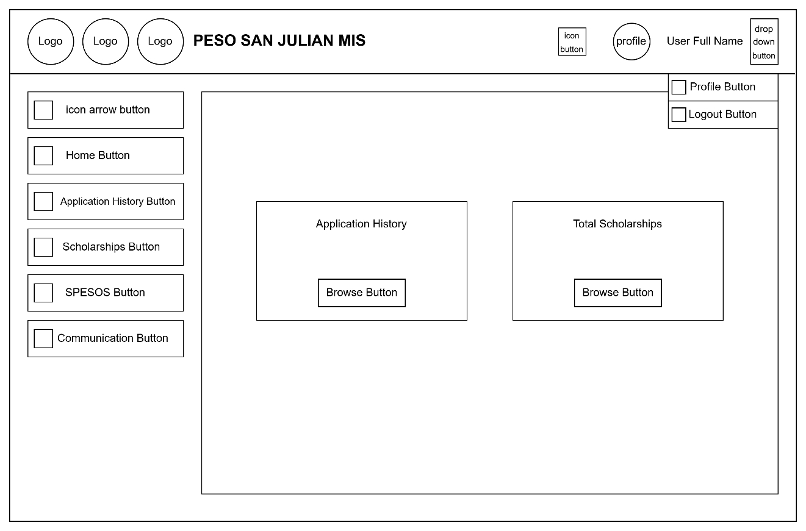
Figure 10: User dashboard homepage
The user dashboard page of the PESO San Julian MIS, featuring navigation buttons on the left and key sections like Application History and Total Scholarships in the main area. A dropdown menu in the top-right corner offers quick access to the user profile and logout options.

User Dashboard Home Page - Notification
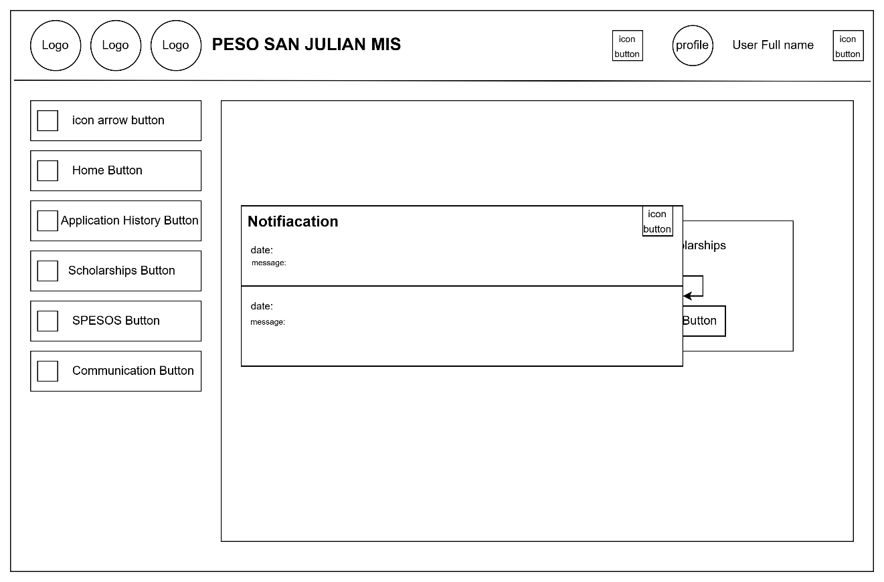
Figure 11.: User Dashboard Home Page – Notification
The notification page of the PESO San Julian MIS dashboard. It displays alerts with dates and messages, allowing users to stay updated on important system activities.

User Dashboard Application History Page
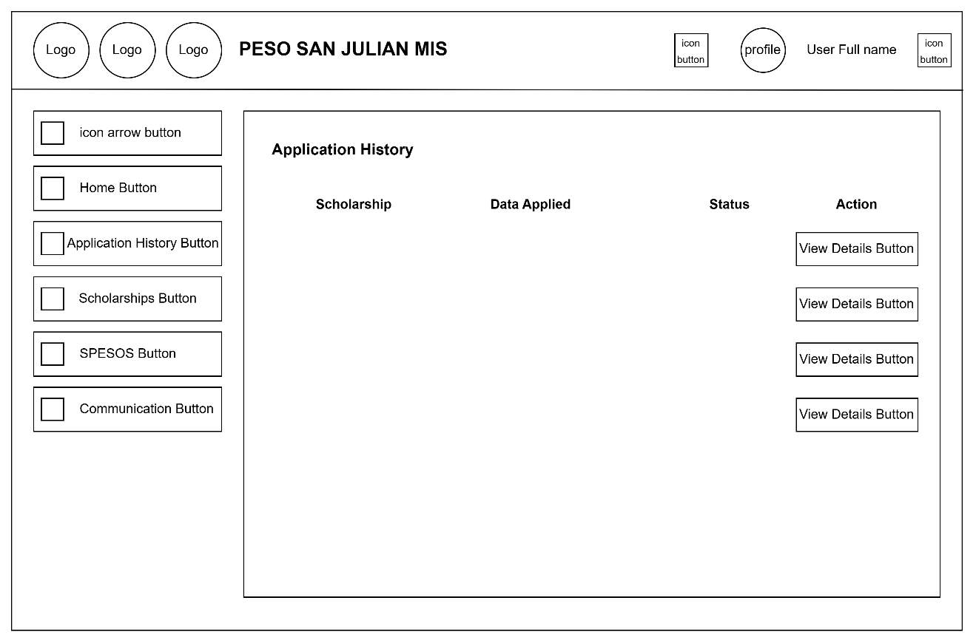
Figure 12: User dashboard application history page
The ApplicationHistory page of the PESO SanJulian MIS. It presents a list of scholarships the user applied for, including the application date, status, and a button to view more details.

User Dashboard Scholarships Page
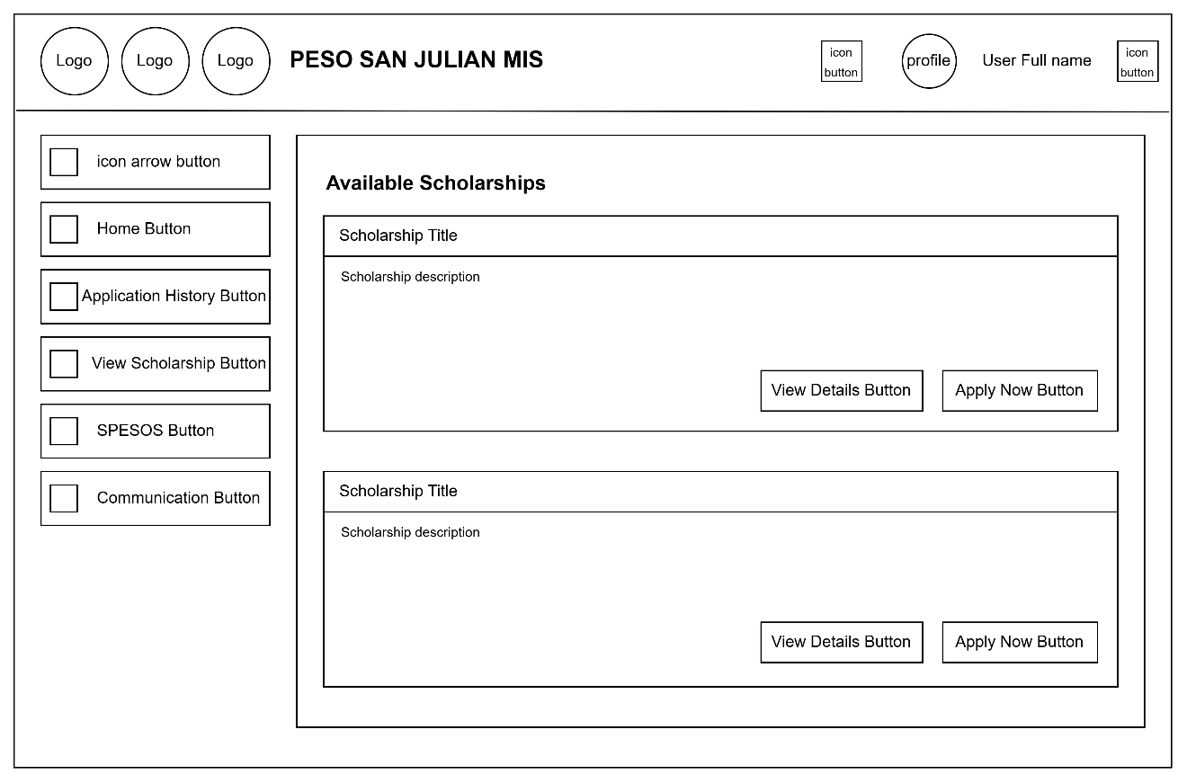
Figure 13: User dashboard view scholarship page
The view Scholarships page of the PESO San Julian MIS. It lists scholarships with brief descriptions, offering two main actions for users: View Details and Apply Now. This layout helps users easily browse and apply for opportunities.

User Dashboard Scholarships Page – View Details
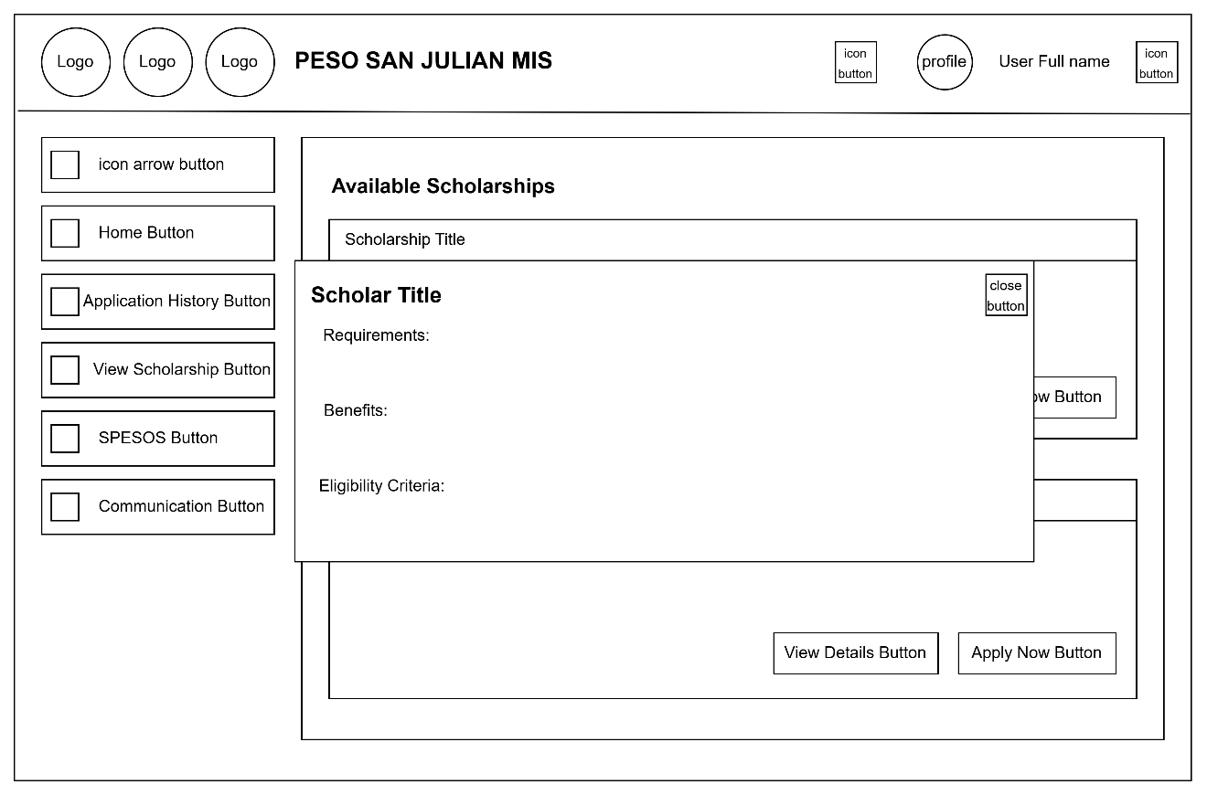
Figure 14: User dashboard view scholarship page – View details
The Scholarship Details Modal within the Available Scholarships section. When a user clicks "View Details", a popup appears displaying (Scholar Title, Requirements, Benefits, Eligibility Criteria) It includes a Close Button to exit the modal, allowing users to review more scholarships

User Dashboard Scholarships Page – Apply Now
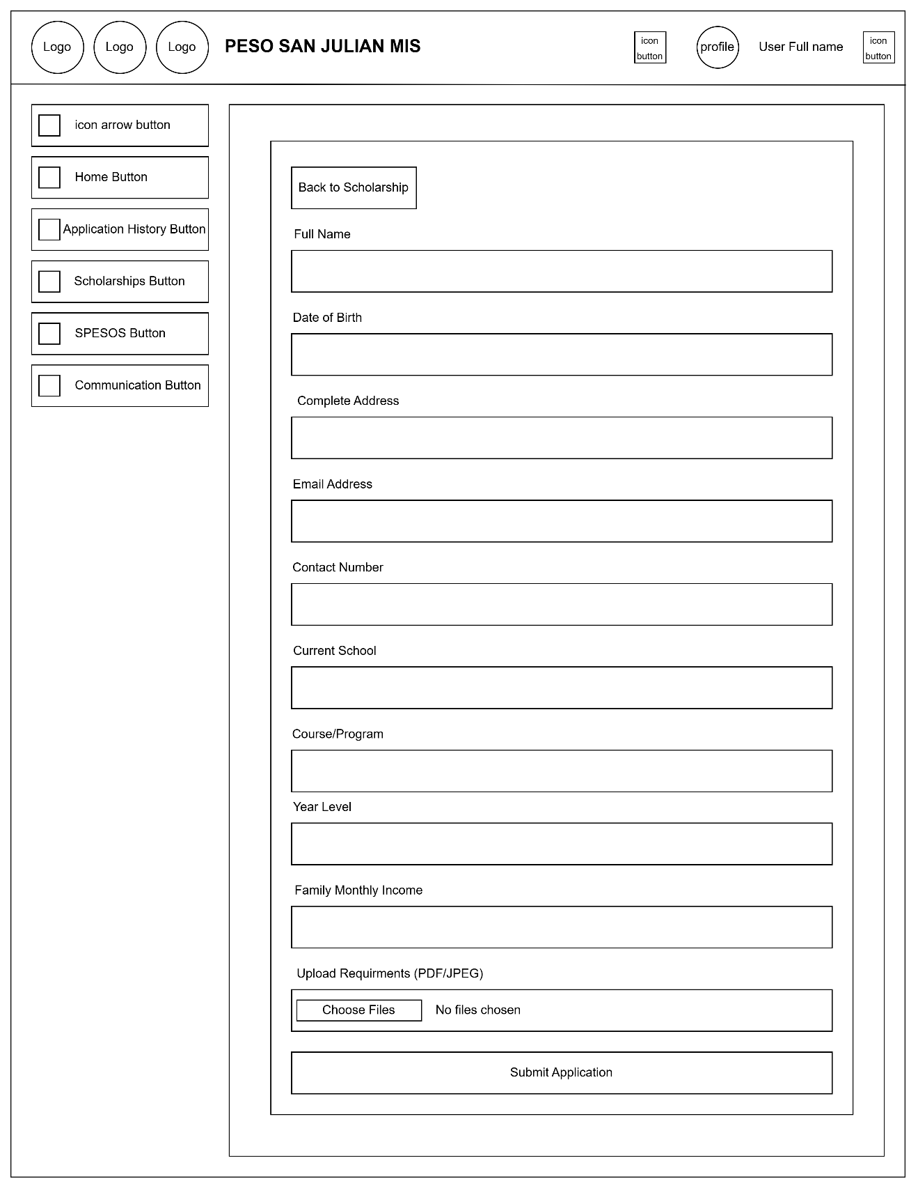
Figure 15: User dashboard view scholarship page – Apply Now
Scholarship application form for PESO San Julian MIS. It includes fields for personal, academic, and contact information, along with an option to upload required documents. Navigation buttons are provided on the side and top, with a "Submit Application" button at the end of the form
User Dashboard SPESOS Page
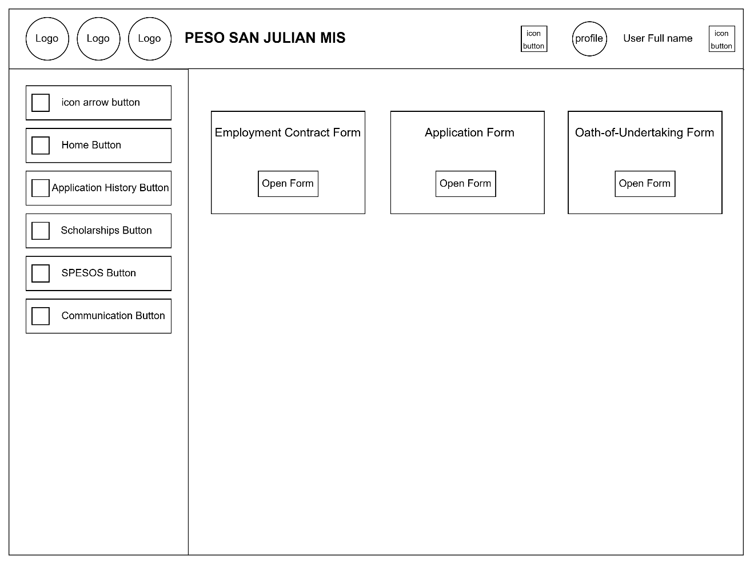
Figure 16: User dashboard spes page
The PESO San Julian MIS system with three form options: Employment Contract, Application, and Oath-of-Undertaking. Each form has a corresponding "Open Form" button for access, with standard navigation on the side and user profile options at the top.

User Dashboard SPESOS Page – Employment Contract Form
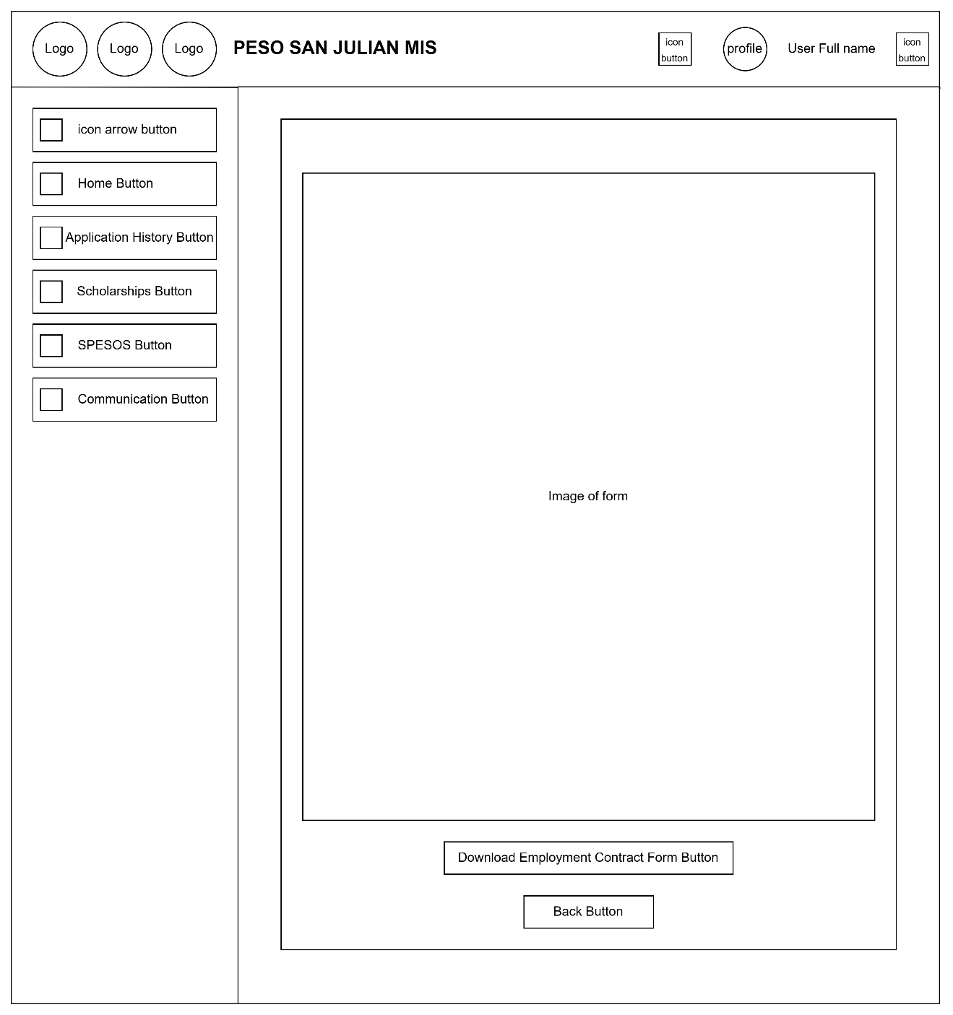
Figure 17: User dashboard spesos page – Employment contract form
The Employment Contract Form within the PESO San Julian MIS. Users can view the form image and choose to download it using the "Download Employment Contract Form" button or return using the "Back" button.

User Dashboard SPESOS Page – Application Form
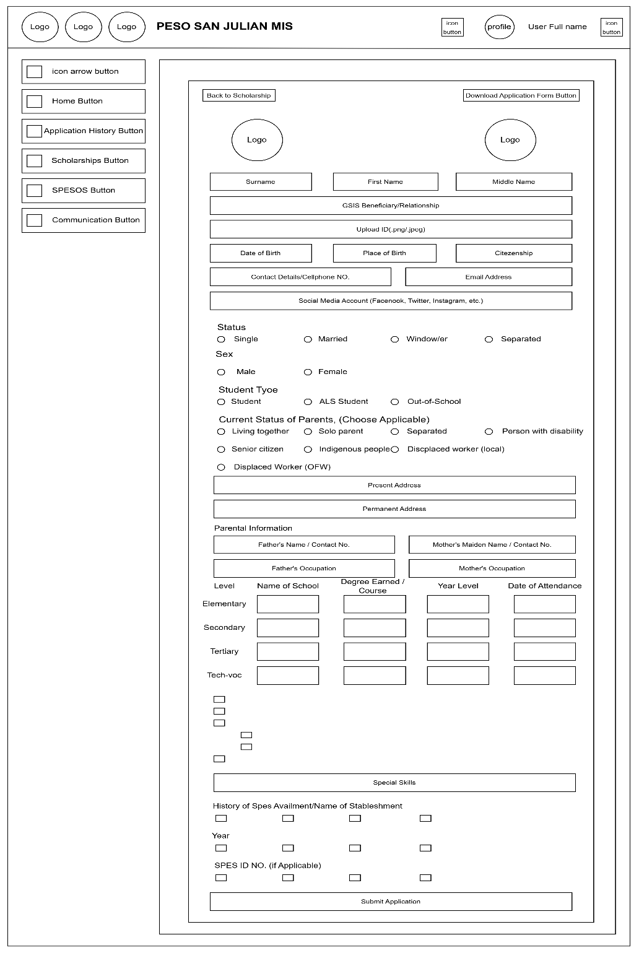
Figure 18: User dashboard peso page – Application form
This Application a comprehensive application form for the PESO San Julian MIS. It collects personal information, contact details, social media, student and parental background, educational history. Users can also upload valid IDs and documents, then submit their application or download a copy using the buttons provided.

User Dashboard SPESOS Page – Oath-of-Undertaking Form
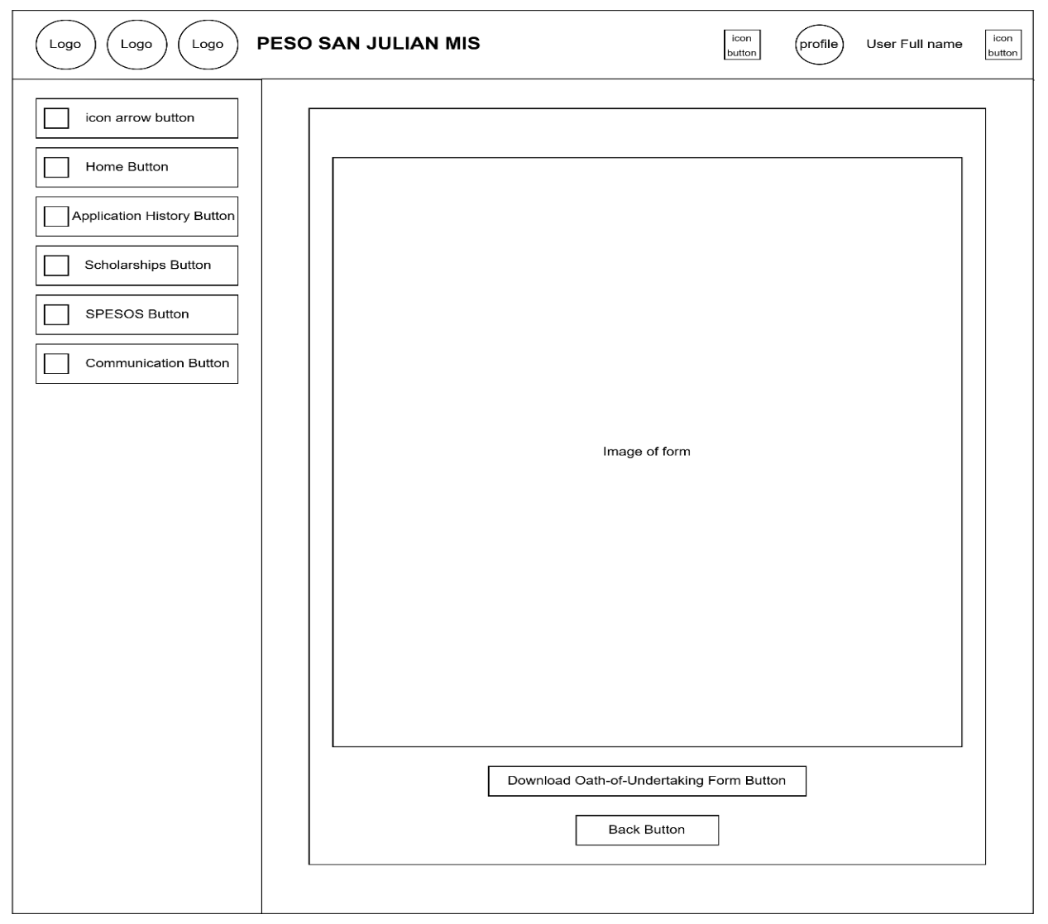
Figure 19: User dashboard spes page – Oath-of-undertaking form
The PESO San Julian MIS allows users to view and download the Oath-of-Undertaking form. It displays the form's image and includes buttons for downloading the form and navigating back to the previous page.

User Dashboard Communication Page
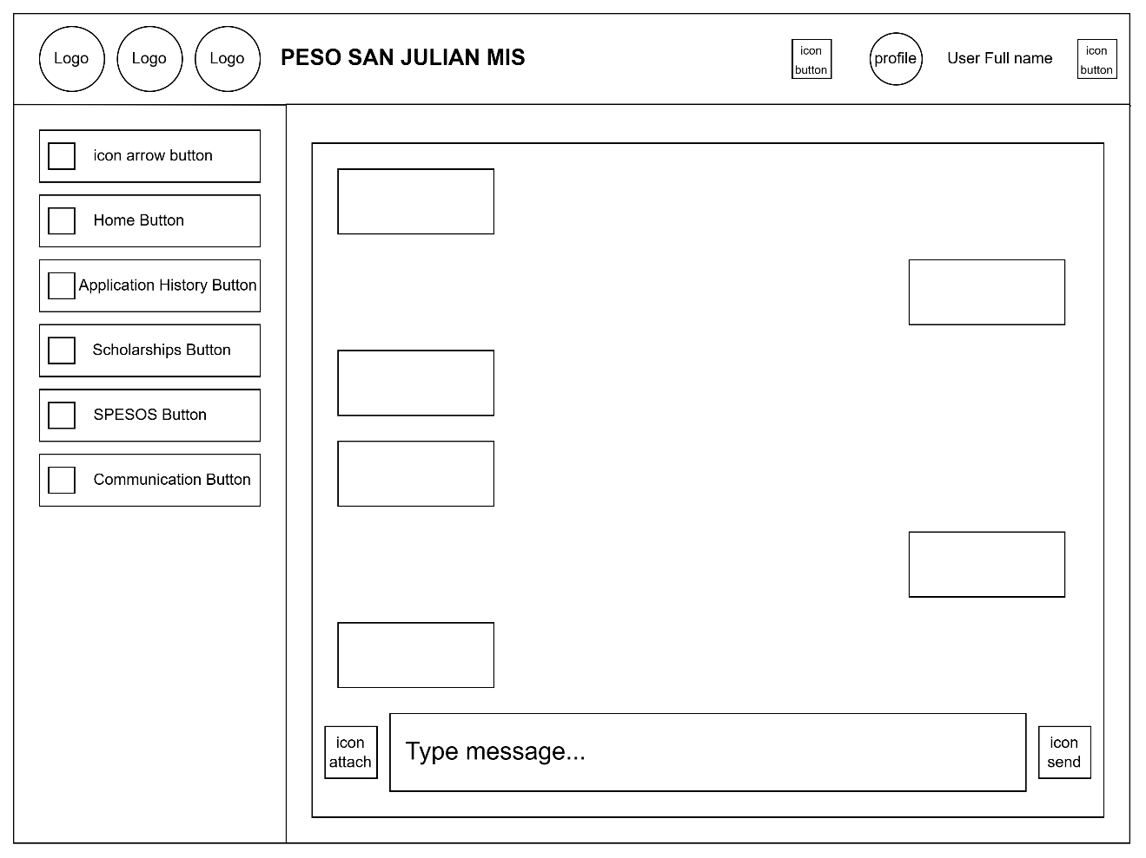
Figure 20: User dashboard communication page
The Communication page, where users can send and receive messages. It includes a message display area, a text input field, and icons to attach files or send messages.

User Profile Page
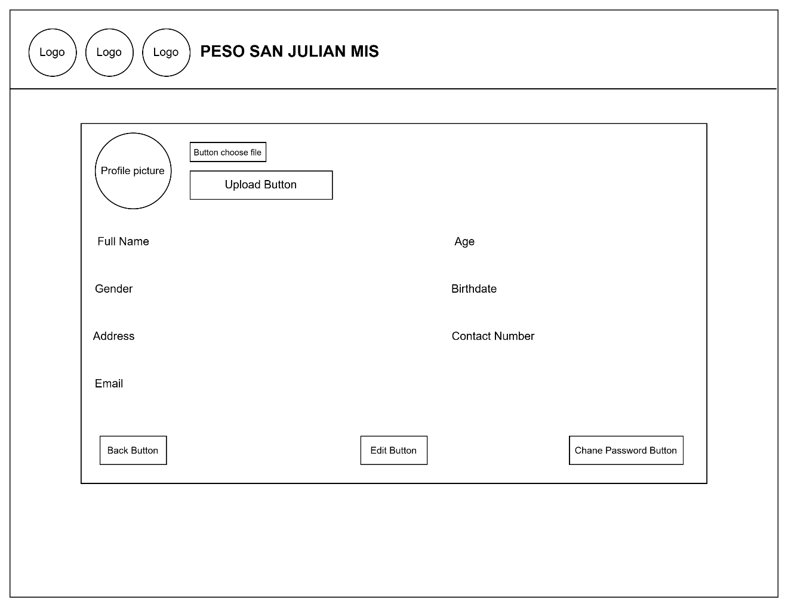
Figure 21: User profile page
The user's profile information, including name, age, gender, birthdate, address, contact number, and email. Users can upload a profile picture and have the option to edit their information or change their password using the respective buttons.

Edit Profile Page
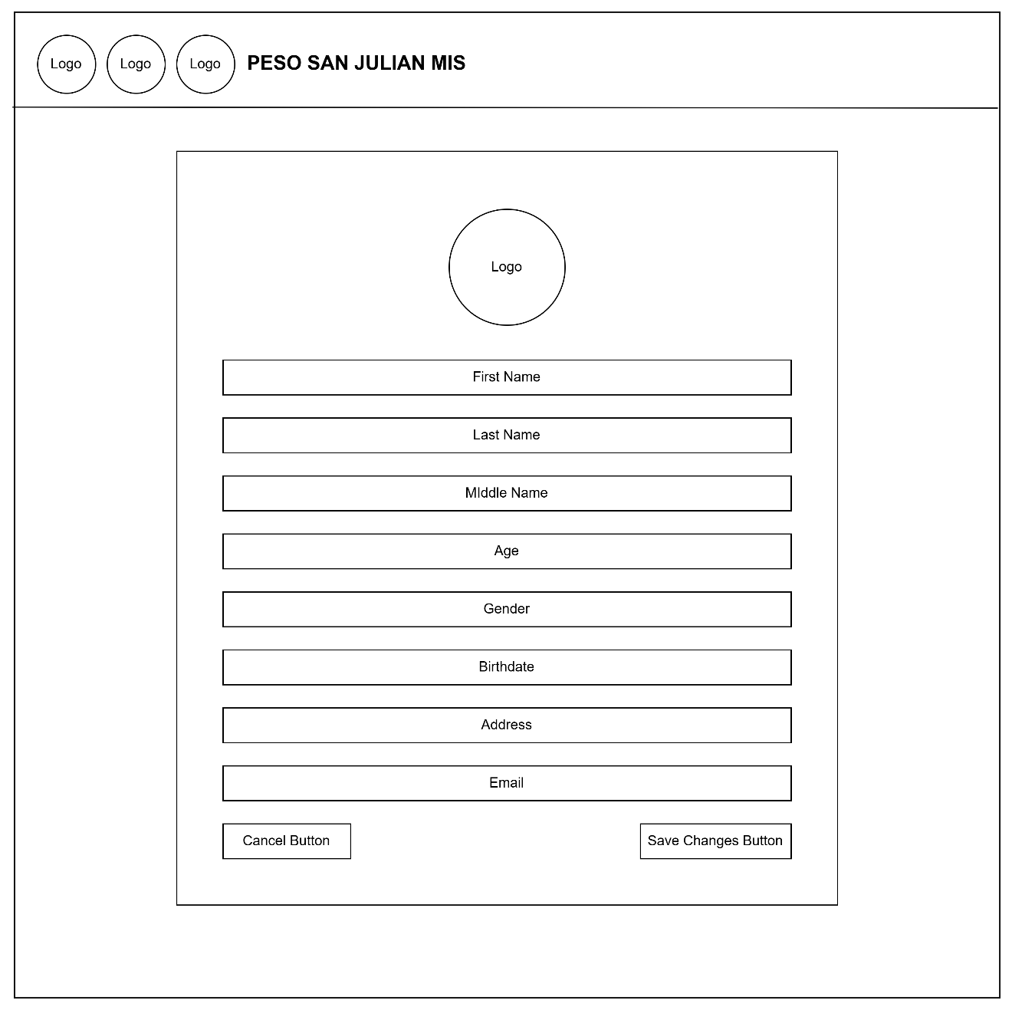
Figure 22: Edit user profile
This page allows users to edit their profile information, including name, age, gender, birthdate, address, and email. At the bottom, users can choose to cancel or save the changes using the respective buttons

Change Password Page
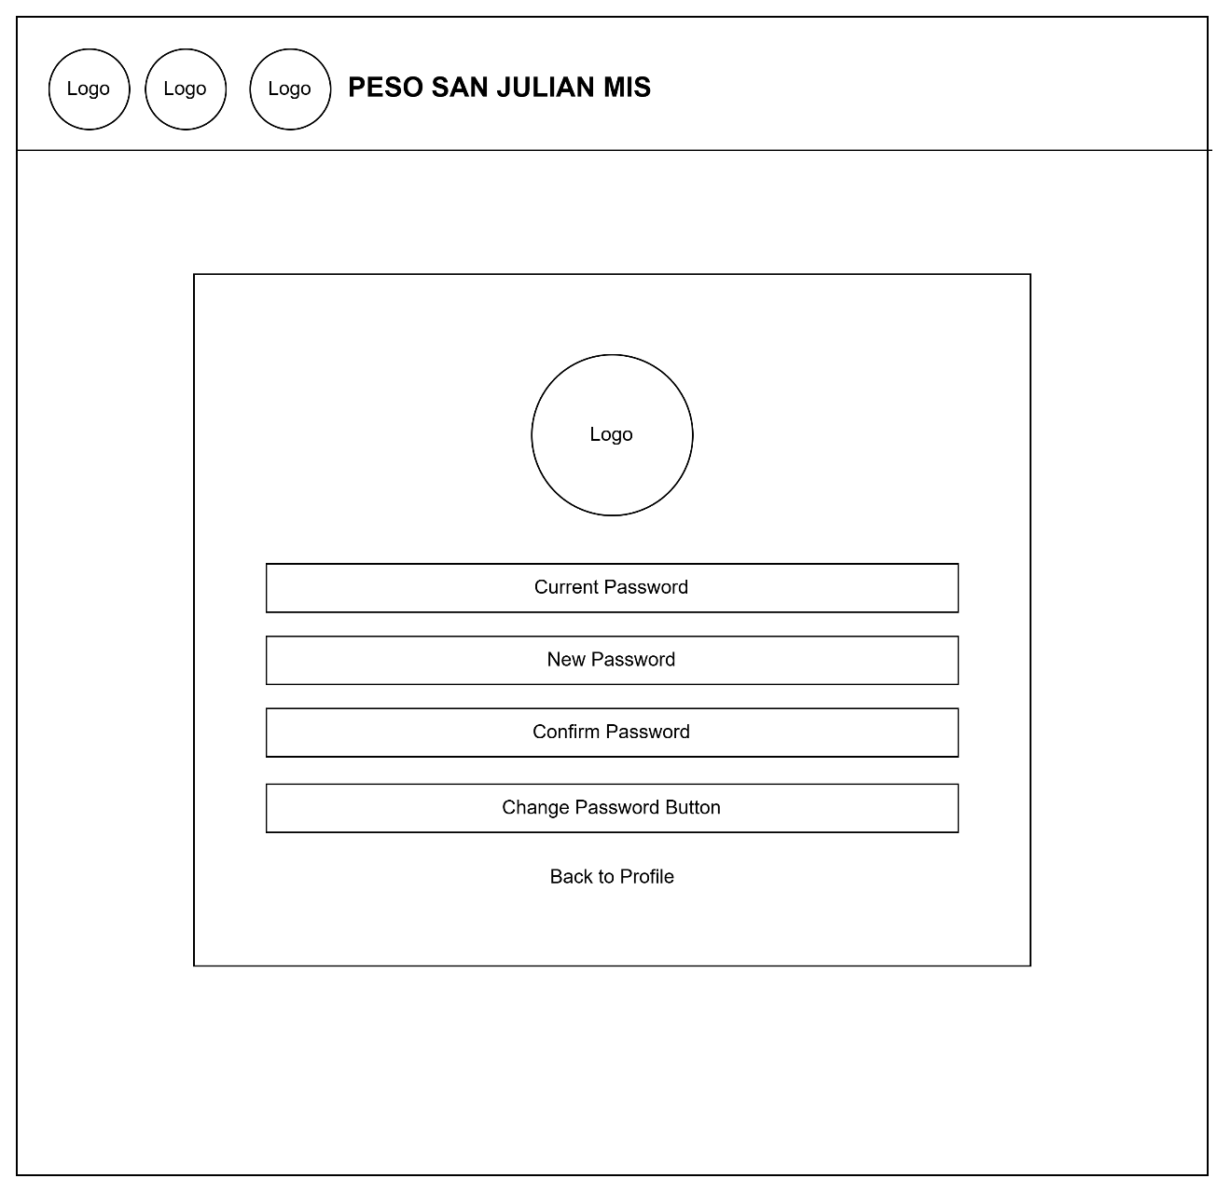
Figure 23: Change password page
The Change Password page of the PESO San Julian MIS. It includes fields for the current, new, and confirmed password, along with buttons to change the password or return to the profile. The layout is simple and user-friendly, focusing on security and ease of navigation.

Admin Dashboard Home Page
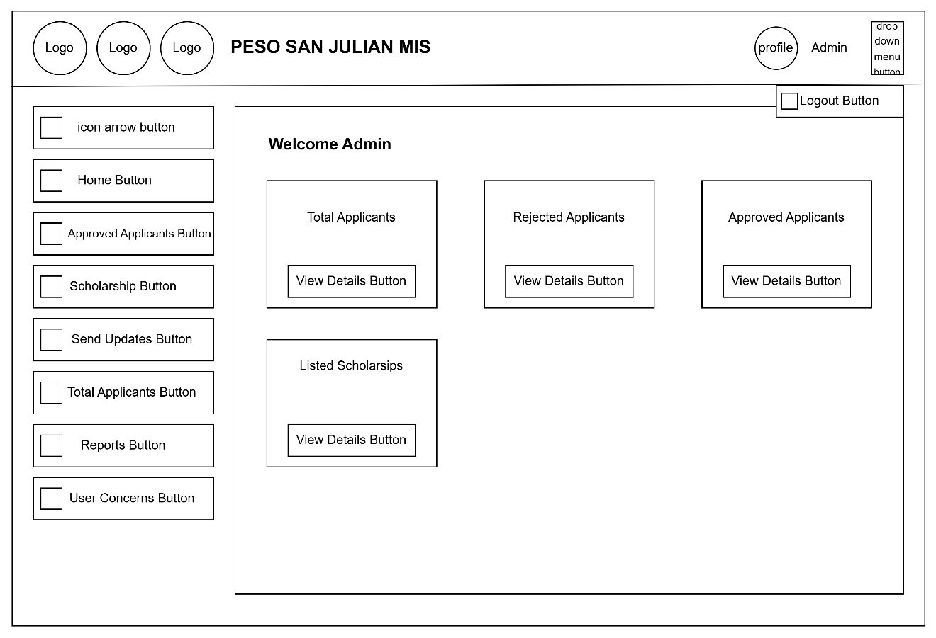
Figure 24: Admin dashboard Home page
The Admin Dashboard for the PESO San Julian MIS. It features a sidebar with navigation buttons for managing applicants, scholarships, reports, and user concerns. The main area displays summaries for total, approved, and rejected applicants, along with listed scholarships, each with a “View Details” button for deeper insights. The layout supports efficient admin monitoring and quick access to key data.

Admin Dashboard Approved Applicants Page
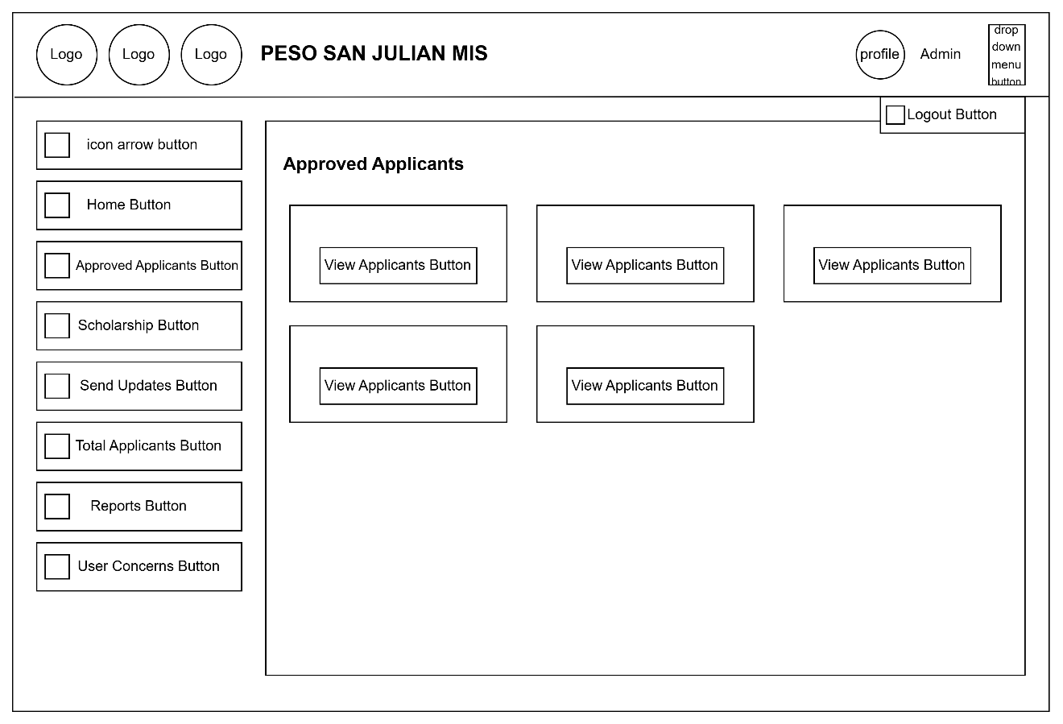
Figure 25: Admin dashboard approved applicant page
The Approved Applicants Page of the PESO San Julian MIS. It features a consistent sidebar for navigation and a main content area with buttons to view individual approved applicants. This layout helps administrators quickly access and review approved applicants in an organized manner.

Admin Dashboard Manage Scholarship Page
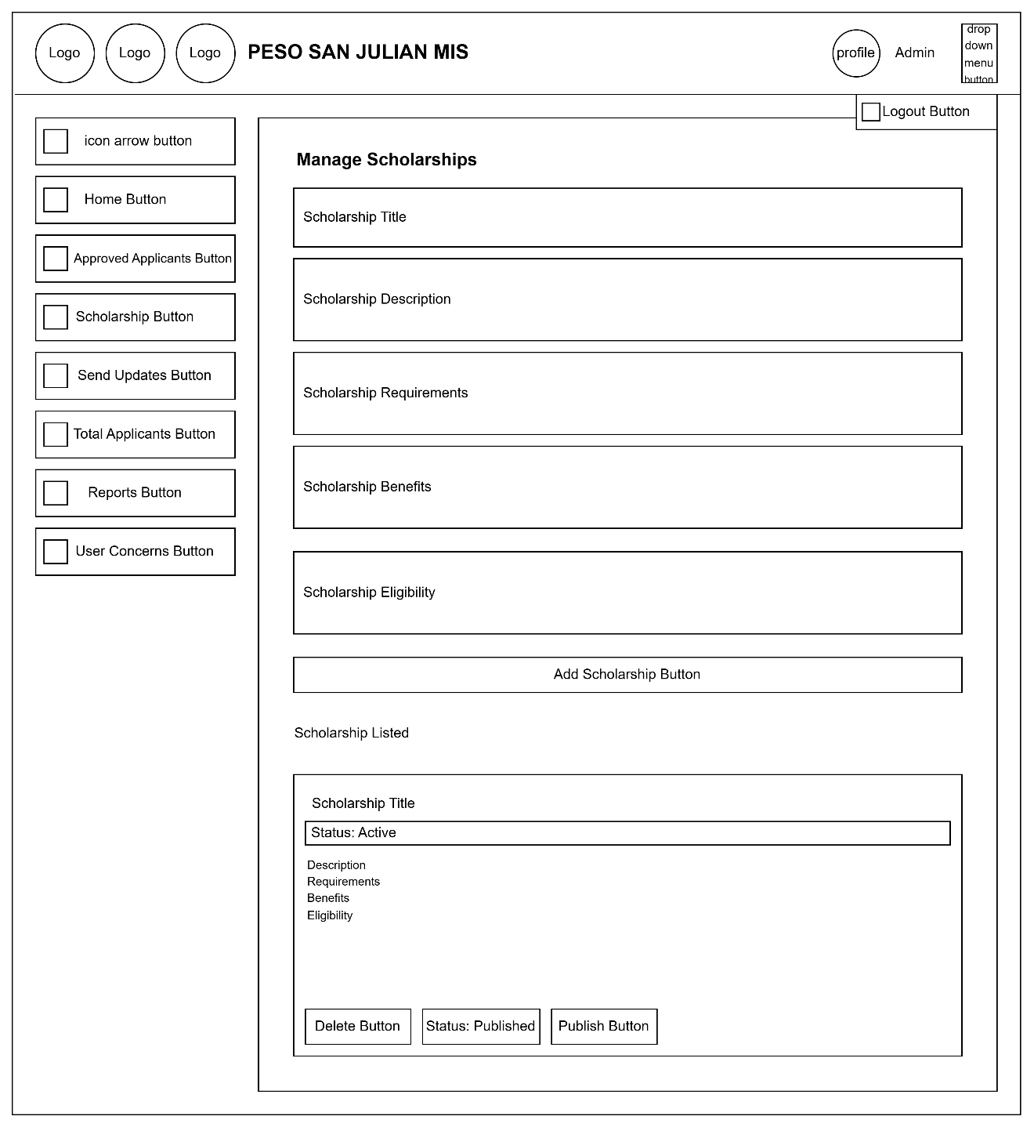
Figure 26: Admin dashboard manages scholarship page
The admin dashboard Manage Scholarships Page of the PESO San Julian MIS. It allows admins to input details such as the title, description, requirements, benefits, and eligibility of a scholarship. Below, listed scholarships can be reviewed, published, or deleted, to improved the management of scholarship offerings.

Admin Dashboard Send Updates Page
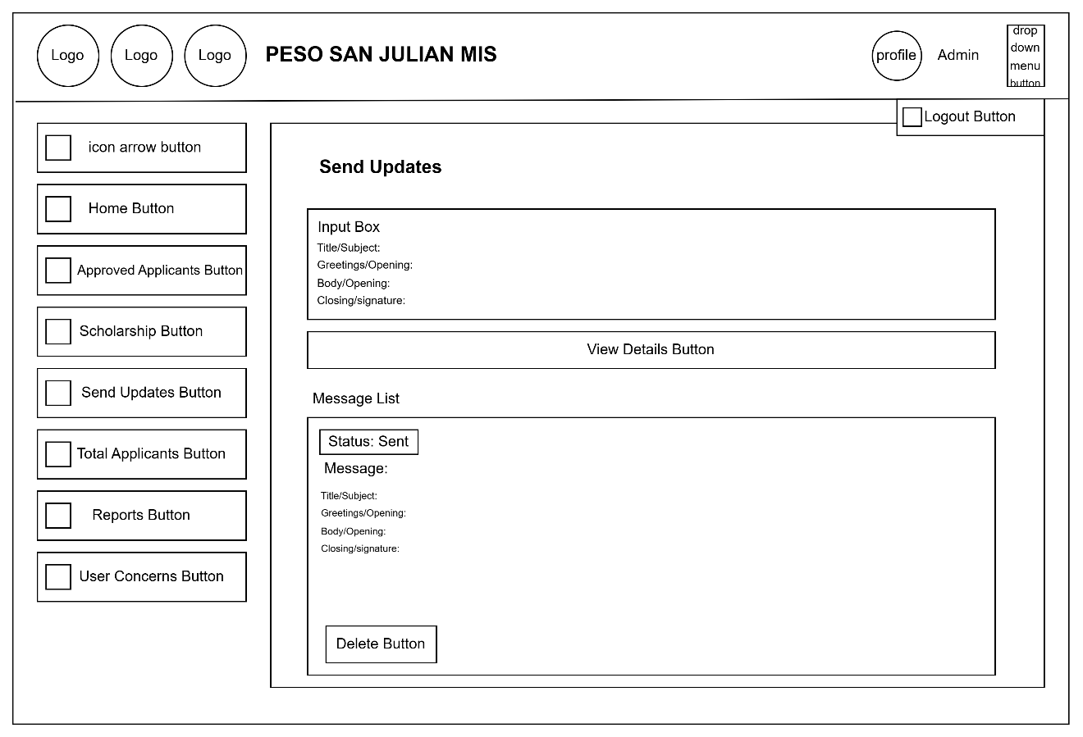
Figure 27: Admin dashboard sends updates page
The Send Updates Page of the PESO San Julian MIS. Admins can compose announcements with a subject, greeting, then send and view them. Sent messages appear in a list with their status and can be deleted if needed.

Admin Dashboard Total Applicants Page
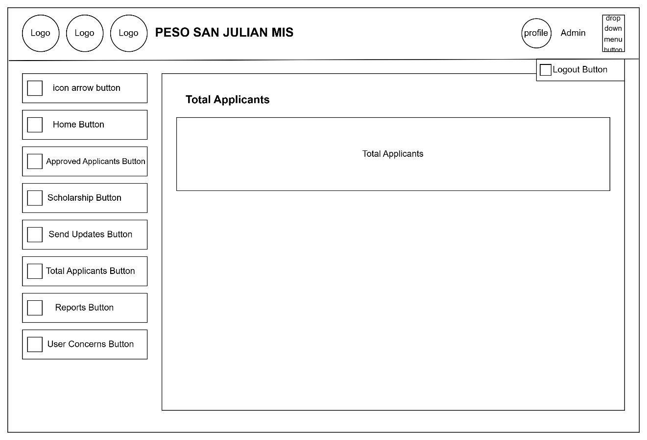
Figure 28: Admin dashboard total applicant page
The Total Applicants Page of the PESO San Julian MIS. It provides an overview of all applicants, accessible via the sidebar. Admins can view the total number and possibly details of each applicant from this section.

Admin Dashboard Reports Page
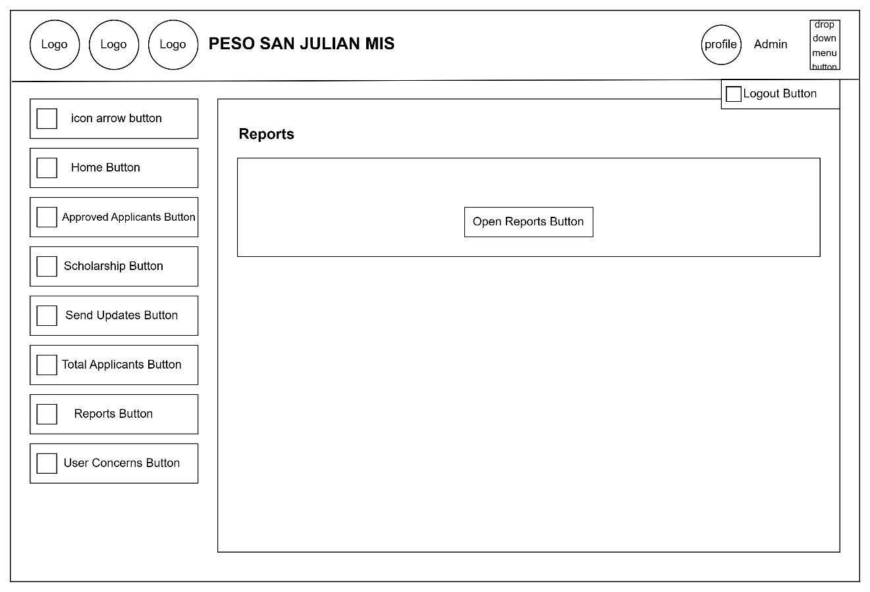
Figure 29: Admin dashboard reports page
The Reports Page of the PESO San Julian MIS. It allows admins to access and open various reports related to the system's operations using the Open Reports Button.

Admin Dashboard User Concerns Page
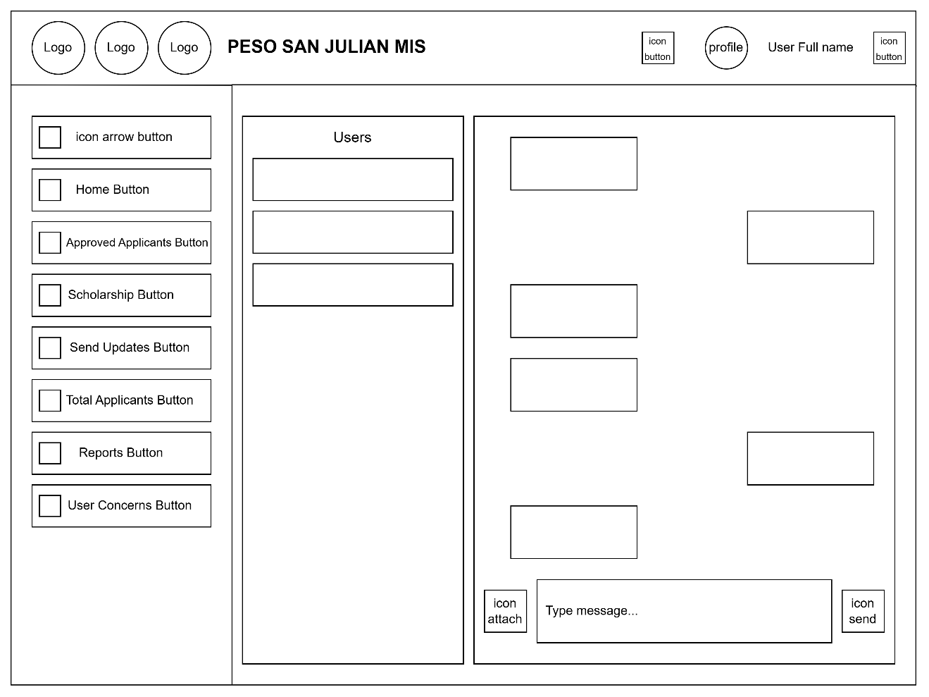
Figure 30: Admin dashboard user concern page
The User Concerns Page of the PESO San Julian MIS. It includes a user list on the left and a chat-style conversation panel on the right, allowing admins to view and respond to user messages in real time. The interface includes message input, attach, and send icons for smooth communication.

Data Flow Diagram
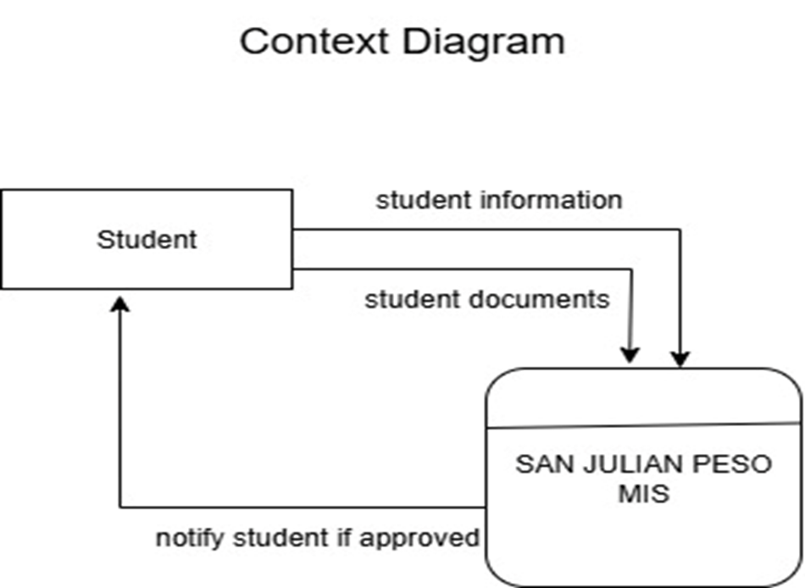

Figure 31: Context Diagram Data Flow Diagram
The PESO San Julian MIS served as the central hub connecting applicants with the Local Government Unit of San Julian. Applicants submitted their information and received responses, while the government unit received scholarship reports for oversight

Data Flow Diagram
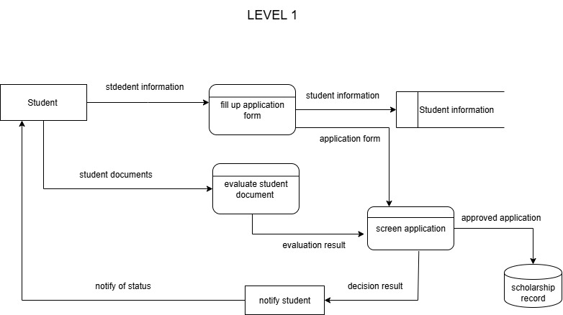

Figure 32: Context Diagram Data Flow Diagram
The process starts with the Applicant submitting their information, which is evaluated in the Check Qualification step. This step verifies details using the Applicant Database. Once verified, the system Identifies if the applicant qualifies for a Scholarship or SPES, based on the provided information. Finally, the application is sent to Validate Application to confirm eligibility and completeness.

System Flowchart
This portion discusses the system flow of the application, outlining its process and functionalities through the use of detailed system flowchart.
Figure Definition
Following are the symbols used in presenting processes in system flowchart. Each Symbol has a corresponding role used in developing and planning the systems flow to understand the system flowchart in developing the symbols with each description.

Terminator - Indicates the beginning or end of program flow in the diagram.
Process - Indicates any processing function.

Decision - Indicates a decision point between two or more paths in a flowchart.

Data - Can represent any type of data in a flowchart may it be an input or output data.

Off-page Connector - An off-page connector is used when the target is on another page.
Off-page Connecter - Are used to replace long lines on a flow chart page.

Database - Represent data housed on a storage service.

System Flowchart
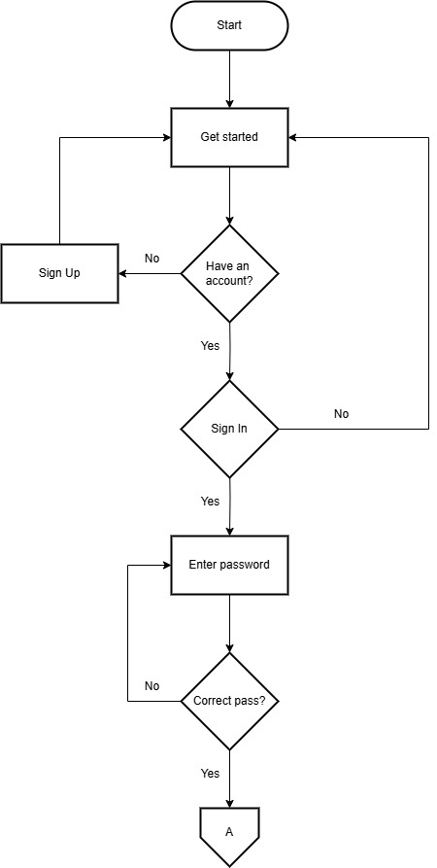
Figure 33: System Flowchart
The PESO San Julian MIS users to get started. If users didn’t have an account, they were directed to sign up. Those with existing accounts proceeded to sign in. After entering their password, the system checked if the password is correct. If the password was correct, users successfully accessed the system.

Flowchart: Sign In
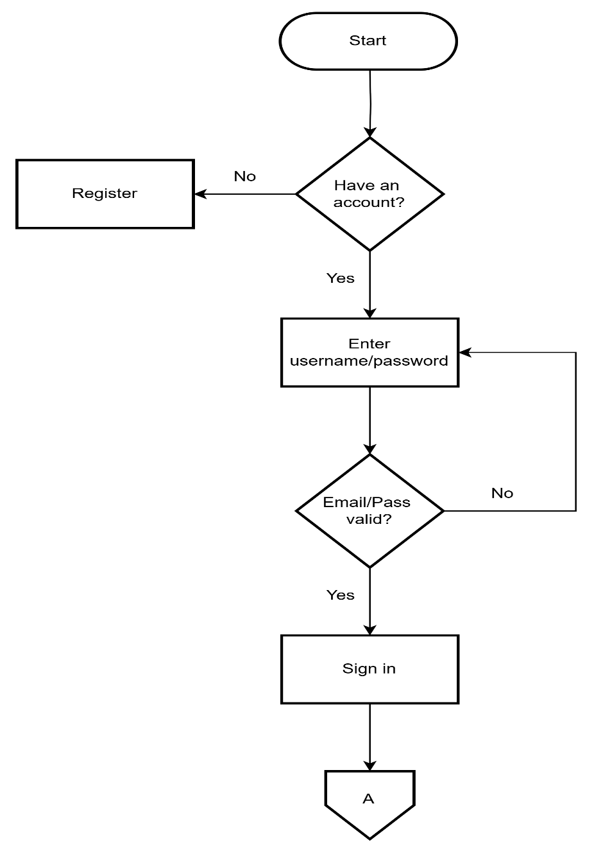
Figure 34: Sign In
The PESO San Julian MIS started by asking users if they had an account. If not, they were directed to register. If they had an account, they entered their username and password. The system then verified the credentials. If the email and password were valid, the user successfully signed in and continued to the next step.

Flowchart: User homepage
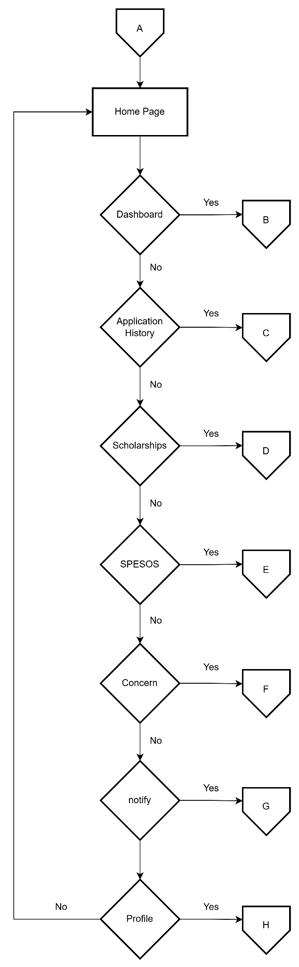
Figure 35: User homepage
The PESO San Julian MIS homepage. Starting from the home page, users can choose from different sections like Dashboard, Application History, Scholarship, SPESOS, Notifications, and Profile. Each choice leads to a specific page, and users are brought back to the home page after completing a task

Flowchart: Home Page
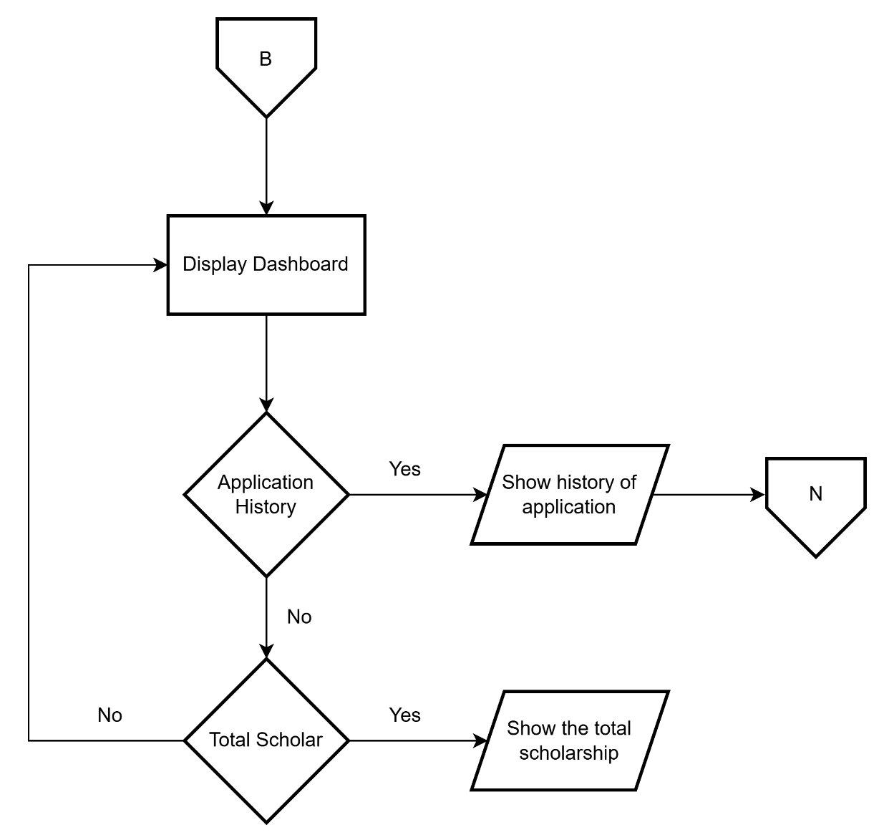
Figure 36: Home Page
The PESO San Julian MIS showed the steps a user followed on the dashboard. It started by displaying the dashboard, then checked if the user wanted to view their application history. If yes, it showed the history. If not, it checked if the user wanted to see their total scholarship. If selected, it displayed the total amount. This process ensured users quickly access key information.

Flowchart: Application History
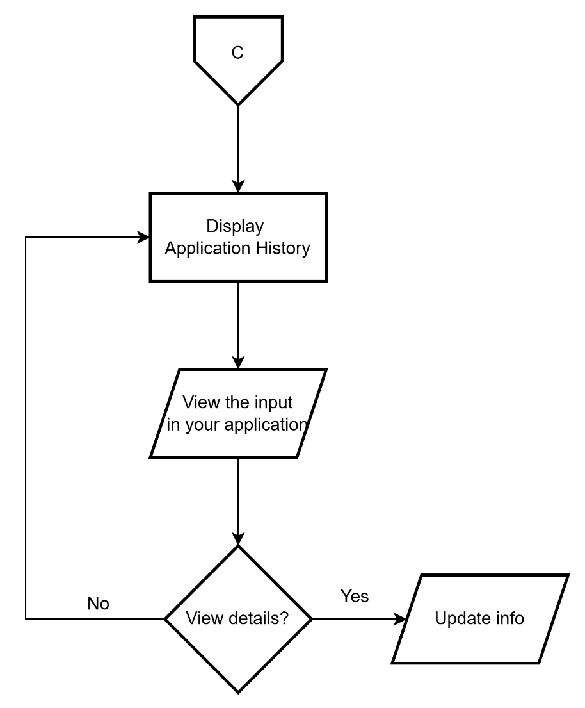
Figure 37: Application history
The PESO San Julian MIS displayed the application history to users. If the user chose to view the details of their application, the system allowed them to check the inputs. If needed, users could proceed to update or edit their application. Once the information was updated, the system confirmed that the changes had been made successfully.

Flowchart: Scholarships
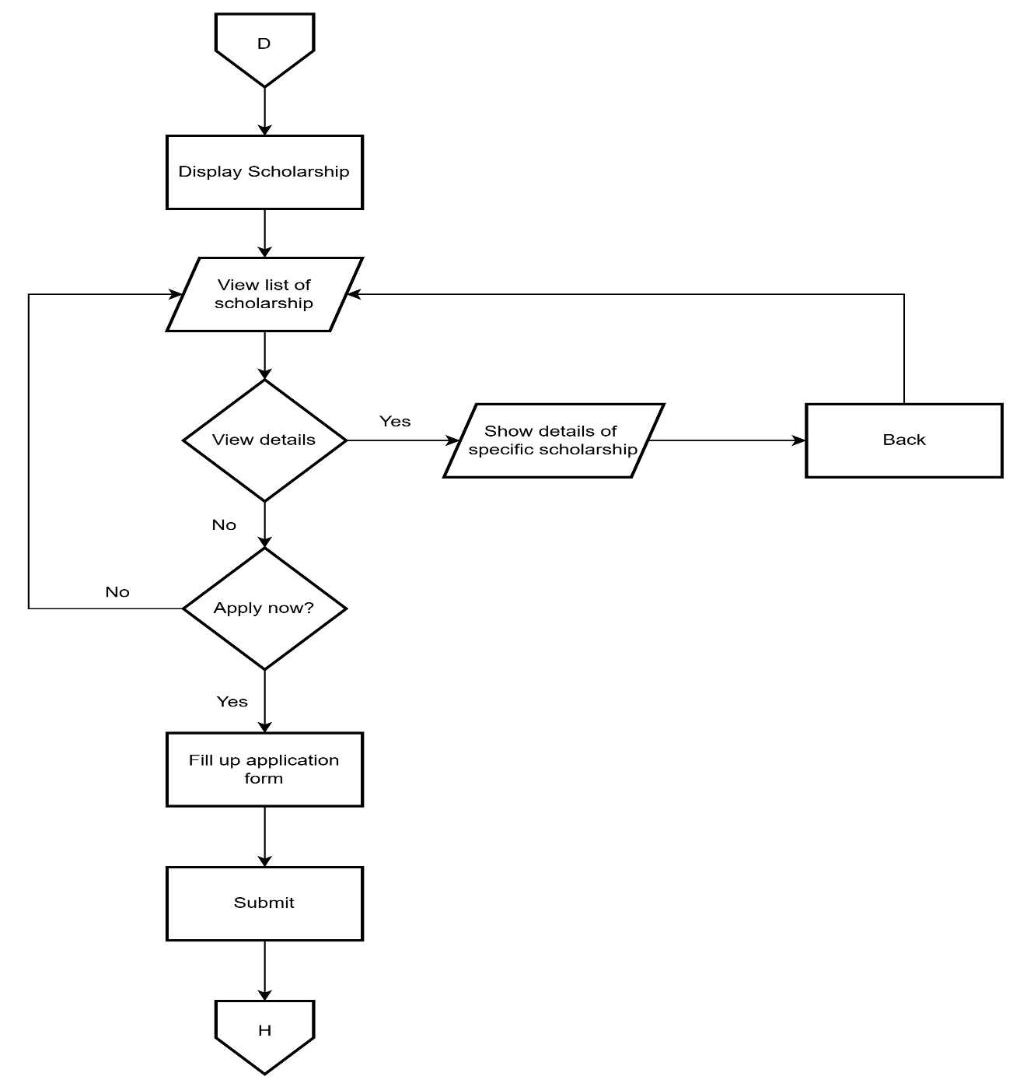
Figure 38: Total scholarship
The scholarship application process. It started by displaying the list of scholarships. If the user chose to view details, specific information was shown. The user then decided whether to apply. If yes, they filled out and submitted the application form. This process guided users step-by-step through checking and applying for scholarships.

Flowchart: SPESOS
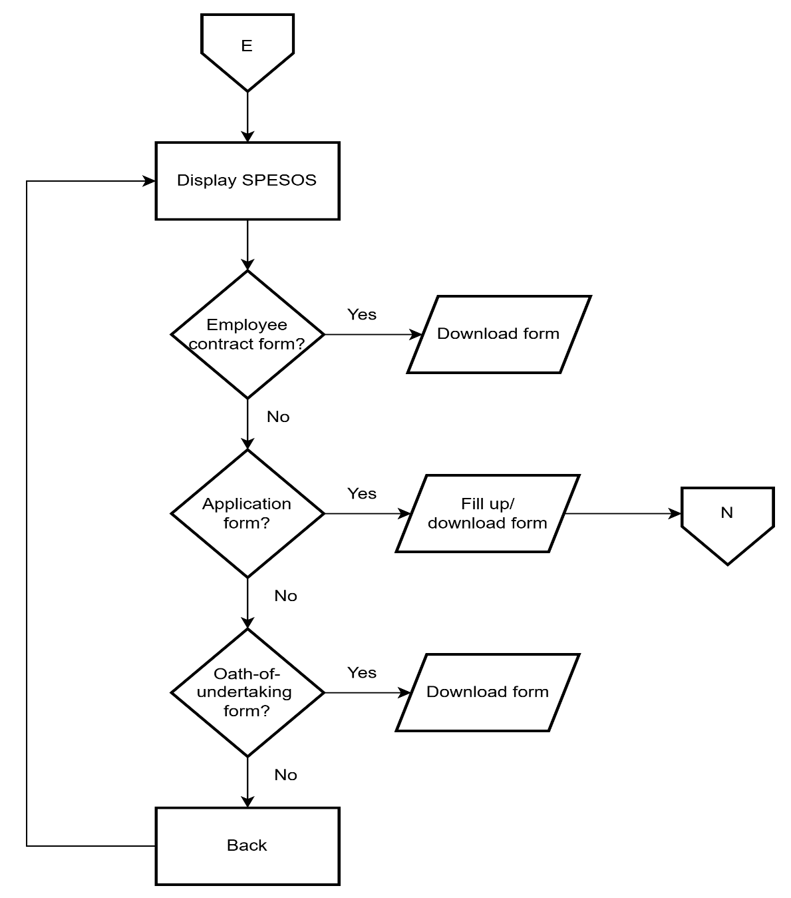
Figure 39: SPESOS
The SPESOS process. It began by displaying SPESOS options. If the user needed the employee contract form, it was downloaded. If not, the system checked for the application form. When needed, the form was filled out or downloaded. Lastly, the system asked for the oath-of-undertaking form, which was also downloaded if required. The process then ended or returned to the main menu.

Flowchart: Concern
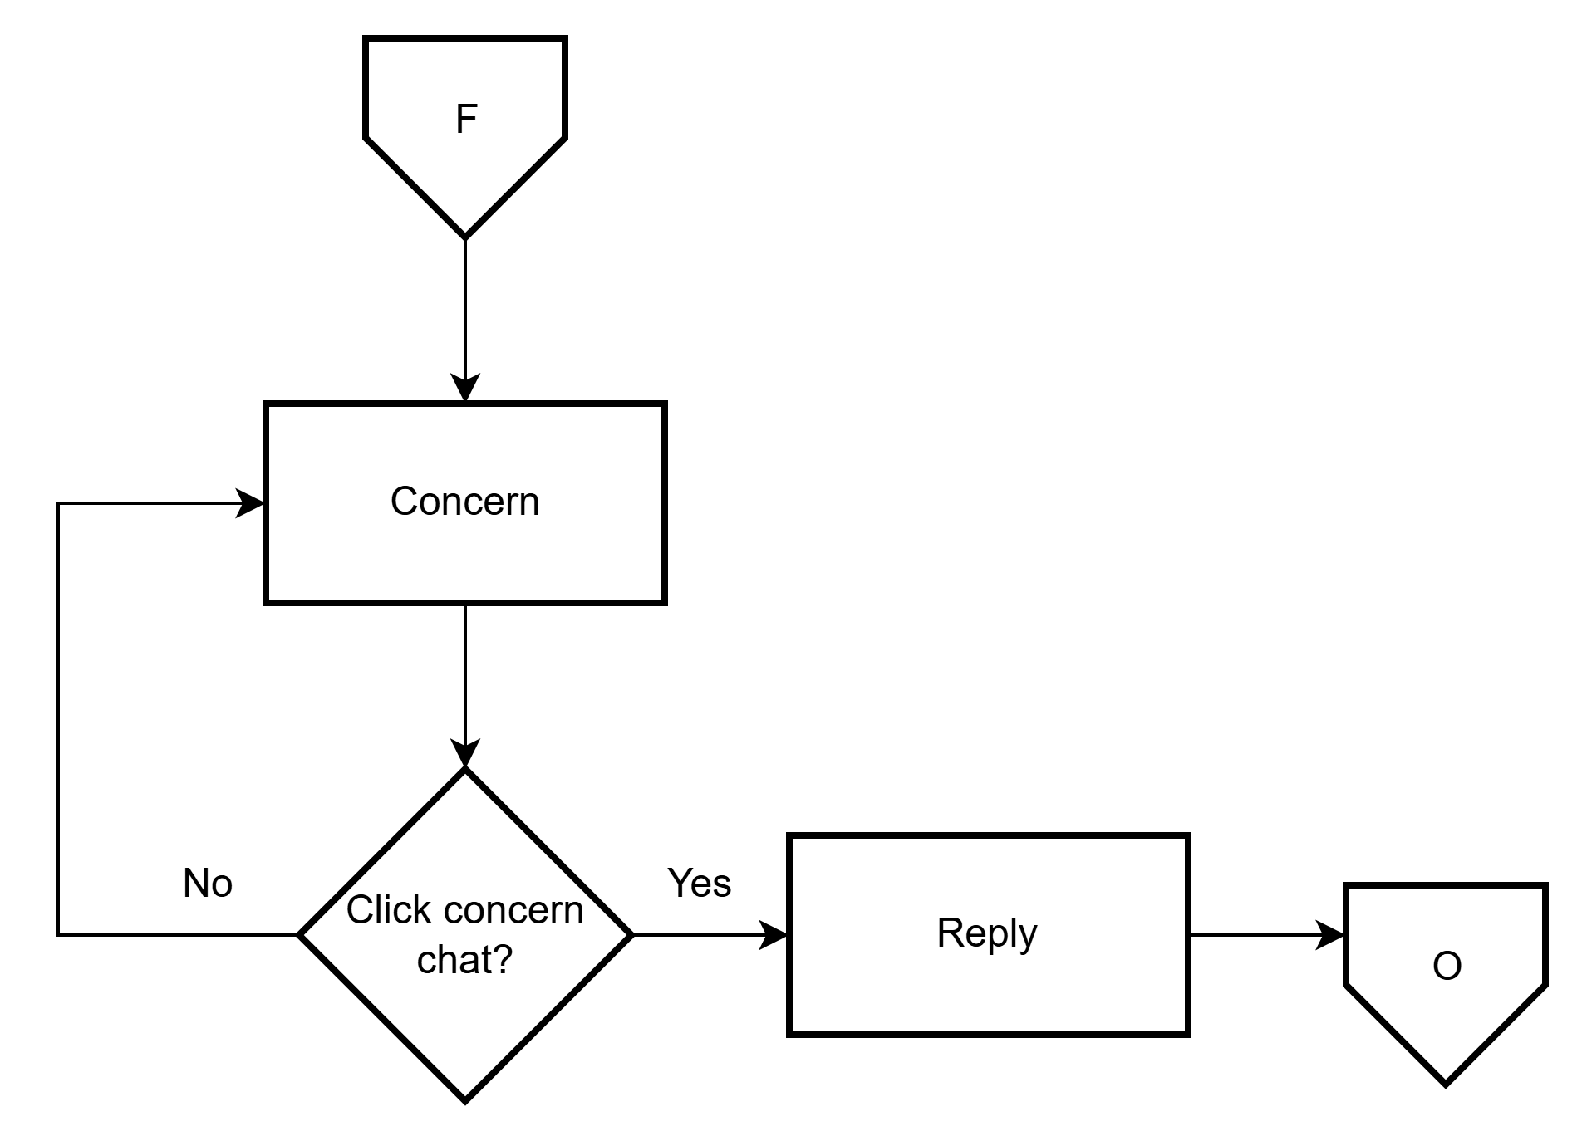
Figure 40: Concern
The PESO San Julian MIS provides a structured approach to handling concerns effectively. It begins with identifying a concern, then moves through a process where the concern is addressed via a designated chat system. The response phase follows, ensuring engagement and resolution. and responding accordingly. This ensures clear communication and efficient problem-solving.

Flowchart: Notification

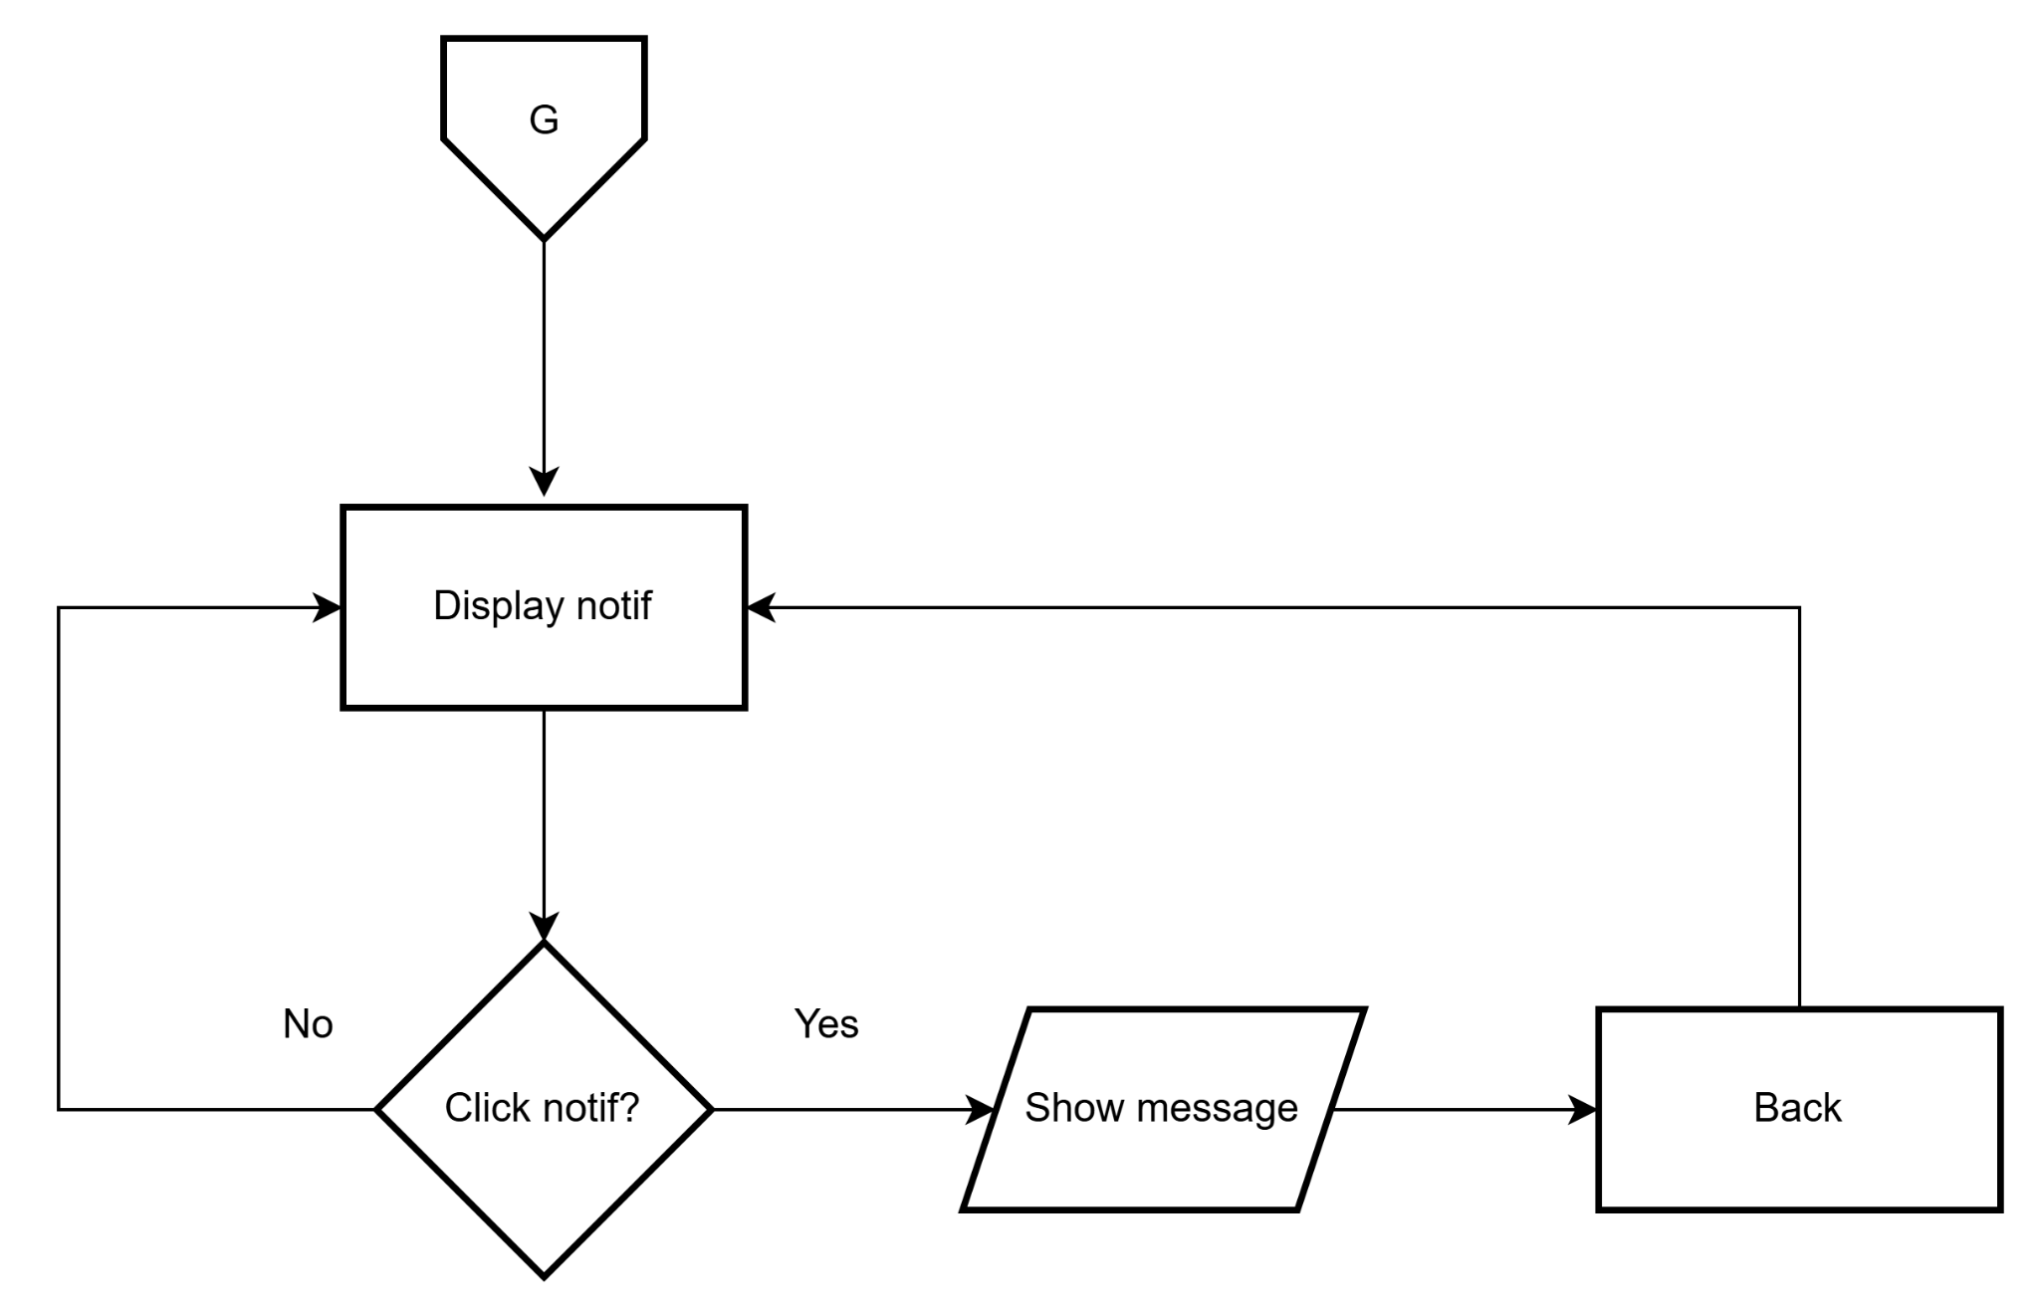
Figure 41: Notification
The PESO San Julian MIS outlined the process of handling notifications. It started with a displayed notification. If the user clicked the notification, a message was shown. Otherwise, the notification remained visible. The process included an option to go back, looping the flow for continued interaction.

Flowchart: Profile
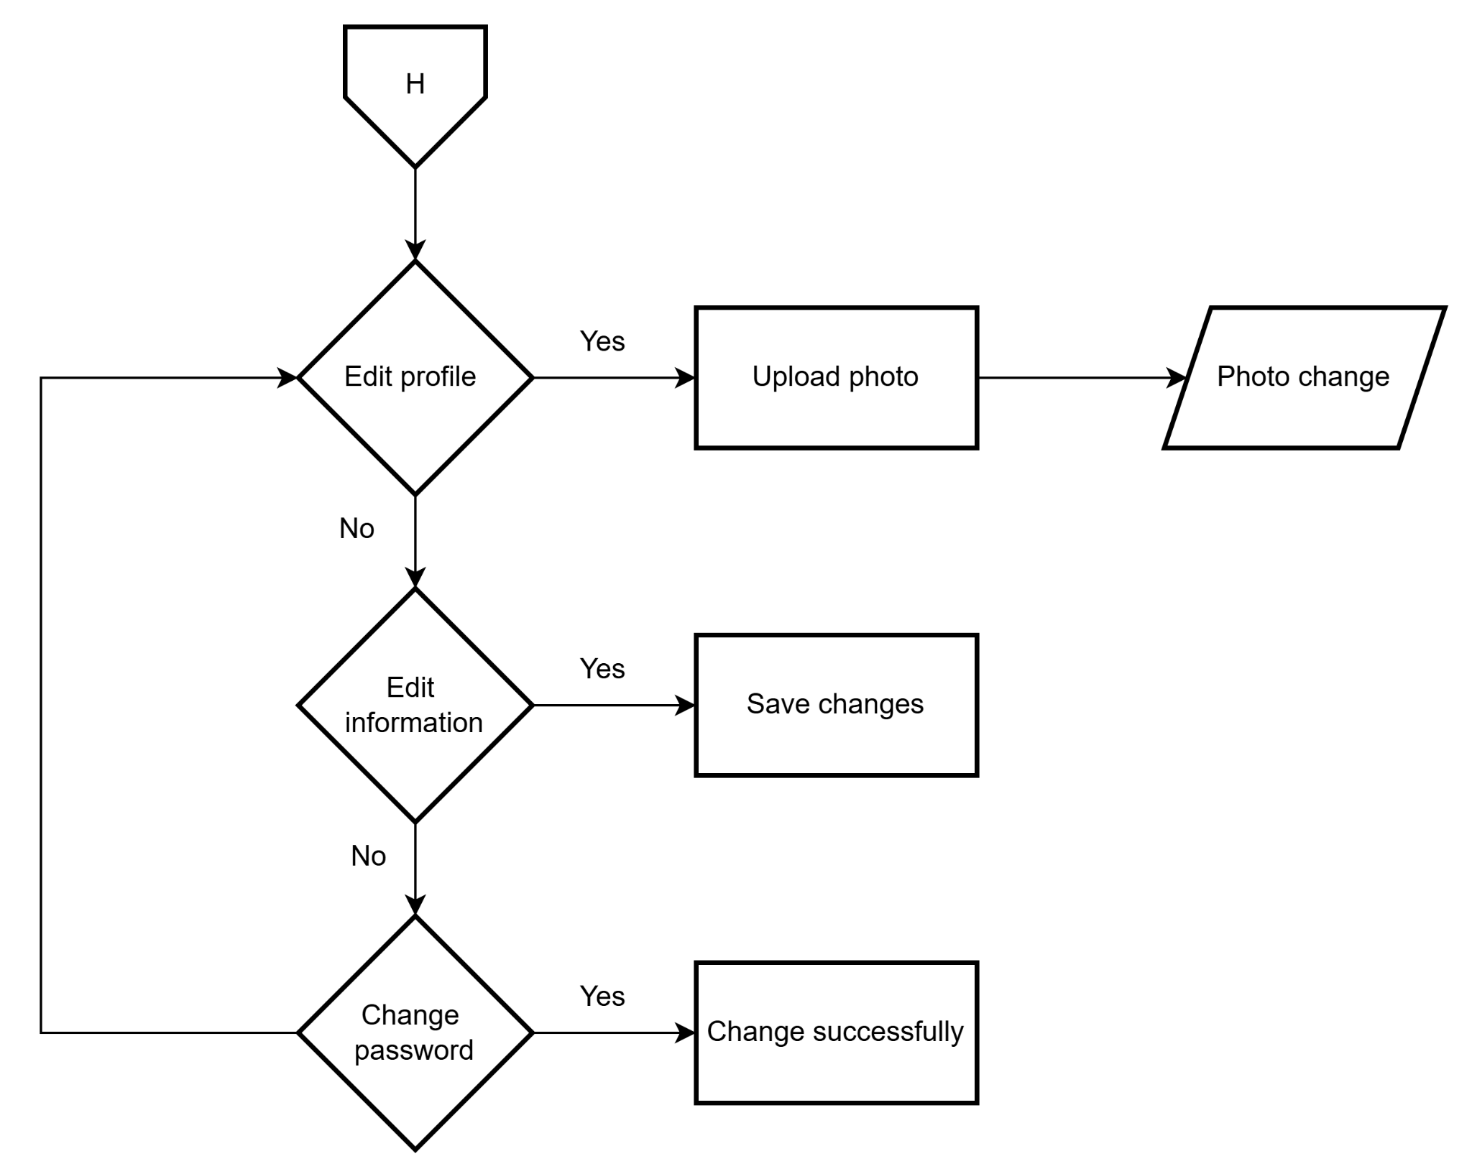
Figure 42: Profile
The PESO San Julian MIS It began with a presented options for modifying different aspects of the profile. If the user chose to edit their profile, they could upload a photo, resulting in a photo change. If they declined, they had the option to edit their information, which led to saving changes. If they skipped this step, they could opt to change their password, which, if successful, completed the process.

Flowchart: Admin
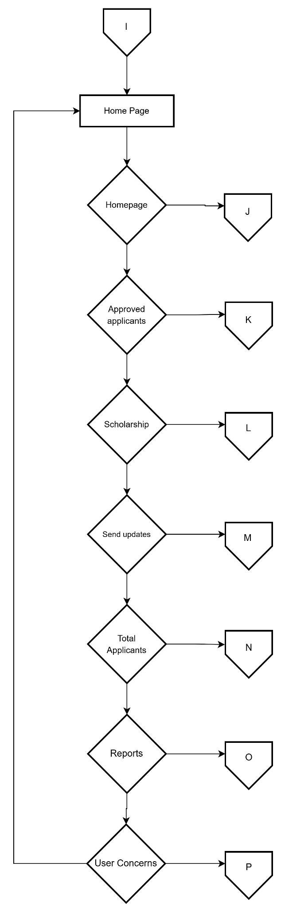
Figure 43: Admin homepage
he PESO San Julian MIS Admin Homepage shows the main functions available to an admin. From the home page, the admin can access features such as user concerns, reports, applicant details, updates, scholarships, and approved applications. Each option leads to a specific task and returns to the homepage, allowing for efficient and organized navigation.

Flowchart: Admin dashboard
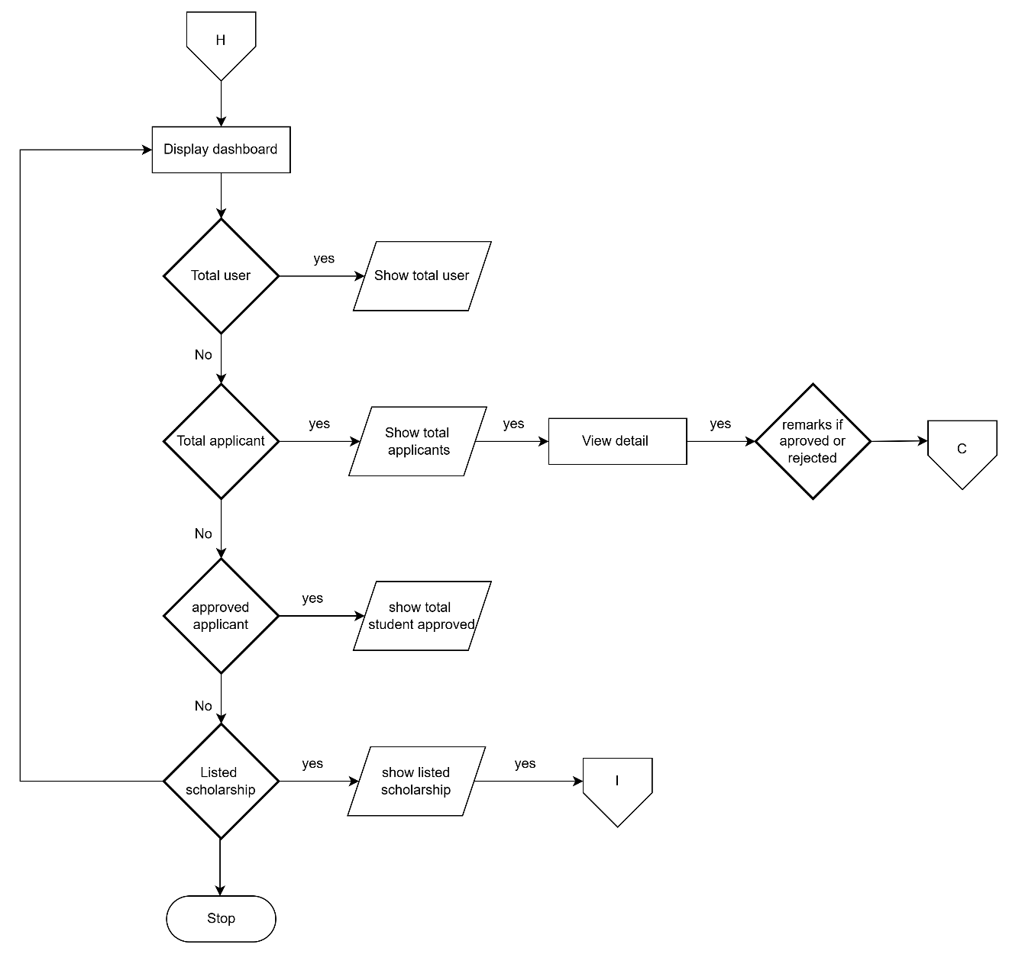
Figure 44: Admin dashboard
This admin dashboard outlines a process starting from a dashboard, checking for users and applicants, displaying totals and details, showing approval/rejection remarks, and finally showing listed scholarships.

Flowchart: Approved applicants
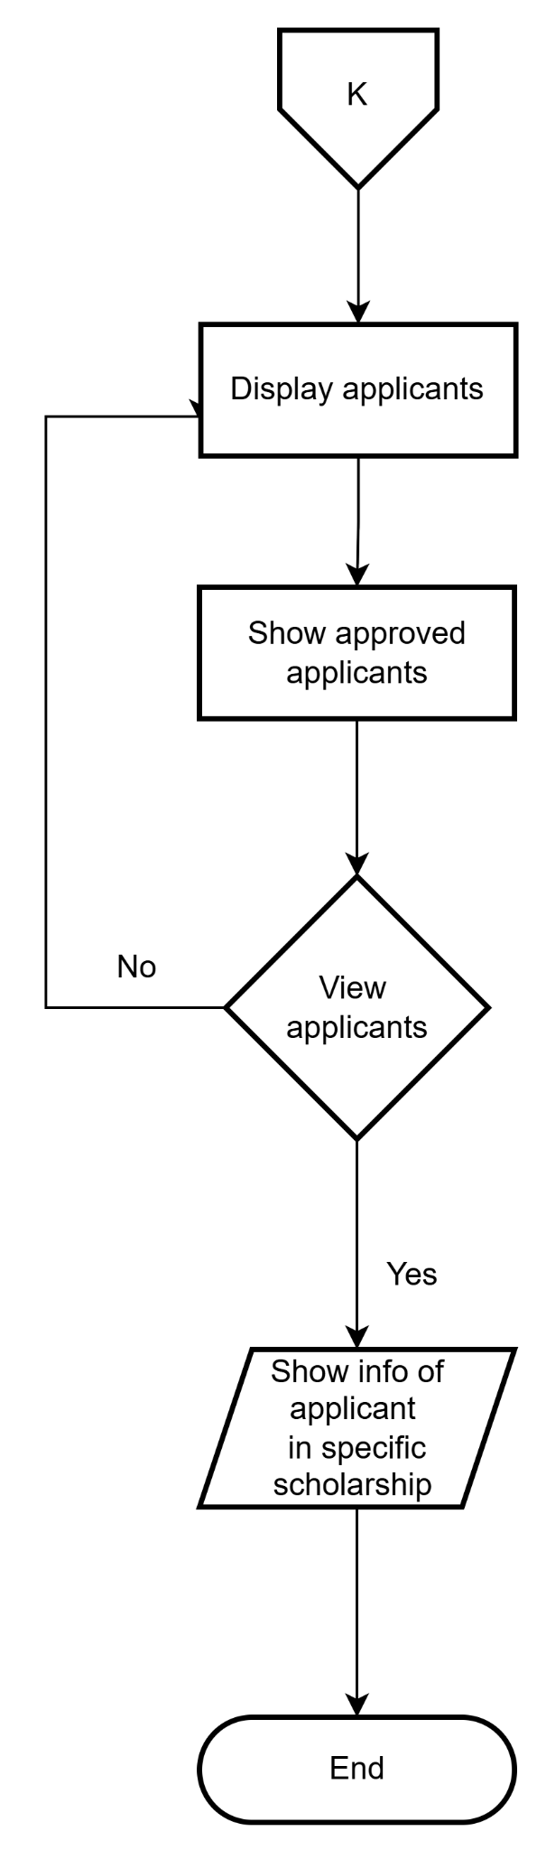
Figure 45: View applicant
The PESO San Julian MIS view applicant flowchart begins at It displays all applicants, then shows approved applicants. A decision point follows: if the user chooses to view applicants, information about a specific applicant within a specific scholarship is shown. The process ends.

Flowchart: Scholarship
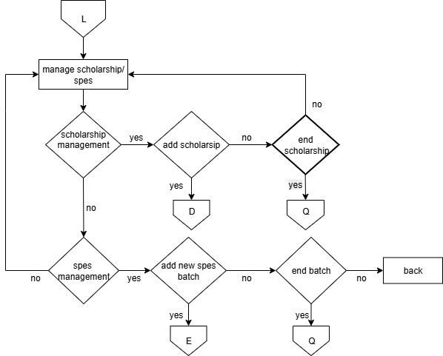
Figure 46: scholarship
This Scholarship/Spes flowchart explains the process of managing scholarships and SPES. It begins with the option to manage either scholarships or SPES.If the user chooses scholarship management, they can either add a new scholarship or end an existing one. If you can add scholarship it will go to scholarship page of user, while ending a scholarship directs the system to record it in the scholarship history. On the other hand, if the user choose SPES management, they can add a new SPES batch. Once the batch is completed, the system proceeds if you want to end the batch if yes it proceed to scholarship spes history
Flowchart: Send updates
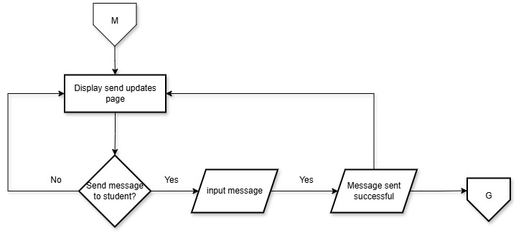
Figure 47: Send updates
The San Julian MIS send update page flowchart starts at displaying a send update It then asks if a message should be sent to a student. If yes, a message is inputted if successful, it send to user notification. If no message is to be sent, the process back to the send updates page.

Flowchart: Admin Total Applicant page
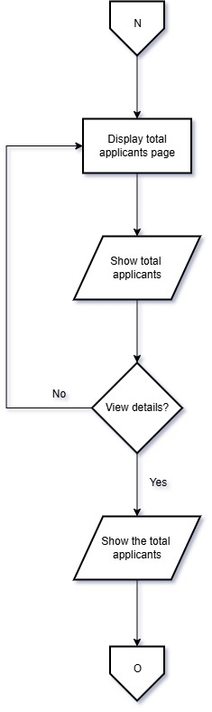
Figure 48: Admin Total Applicant page
The PESO San Julian MIS total applicant flowchart starts at displaying the total number of applicants is shown. The total number of applicants is then displayed. The system asks if details should be viewed. If yes, the total number of applicants is moved to the report page. If no, the process also returns to N.

Flowchart: Report page
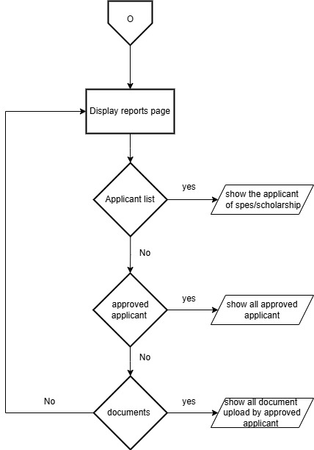
Figure 49: Report page
The PESO San Julian MIS displaying reports on SPES or scholarship applicants. It begins with the "Display reports page" and checks for available applicant lists, approved applicants, and uploaded documents. If none are found, it loops back, ensuring efficient access to relevant information.

Flowchart: User concern
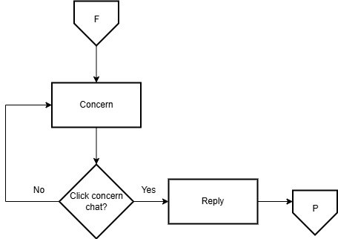
Figure 50: User concern
The PESO San Julian MIS provides a structured approach to handling concerns effectively. It begins with identifying a concern, then moves through a process where the concern is addressed via a designated chat system. The response phase follows, ensuring engagement and resolution. and responding accordingly. This ensures clear communication and efficient problem-solving.

Flowchart: Scholarship/Spes history
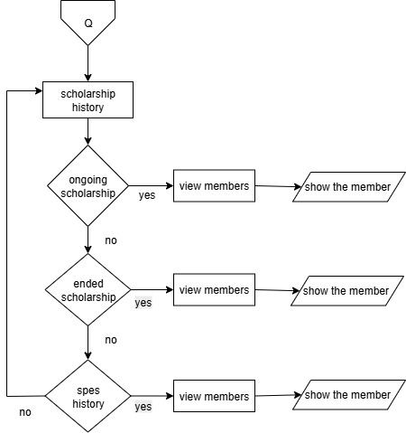
Figure 51: User concern
The Scholarship/Spes flowchart shows how the scholarship history system works. It starts with a query and then leads to different categories of scholarships. If the scholarship is ongoing, the user can view its members and check their details. If it has already ended, the process is the same users can still view members and see their information. There is also a section for SPES history, where users can do the same steps. In simple terms, the system makes it easy to track view scholarship records, whether they are active, finished, or part of a special program.

Entity Relation Diagram
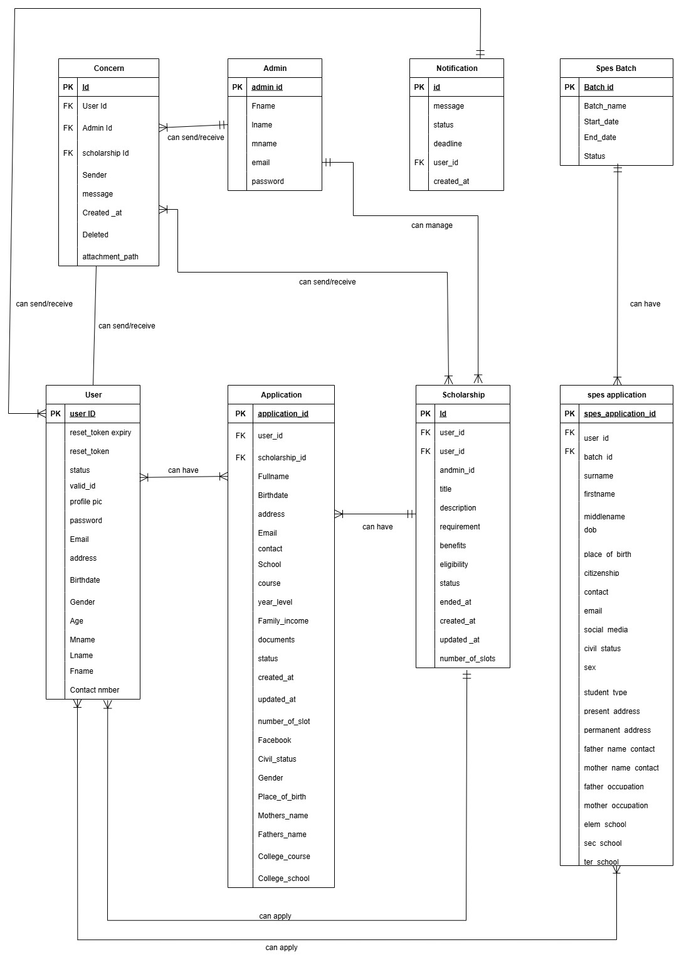
Figure 52: Entity Relationship Diagram
The PESO San Julian MIS Entity Relationship Diagram shows how users interact with the scholarship system. Key entities include User, Scholarship, Application, Message, Notification, and Concern. Users can apply for scholarships, send concerns, and receive messages and notifications. Admins can manage scholarships and handle user interactions. The diagram outlines the relationships and data flow between these entities
Data Dictionary
Table 3 User
Fields Name | Data Type | Size | Attribute | Description
Id | int | 11 | PK | User id
Fname | varchar | 20 |  | First Name
Lname | varchar | 20 |  | Last Name
Mname | varchar | 20 |  | Middle Name
Age | int | 3 |  | Age
Gender | Varchar | 15 |  | Gender
Birthdate | date |  |  | Birthdate
Address | varchar | 100 |  | Address
contact_number | int | 11 |  | Contact Number
Email | varchar | 50 |  | Email
Password | varchar | 60 |  | Password
reset_token | varchar | 6 |  | Reset Token
reset_token_expiry | datetime |  |  | Reset Token Expiry
profile_pic  valid_id  status | Varchar  Varchar  Enum(‘Pending’, approved, rejected) | 100  150 |  | Profile Picture  Valid ID  Status of application

Table 4 Admin
Fields Name | Data Type | Size | Attribute | Description
Id | Int | 11 | PK | Admin id
fname | varchar | 20 |  | First Name
lname | varchar | 20 |  | Last Name
mname | varchar | 20 |  | Middle Name
email | varchar | 50 |  | Email
password | varchar | 60 |  | Password
Table 5: Notifications
Fields Name | Data Type | Size | Attribute | Description
Notification_id | Int | 11 | PK | Notification id
message | text |  |  | message
deadline | datetime |  |  | deadline
user_id  status  created_at | int  enum(‘unread’,’read’)  timestamp | 11 | FK | User id  status  Created_at

Table 6: Scholarships
Fields Name | Data Type | Size | Attribute | Description
Id  User_id  Admin-id | Int  Int  Int | 11  11  11 | PK  FK  FK | Scholarship id  Id of the user  Id of the admin
title | varchar | 50 |  | Title
description | text |  |  | Description
requirements | text |  |  | Requirements
benefits | text |  |  | Benefits
eligibility | text |  |  | Eligibility
status | enum (‘pending’, active’) |  |  | Status
created_at | timestamp |  |  | Created At
updated_at  number_of_slots | Timestamp  int | 3 |  | Updated At  Number_of_slots

Table 7: Application
Fields Name | Data Type | Size | Attribute | Description
id | int | 11 | PK | Application Id
user_id | int | 11 | FK | User Id
scholarship_id | int | 11 | FK | Scholarship Id
fullname | varchar | 255 |  | Full Name
birthdate | Date |  |  | Birthdate
address | Text |  |  | Address
email | varchar | 255 |  | Email
contact | int | 11 |  | Contact
school | varchar | 255 |  | School
course | varchar | 255 |  | Course
year_level | varchar | 50 |  | Year Level
family_income | decimal (10.2) |  |  | Family Income
documents | text |  |  | Documents
Status | enum (“pending”, “approved”, “rejected”) |  |  | Status
created_at | timestamp |  |  | Created At
updated_at  number_of_slot  facebook  civil_status  Gender  Place_of_birth  Mothers_name  Fathers_name  College_course  College _school | Timestamp  Int  Varchar  Enum  Varchar  Varchar  Varchar  Varchar  Varchar  Varchar | 3  30  10  50  50  50  50  50 |  | Updated At  Number of slots  Facebook acc  Status  User Gender  Place of birth  Mothers name  Fathers name  Course  School
Table 8: Concerns
Fields Name | Data Type | Size | Attribute | Description
Id | int | 11 | PK | Application Id
user_id | int | 11 | FK | User Id
admin_id  scholarship_id | Int  int | 11  11 | FK  FK | Admin Id  Scholarship id
Sender | enum(‘user’,’admin’) |  |  | Sender
message | text |  |  | Messages
created_at | datetime |  |  | Created at
Deleted  Attachments_path | Tinyint  varchar | 100 |  | Delete  Attachment path

Table 9: spes batch
Fields Name | Data Type | Size | Attribute | Description
Batch_id  Batch_name  Start_date  End_date  Status | Int  Varchar  Datetime  Datetime  Varchar | 11  8 | PK | Batch id  Batch name  Start date  End date  The status of application

Table 10: spes application
Fields Name | Data Type | Size | Attribute | Description
spes_application_id  user_id  batch_id  surname  firstname  middlename  dob  place_of_birth  citizenship  contact  email  social_media  civil_status  sex  student_type  present_address  permanent_address  father_name_contact  mother_name_contact  father_occupation  mother_occupation  elem_school  sec_school  ter_school | Int  Int  int  Varchar  Varchar  Varchar  date  Varchar  Varchar  Varchar  Varchar  Varchar  Varchar  Varchar  Varchar  Text  Text  Varchar  Varchar  Varchar  Varchar  Varchar  Varchar  Varchar | 11  11  11  50  50  50  50  20  50  50  50  10  6  20  50  50  50  50  50  50  50  50  50 | PK  FK  Fk | Spes application id  user_id  batch_id  lastname  firstname  middlename  date of birth  place of birth  citizenship  contact  email  social media account  civil_status  sex  student_type  present_address  permanent_address  father_name_contact  mother_name_contact  father_occupation  mother_occupation  elem_school  sec_school  ter_school

Development
The PESO San Julian MIS followed a systematic and iterative approach, ensuring that all functional and non-functional requirements were met, and the system could be scaled and maintained over time. The development process was divided into several key stages, including planning, design, development, testing deploy, and review, with each stage involving continuous collaboration between stakeholders and the development team.
Program Specification
Program specification is a precise statement of the effects that individual program is required to achieve.
Input Description
The PESO San Julian MIS collects and processes input data from students, and administrative to manage scholarship applications efficiently. The system requires the following inputs
- Student Information
- Scholarship/SPES Application Details
- System Administrator Input
Output Description
The output of the system are application status update, application review dashboards, verification status Reports
Data structure description
The PESO San Julian MIS employs a relational database structure designed to manage user accounts, scholarship applications, document submissions, and administrative actions efficiently. The core data entities include users, applications, notifications, users table stores basic account information for all system participants, including roles such as students, reviewers, and administrators. Scholarship Applications table records application data, including submission dates and statuses,
Program description
The PESO San Julian MIS was developed using a combination of web-based programming languages and modern development frameworks to ensure a responsive, scalable, and user-friendly platform. The frontend was developed using HTML, CSS, PHP, and JavaScript, his allowed for real-time updates, responsive design across devices, and smooth navigation for users such as students, reviewers, and administrators.
Programming Environment
HTML Hypertext Markup Language is the standard markup language used to create and structure content on the web. It forms the basic building blocks of web pages by defining elements such as headings, paragraphs, links, images, and other multimedia.
CSS Cascading Style Sheets is a style sheet language used to control the visual presentation of HTML documents. It allows developers to apply styles such as colors, fonts, spacing, and layout to web pages, ensuring consistency and responsiveness across devices.
PHP Hypertext Preprocessor is a widely-used open-source server-side scripting language designed specifically for web development. It can be embedded within HTML to manage dynamic content, interact with databases, and handle server-side logic.
JavaScript is a high-level, text-based programming language that enables interactive and dynamic content on websites. It can run both on the client side allowing developers to create responsive user interfaces, validate forms, update content in real time, and more.
Research Design
The evaluation of the PESO San Julian MIS is grounded in a developmental research approach, a methodology often used in the field of instructional and systems design, which emphasizes iterative development, continuous testing, and improvement of technological solutions.
Research Locale
The study was conducted at Municipality of San Julian Eastern Samar, Philippines.
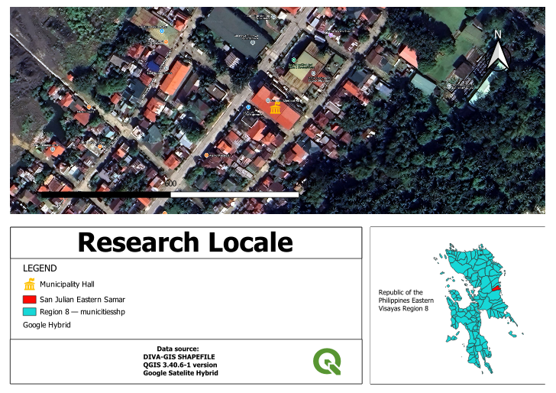
Figure 53: Research locale
The research was conducted in San Julian, Eastern Samar around the Municipality This location was chosen as it serves as the central hub for local governance and public services, making it ideal for gathering relevant data on community programs like the PESO MIS.

System Architecture Diagram
System architecture is a blueprint that defines the structure, behavior, and interaction of a system's components. It's a conceptual model that guides how different parts of a system work together to achieve specific goals, encompassing both hardware and software, interfaces, and security. A system architecture helps ensure all parts of a system align with the overall objectives and provides a framework for communication and understanding among stakeholders.
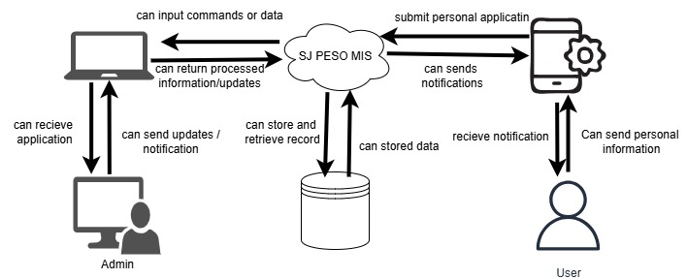
Figure 54: System Architecture Diagram
The PESO San Julian MIS worked by connecting users and admins through a centralized online platform. Users accessed the system using their smartphones to apply, track their applications, and receive updates. Admins, on the other hand, used computers to manage user information, approve applications, and send updates.

Data Analysis
The data collected during the testing and evaluation phase of the PESO San Julian MIS were analyzed using a combination of statistical and thematic methods to ensure a thorough understanding of both system performance and user experience.
The answers from the Computer Usability Satisfaction Questionnaire will be analyzed using average scores. Each question will be rated using a scale (, 1 to 5), and the scores will be added and divided to obtain the average. These averages will help determine how easy the system is to use, how well it works, and how satisfied the users are. The results will show whether the system meets the users’ needs and expectations.
Unit Testing
Each individual module of the PESO San Julian MIS was tested in isolation to verify that it performed as expected. Each unit was tested with multiple inputs and edge cases to ensure accuracy, reliability, and proper error handling.
- User Registration and Login
- Scholarship Application Form Submission
- Document Upload Functionality
- Verification Workflow
- Notification System
- Admin Panel and Reporting Tool
Integration Testing
After verifying the individual modules, the researcher they were combined to test data flow and communication between components. This ensured the entire system worked together seamlessly, such as how student data flowed from application to verification to disbursement. Integration testing helped uncover previously unnoticed issues related to system timing, data validation, and error handling. Delays in communication between modules, inconsistent data formatting, or improper error messages were all identified and resolved during this phase.
Implementation
The system will be developed and made available for use by both the PESO in charge and students. It will be implemented as a web-based platform that enables students to manage their scholarship applications, view updates, and receive announcements. Meanwhile, PESO in charge will be able to post announcements, review applications, and oversee the entire process PESO San Julian MIS. The implementation was carried out gradually, providing sufficient time to gather real-world feedback from users and make necessary adjustments before expanding the system to a wider audience. Continuous support and system monitoring played a crucial role in ensuring a smooth and effective transition from manual to digital scholarship/SPES processing. To ensure the system functions efficiently, specific software and hardware requirements must be met. On the software side, the platform will run on major operating systems such as Windows 10/11, macOS, Users will need access to modern web browsers Google Chrome, or Microsoft Edge. The backend may be powered by frameworks .Java script (PHP), while the frontend will utilize standard web technologies such as HTML5, CSS3, and. The system will rely on a database management system such as MySQL, or MongoDB. In terms of hardware, client devices used by students and PESO in charge should have at least an 4GB of RAM and 64GB of mobile phone and Intel Core i3 processor, 4GB of RAM, and 100 GB of free disk space, along with a stable internet connection. For server hosting, whether self-hosted or cloud-based, the system should be supported by a machine with a quad-core 2.5 GHz processor or higher, at least 8 GB of RAM (16 GB recommended), and 250 GB or more of SSD storage.
Research Instrument
The system was evaluated using IBM and ISO Software Quality Evaluation Tool based on ISO 25010 for Quality Metrics. It is consisting of questions that measure user satisfaction with the system functionality, efficiency, maintainability, reliability, portability, and security.

Statistical Tools
Upon the collection of data through the survey questionnaire, the resultant data was collected and tabulated. It was processed using the frequency and percentage of the descriptive statistics.
The gathered survey result of the sample size during the alpha testing will be interpreted using mean and a 5-point Liked as method of scoring to determine the ISO 25010 of the system.
Mean. This is the average of the score - the mathematical center of a distribution. It used symmetrical, unimodal distributions of interval or ratio scores. This formula mean is
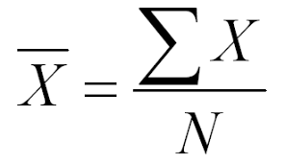
∑X = Sum of all values (add all the data together)
N = Number of values (how many data points there are)

Table 12. METHOD OF SCORING
Rating scale | Qualitative description
5 | Highly Agree
4 | Agree
3 | Slightly Agree
2 | Slightly Disagree
1 | Highly Disagree

Table 9 presents the method used to score the respondents’ answers. It uses a five-point rating scale where 5 means Highly Agree and 1 means Highly Disagree. This scale helps interpret how strongly users agree or disagree with each statement related to the system’s performance and features.

Table 13 Functionality Parameter Interpretation
Numerical Rating Scale | Adjective Rating | Interpretation
4.21 – 5.00 | Strongly Agree | Highly Functional
3.41 – 4.20 | Agree | Functional
2.61 – 3.40 | Slightly Agree | Moderately Functional
1.81 – 2.60 | Slightly Disagree | Slightly Functional
1.0 – 1.80 | Strongly Disagree | Not Functional
Table 10 shows how users rated the system’s functionality. Ratings from 4.21 to 5.00 mean users strongly agree that the system is highly functional, while 3.41 to 4.20 indicates it is functional. Scores between 2.61 and 3.40 suggest it is moderately functional, showing it performs well but can still be improved. Ratings from 1.81 to 2.60 mean it is slightly functional, and 1.00 to 1.80 indicate the system is not functional based on user feedback.
Table 14.Reliability Parameter Interpretation
Numerical Rating Scale | Adjective Rating | Interpretation
4.21 – 5.00 | Strongly Agree | Highly Reliable
3.41 – 4.20 | Agree | Reliable
2.61 – 3.40 | Slightly Agree | Moderately Reliable
1.81 – 2.60 | Slightly Disagree | Slightly Reliable
1.0 – 1.80 | Strongly Disagree | Not Reliable

Table 14 Reliability Show how users rated the system’s reliability. A score between 4.21 and 5.00 means users strongly agree that the system is highly reliable, while 3.41 to 4.20 indicates it is reliable. Ratings from 2.61 to 3.40 show it is moderately reliable, meaning it performs well but may have minor issues. Scores from 1.81 to 2.60 suggest the system is slightly reliable, and 1.00 to 1.80 indicate users find it not reliable.

Table 15.Safety Parameter Interpretation
Numerical Rating Scale | Adjective Rating | Interpretation
4.21 – 5.00 | Strongly Agree | Highly Secured
3.41 – 4.20 | Agree | Secured
2.61 – 3.40 | Slightly Agree | Moderately Secured
1.81 – 2.60 | Slightly Disagree | Slightly Secured
1.0 – 1.80 | Strongly Disagree | Not Secured
Table 15 shows how users rated the system’s level of safety and security. Ratings from 4.21 to 5.00 mean users strongly agree that the system is highly secured, while 3.41 to 4.20 indicate it is secured. Scores between 2.61 and 3.40 suggest the system is moderately secured, showing it provides adequate protection but may still need improvements. Ratings from 1.81 to 2.60 mean it is slightly secured, and 1.00 to 1.80 indicate that users find it not secured.
Table 16 Efficiency Parameter Interpretation
Numerical Rating Scale | Adjective Rating | Interpretation
4.21 – 5.00 | Strongly Agree | Highly Efficient
3.41 – 4.20 | Agree | Efficient
2.61 – 3.40 | Slightly Agree | Moderately Efficient
1.81 – 2.60 | Slightly Disagree | Slightly Efficient
1.0 – 1.80 | Strongly Disagree | Not Efficient

Table 16 Efficiency shows how users rated the system’s efficiency based on their experience. Ratings from 4.21 to 5.00 mean users strongly agree that the system is highly efficient, while 3.41 to 4.20 indicates it is efficient. Scores between 2.61 and 3.40 suggest the system is moderately efficient, showing it works well but can still improve. Ratings from 1.81 to 2.60 mean it is slightly efficient, and 1.00 to 1.80 show that users find it not efficient at all.
Table 17 Compatibility Parameter Interpretation
Numerical Rating Scale | Adjective Rating | Interpretation
4.21 – 5.00 | Strongly Agree | Highly Compatible
3.41 – 4.20 | Agree | Compatible
2.61 – 3.40 | Slightly Agree | Moderately Compatible
1.81 – 2.60 | Slightly Disagree | Slightly Compatible
1.0 – 1.80 | Slightly Disagree | Not Compatible

Table 17 presents how users rated the system’s compatibility. A rating from 4.21 to 5.00 means users strongly agree that the system is highly compatible, while 3.41 to 4.20 indicates it is compatible with different devices or platforms. Scores between 2.61 and 3.40 suggest it is moderately compatible, showing that it works but may have minor issues. Ratings from 1.81 to 2.60 mean it is slightly compatible, and 1.00 to 1.80 indicate users find it not compatible.
Table 18 Maintainability Parameter Interpretation
Numerical Rating Scale | Adjective Rating | Interpretation
4.21 – 5.00 | Strongly Agree | Highly Maintainable
3.41 – 4.20 | Agree | Maintainable
2.61 – 3.40 | Slightly Agree | Moderately Maintainable
1.81 – 2.60 | Slightly Disagree | Slightly Maintainable
1.0 – 1.80 | Slightly Disagree | Not Maintainable

Table 18 Show how users rated the system’s maintainability. A rating between 4.21 and 5.00 means users strongly agree that the system is highly maintainable, while 3.41 to 4.20 indicates it is maintainable. Scores from 2.61 to 3.40 it is moderately maintainable, meaning it can be maintained but may need some improvements. Ratings from 1.81 to 2.60 mean it is slightly maintainable, and 1.00 to 1.80 show that users find it not maintainable.
Chapter IV
RESULTS AND DISCUSSIONS
This chapter presents the findings and outcomes of the system's development and evaluation process. It includes discussion of the system development results. Additionally, it covers the results of the alpha testing phase, and the beta testing phase.
SYSTEM DEVELOPMENT RESULTS
This section presents the system development results that has been undertaken by the proponents. Below are the screenshots of results in every objective
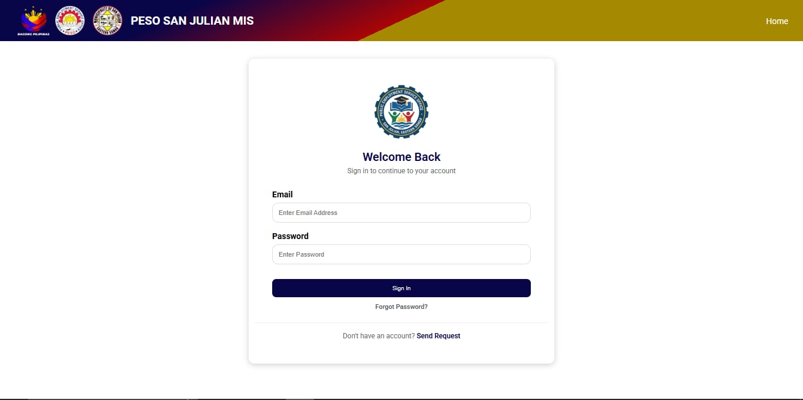
Figure 55: PESO SAN JULIAN MIS Login Screen
Figure 40 presents the login interface of the Public employment service office(PESO) developed for the Municipality of San Julian Public employment service office. This feature serves as the initial access point for users, to securely log in and manage. The login screen is an essential component of the system, College of Computer Studies

Figure 56: notification upadate
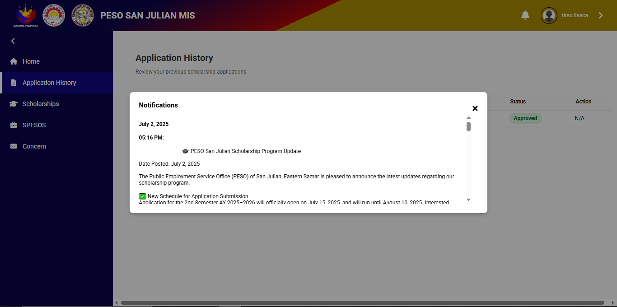
The Application History page of the PESO San Julian MIS, where users can review their previous scholarship applications. A notification window is displayed, announcing updates regarding the San Julian Scholarship Program. For example The notification, dated July 2, 2025, provides information from the Public Employment Service Office (PESO) of San Julian, Eastern Samar. It highlights the new schedule for application submission for the first semester of AY 2025–2026, stating that the process will begin on July 5, 2025, and close on August 10, 2025. this figure demonstrates how the PESO San Julian MIS provides a user-friendly way to communicate updates and application status. By centralizing important announcements and application details in one interface, the system ensures that students are well-informed and updated on the progress of their scholarship.
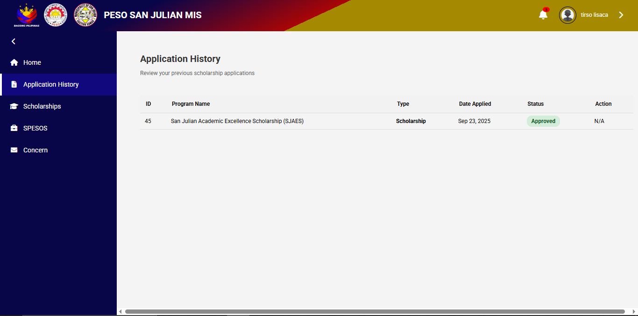
Figure57: user application history

The Application History section of the PESO San Julian MIS, which allows users to review their past scholarship applications. The interface presents a table format with columns for ID, Program Name, Type, Date Applied, Status, and Action.In the interface, the user has one recorded entry. The program listed categorized under the Scholarship type. The date of application is shown The application status is marked, highlighted in green to indicate a successful outcome. Meanwhile, the Action column is labeled N/A (Not Applicable), meaning that no further steps are required from the user after approval. This figure demonstrates how the system organizes and presents scholarship application records in a clear and accessible way, helping users keep track of their submissions and outcomes efficiently

Figure 58: admin manage scholarship/spes
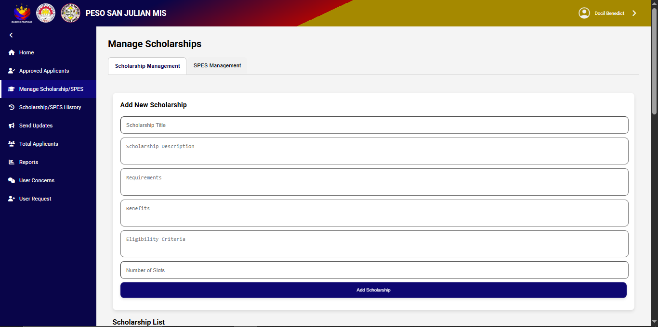
The Manage Scholarships interface of the PESO San Julian MIS, specifically under the Scholarship Management page. This section allows administrators to create and manage scholarship programs within the system. At the center of the page, there is a form labeled Add New Scholarship, which contains several input fields that the admin must complete. These fields include: Scholarship Title, Scholarship Description, Requirements, Benefits, Eligibility Criteria, and Number of Slots. Once the information is filled out, the administrator can finalize the entry by clicking the Add Scholarship button. This functionality ensures that scholarship programs are systematically recorded with complete details, making it easier to organize opportunities for applicants. Below this form is the Scholarship List, which likely contains a list of existing scholarships that have already been added to the system.

Figure 59: Total applicant
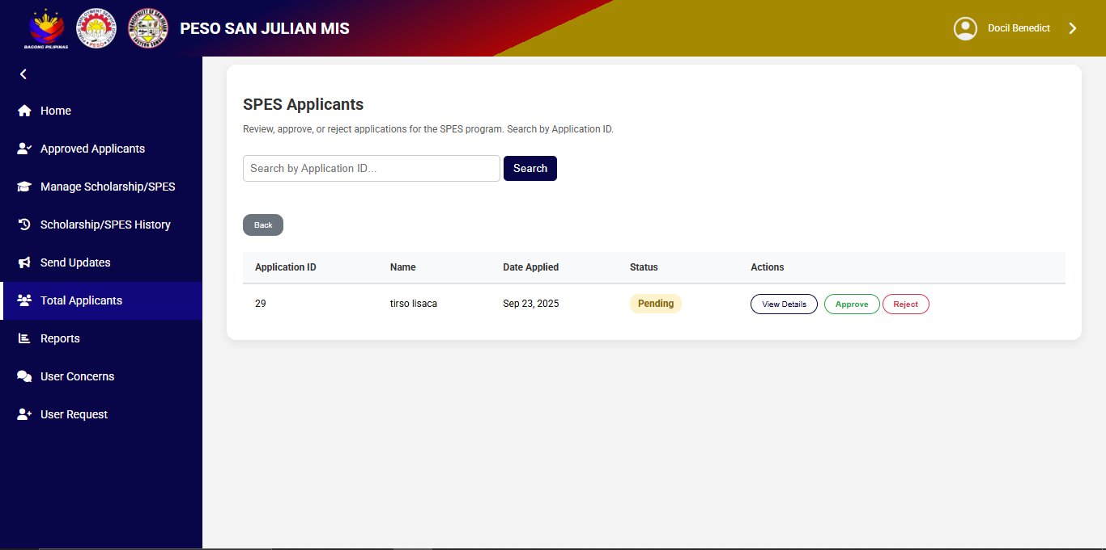
The figure presents the SPES Applicants interface of the PESO San Julian MIS, which allows administrators to review, approve, or reject applications for the Special Program for the Employment of Students (SPES). At the top of the panel, there is a search bar where admins can input an Application ID to quickly locate a specific applicant. Below the search function, the applicant list is displayed in a tabular format with the Application ID, Name, Date Applied, Status, and Actions. In this example, the table shows one applicant with Application ID ,name and the applied . The application is currently marked with the status “Pending”, ”approved ”, ” rejected ”. Under the Actions, the admin has three available options: View Details (to check the applicant’s full information), Approve (to accept the application), and Reject (to decline the application. This interface highlights the system’s capability to improve the evaluation of SPES applications, providing administrators with an organized and efficient workflow for applicant management.

Figure 60: scholarship
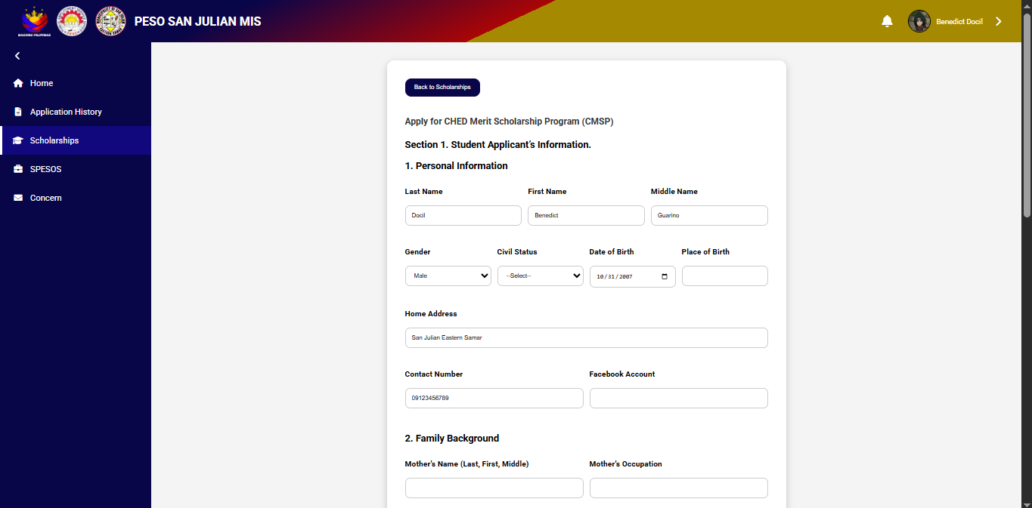
The figure displays the Scholarship Application Form section of the PESO San Julian MIS, where students can apply for the scholarship. The form is organized into multiple sections, beginning with Personal Information. In this section, applicants are required to provide details such as Last Name, First Name, Middle Name, Gender, Civil Status, Date of Birth, Place of Birth, Home Address, Contact Number, and Facebook Account. The form also includes a Family Background section, which asks for information about the applicant’s parents, including Mother’s Name and Occupation. This ensures that the system gathers both personal and family details to support the scholarship evaluation process. This interface highlights how the system simplifies the scholarship application process by providing a structured, digital form that collects all essential student data for screening and evaluation

Figure 61: User scholarship 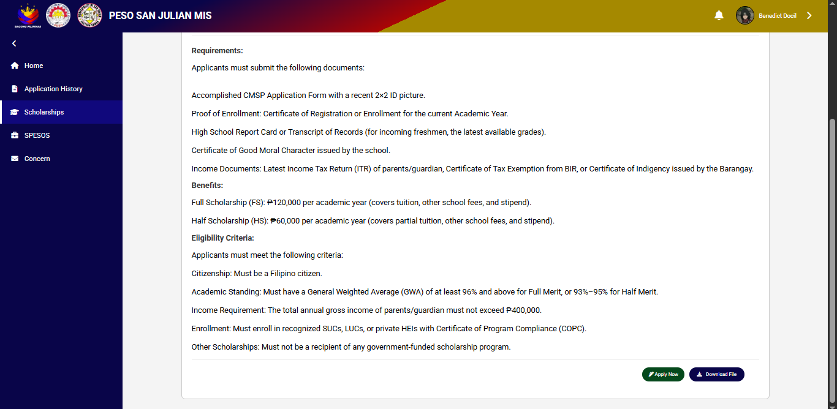
The scholarship page presents the detailed requirements, benefits, and eligibility criteria for scholarship. To qualify, applicants must prepare and submit a set of documents, including a completed application form with a recent 2x2 picture, proof of enrollment such as a certificate of registration, a copy of their high school report card or transcript of records, and a certificate of good moral character issued by their school. Additionally, income documents such as, certificate of tax exemption, or a certificate of indigency issued by the barangay are also required to validate the applicant’s financial background. this scholarship page is a valuable opportunity for academically deserving yet financially challenged students to pursue higher education. By laying out the requirements and guidelines clearly, it ensures that applicants are well informed about the process, increasing their chances of successfully securing support for their academic journey.

Figure 62: admin home dashboard
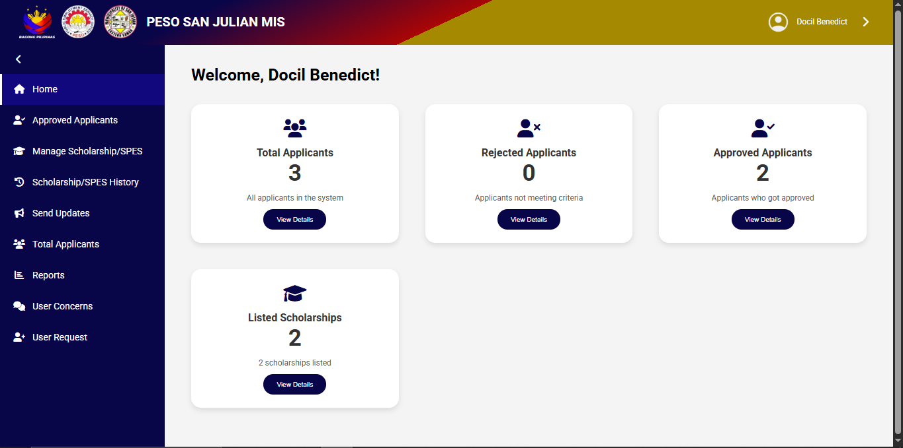
The dashboard provides a quick summary of the scholarship system’s current status. It greets the logged-in adminand displays key statistics in an organized manner. The summary shows the total number of applicants , with a breakdown of rejected applicants and approved applicants, making it easy to track application outcomes. Additionally, it highlights that there are listed scholarships currently available in the system. Each section is presented in card format with a “View Details” button, allowing the admin to quickly navigate and access more specific information.This feature is designed to give administrators an at-a-glance view of the system’s performance, enabling them to monitor applications and scholarship programs efficiently

Figure 63: admin reports
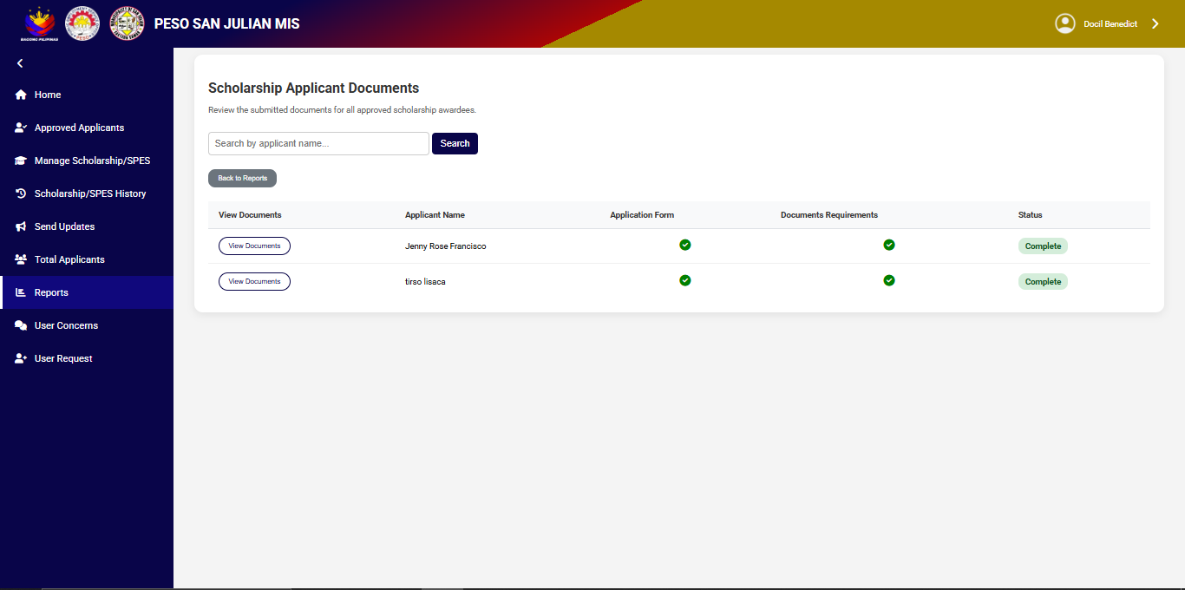
The figure report page of the PESO San Julian MIS, specifically for scholarship applicants. This section allows administrators to review and track the submission status of required documents from applicants. The interface lists applicants’ names along with indicators for the Application Form, Document Requirements, and the overall Status. In the example, two applicants, are listed. Both applicants have successfully completed their submissions, as reflected by the green checkmarks and the status labeled “Complete.” The system also provides a “View Documents” button for each applicant, enabling admins to review uploaded files in detail. This feature ensures transparency in monitoring scholarship requirements, making it easier for administrators to confirm eligibility and process applications without delays.

Figure 64: scholarship upload documents
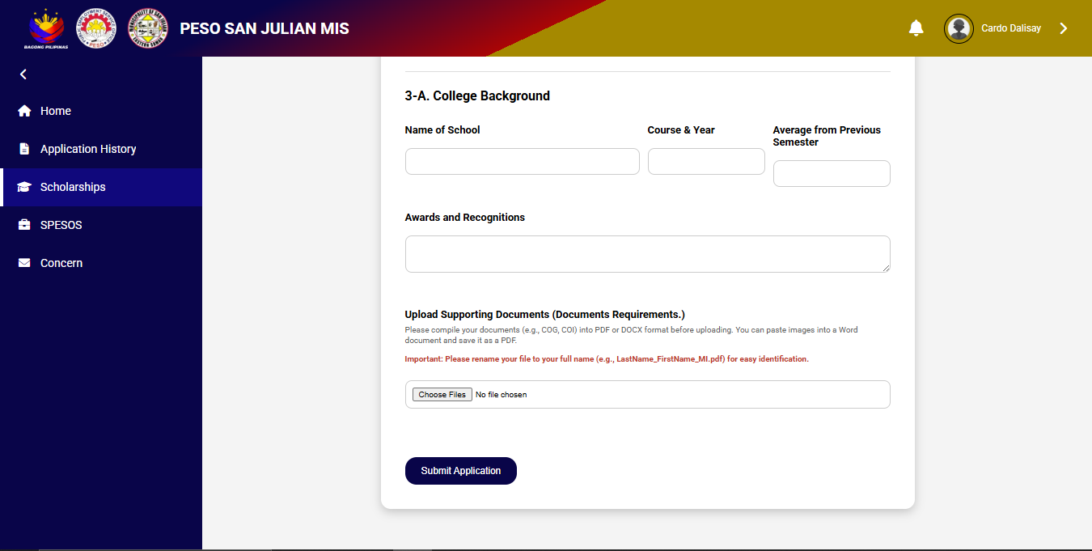
The figure displays the form includes an option to upload supporting documents to validate the provided information. Accepted formats include PDF, JPG, PNG, DOC, and DOCX, with clear instructions for proper file naming (Lastname_Firstname.pdf) to ensure easy identification. At the bottom, a Submit Application button allows applicants to finalize and send their application once all required fields and documents are completed. This section ensures that the scholarship committee receives a comprehensive overview of the applicant’s academic performance and achievements, along with the necessary documents to support their eligibility.

Table 19: Functionality Suitability Evaluation
Question | Total Mean | Interpretation
The system performs all function as  Specified without missing any feature or capabilities | 4.8 | Highly Functional
The system’s feature work as expected in different scenarios . | 4.7 | Highly Functional
The system provides correct outputs based on user inputs. | 4.8 | Highly Functional
Total Mean | 4.7 | Highly Functional

The table shows that users rated the system as highly functional in terms of performing its intended tasks. The system performs all specified functions without missing any features, earning a high mean score of 4.8. It also works well in different scenarios with a mean of 4.7, and provides correct outputs based on user inputs, also rated 4.8. With an overall mean of 4.7, the results indicate that the system is highly functional and performs effectively according to its design and purpose.
Table 20: Reliability Suitability Evaluation
Question | Total Mean | Interpretation
The system correctly saves, retrieves and maintain user data without loss or corruption | 4.5 | Highly Reliable
. The systems behave predictable and error free under various load conditions. | 4.4 | Highly Reliable
The system operates consistently without crashes, error, or unexpected shutdown during prolonged use. | 4.5 | Highly Reliable
Total Mean | 4.4 | Highly Reliable

The table shows that users rated the system as highly functional in terms of reliability. The system correctly saves, retrieves, and maintains user data without loss or corruption, earning a mean score of 4.5. It also performs predictably and remains error-free under different load conditions with a mean of 4.4. Additionally, it operates consistently without crashes or unexpected shutdowns during long use, also scoring 4.5. With an overall mean of 4.4, the results indicate that the system is highly reliable and performs smoothly even under continuous operation.

Table 21: Safety Suitability Evaluation
Question | Total Mean | Interpretation
The system process and respond to user interaction within an acceptable timeframe. | 4.7 | Highly Secured
the system perform task quickly and without unnecessary delays | 4.8 | Highly Secured
The system utilize system resources efficiently | 4.5 | Highly Secured
Total Mean | 4.6 | Highly Secured

The table safety shows that users rated the system as highly secured in terms of safety and performance. The system processes and responds to user interactions within an acceptable timeframe, earning a mean score of 4.7. It performs tasks quickly without unnecessary delays, receiving the highest mean of 4.8, and efficiently utilizes system resources with a score of 4.5. With an overall mean of 4.6, the results indicate that the system is highly secured, stable, and performs efficiently while maintaining data safety.

Table 22: Efficiency Suitability Evaluation
Question | Total Mean | Interpretation
The system process and respond to user interaction within an acceptable timeframe. | 4.4 | Highly Efficient
the system perform task quickly and without unnecessary delays | 4.5 | Highly Efficient
The system utilize system resources efficiently | 4.7 | Highly Efficient
Total Mean | 4.5 | Highly Efficient

The table shows that users rated the system as highly efficient. The system processes and responds to user interactions within an acceptable timeframe, earning a mean score of 4.4. It performs tasks quickly without unnecessary delays, with a mean of 4.5, and efficiently utilizes system resources, gaining the highest score of 4.7. With an overall mean of 4.5, the results indicate that the system is highly efficient, fast, and capable of delivering smooth performance with optimal resource use.

Table 23: Compatibility Suitability Evaluation
Question | Total Mean | Interpretation
The system seamlessly across different operating system and devices . | 4.7 | Highly Compatible
the system is compatible with different browser | 4.8 | Highly Compatible
The system integrates correctly with other software or system | 4.5 | Highly Compatible
Total Mean | 4.6 | Highly Compatible

The table Compatibility shows that users rated the system as highly compatible. The system works seamlessly across different operating systems and devices, earning a mean score of 4.7. It is also compatible with various browsers, receiving the highest mean of 4.8, and integrates correctly with other software or systems with a score of 4.5. With an overall mean of 4.6, the results indicate that the system is highly compatible and performs well across multiple platforms and environments.

Table 24: Maintainability Suitability Evaluation
Question | Total Mean | Interpretation
The systems follows coding standard and is readable | 4.4 | Highly Maintainable
The system is easy to fix and update | 4.5 | Highly Maintainable
The system is well documented | 4.5 | Highly Maintainable
The system organizes module for testing and reuse | 4.5 | Highly Maintainable
Total Mean | 4.5 | Highly Maintainable

The table maintainability shows that users rated the system as highly maintainable. The system follows coding standards and is easy to read, with a mean score of 4.4. It is also easy to fix and update, and well-documented, both earning a mean of 4.5. Additionally, the system organizes its modules effectively for testing and reuse, also rated 4.5. With an overall mean of 4.5, the results indicate that the system is highly maintainable, easy to modify, and well-structured for future improvements.

BETA TESTING RESULT
The developed system's performance was assessed through beta testing. utilizing the IBM Computer functionality Satisfaction Questionnaire to evaluate its functionality. and overall user experience.
Table 25: Beta Testing Evaluation
Question | Total Mean | Interpretation
1, Overall, I am satisfied with how easy it is to use this system | 4.4 | Strongly Agree
2, It was simple to use this system. | 4.3 | Strongly Agree
3, I can effectively complete the tasks using this system | 4.6 | Strongly Agree
4, I am able to complete my work quickly using this system. | 4.5 | Strongly Agree
5, I feel comfortable using this system. | 4.3 | Strongly Agree
6, It was easy to learn to use this system | 4.2 | Strongly Agree
7, Whenever I make a mistake using the system, I recover easily and quickly. | 4.2 | Strongly Agree
8, The organization of information on the system screens is clear. | 4.4 | Strongly Agree
9, The interface of this system is pleasant. | 4.3 | Strongly Agree
10, like using the interface of this system | 4.2 | Strongly Agree
11, Overall, I am satisfied with this system. | 4.6 | Strongly Agree
Total Mean | 4.3 | Strongly Agree

Table 25 Show the results of the beta testing evaluation, which measures users’ satisfaction and experience with the system. The results show that users strongly agree with all the statements, giving the system a total mean of 4.3. Respondents found the system easy to use, quick to learn, and comfortable to navigate.
Chapter V
CONCLUSION AND RECOMMENDATIONS
This chapter present the conclusion and recommendations base on the study’s findings
CONCLUSIONS
Following a through evaluation of the study. The researcher have drawn the following conclusion:
- The San Julian PESO management system enable user to apply scholarship/spes and send their requirement
1.2. The system enable scholarship administrators to review, approve, and manage applications
1.3. The system allow documents upload for student to attach necessary files such as ID;s academic record, and certificate as part of their application
1.4. The system enable to generate comprehensive reports on application statistics including the number of applicants, approval and rejection rates
1.5. The Admin can have an administrator dashboard where authorized personnel can review ,filter and manage application efficiently
1.6 The system provide a notification systems that informs applicants about the status of their application and important updates
2. The system underwent extensive testing to ensure that it meets high standards of performance, usability, and user satisfaction.
2.1. Alpha testing conducted using the ISO/IEC 25010 standard confirmed the system's adherence to key software quality characteristics. The system achieved high scores across functionality, performance efficiency, compatibility, flexibility, reliability, and safety, with an overall grand mean score of 4.51, indicating strong overall performance.

Recommendation
Based on results of the study, the researchers suggest the following recommendations to further improve the system. These suggestions aim to make the system more efficient and reliable for future use.
First, develop a mobile App version many students prefer using their phones for online tasks. Creating a mobile app version of the system would make it more accessible and allow users to receive updates and submit forms anytime, anywhere.
Second, Integrate automated notifications and reminders the system would benefit from an automated notification feature that alerts students about scholarship announcements, deadlines, application statuses, and renewal schedules. This will help ensure that important updates reach students on time and minimize missed opportunities.
Third, add an SMS feature to notify users about every transaction or any activity that happens in their account.

BIBLIOGRAPHY
(DOLE). (2020). PESO Employment Information System (PEIS). Department of Labor and Employment https://www.dole.gov.ph/news/philjobnet-and-peis-integration-strengthens-job-matching/
Bachita, E. B., & Bayoneta, M. J. A. R. (2021). Implementation of Public Employment Services in a Philippine Local Government Unit. Philippine Social Science Journal, 4(3), 133-144. https://doi.org/10.52006/main.v4i3.412
Khairati, F., & Putra, H. (2024). Empowering government fiscal efficiency: Usability evaluation and e-government model refinement. International Journal of Management Science and Information Technology, 4(2), 167–177. https://doi.org/10.35870/ijmsit.v4i2.2775
Sultan, Z. (2023). Public Service Model and Employee Work Effectiveness Through a Website-Based Management Information System. Assets: Jurnal Ekonomi, Manajemen dan Akuntansi, 13(2), 328-342. Retrieved from https://journal.uin-alauddin.ac.id/index.php/assets/article/view/41193
Mendoza, A., Cruz, L., & Javier, M. (2024). Educational Benefit System Unit (EBSU): Automating Davao City’s Scholarship Services. International Journal of Emerging Trends in Technology (IJETT), 9(1). https://ijett.org/davao-ebsu-scholarship-system
Ranjitha, V., & Swamydoss, D. (2022, April 2). Job portal system for job seeker and companies. International Journal of Progressive Research in Science and Engineering, 3(03), 63-64. https://journal.ijprse.com/index.php/ijprse/article/view/517
Geneta, P. D., Atienza, R. R., Panopio, J. D. C., & Pesigan, K. W. R. (2019). Development of Public Employment Service Office Job Portal for Municipality of Rosario, Batangas. International Journal of Advanced Research and Publications, 3(6). Retrieved from https://www.ijarp.org/published-research-papers/june2019/Development-Of-Public-Employment-Service-Office-Job-Portal-For-Municipality-Of-Rosario-Batangas.pd
(Migliore et al., 2021) Platforms or websites can maximize the use of educational data to accelerate the development and progress of education in the era of big data. https://www.researchgate.net/publication/354387790_Rethinking_Management_Information_Systems_for_Scaling_up_Employment_Outcomes
Baguio City Government. (2022). PESO Digital Employment Services. https://baguiocity.gov.ph/peso
Quezon City Government. (2021). PESO Management System. https://quezoncity.gov.ph/peso
Ranjitha, V., & Swamydoss, D. (2022, April 2). Job portal system for job seeker and companies. International Journal of Progressive Research in Science and Engineering, 3(03), 63-64. https://journal.ijprse.com/index.php/ijprse/article/view/517
Zamboanga City Government. (2022). Zamboanga City PESO MIS. https://zamboangacity.gov.ph/peso
Kaufman, M., & Phan, H. (2025). Affording the future: A critical analysis of tuition costs and student financial burdens in higher education. Scientia Moralitas: International Journal of Multidisciplinary Research, 10(1), 382–393. https://scientiamoralitas.com/index.php/sm/article/view/319
Bagaporo, M. D. L., & Espinosa, M. L. (2025, February). Online scholarship management system for Camarines Sur Polytechnic Colleges. Global Scientific Journal, 13(2). Retrieved from https://www.globalscientificjournal.com/researchpaper/ONLINE_SCHOLARSHIP_MANAGEMENT_SYSTEM_FOR_CAMARINES_SUR_POLYTECHNIC_COLLEGES.pdf
Valenzuela City Government. (2022). Dr. Pio Valenzuela Scholarship Program: Online application form. Valenzuela City Official Website. https://valenzuela.gov.ph/files/pdfs/scholarship_form.pdf
Bacolod City Government. (2023). Bacolod PESO Job Portal. Retrieved from https://bacolodcity.gov.ph/peso
Kaufman, M., & Phan, H. (2025). Affording the future: A critical analysis of tuition costs and student financial burdens in higher education. Scientia Moralitas: International Journal of Multidisciplinary Research, 10(1), 382–393. https://scientiamoralitas.com/index.php/sm/article/view/319
Paytaren, A. V., Gonzales, H. G., & Dinlasan, R. D. (2023, April 25). Educational Assistance Management System for Batangas State University ARASOF-Nasugbu. Global Journal of Computer Science and Technology, 23(H1). Retrieved from https://gjcst.com/index.php/gjcst/article/view/39
Alvaro, P. A. R., & Gabayan Jr., V. P. (2022, March 21). Scholarship Information Management System with Academic Performance Predictor and Decision Support System. The Journal of Computing and Technology, 2(2). Retrieved from https://isujournals.ph/oldlinkerjournalsfiles/TJCT.isujournals.ph/index.php/tjct/article/view/26
Capinig, C., Godoy, J. J., Guinoo, P., & Dela Cruz, N. (2023). The quality of life and experiences of Tertiary Education Subsidy (TES) grantees. Psychology and Education: A Multidisciplinary Journal, 7(4). https://doi.org/10.5281/zenodo.765759
COE-PSP. (2020). Iskolar ng Laguna Information System. Center of Excellence in Public Sector Productivity. https://coe-psp.dap.edu.ph/compendium-innovation/iskolar-ng-laguna-information-system/
Del Rosario, M., & Tan, J. (2021). PESO Job Portal in Rosario, Batangas: A Municipal Employment Management System. International Journal of Advanced Research and Publications, 5(12). https://www.ijarp.org/papers/v5-i12/1732.pdf
(DOLE). (2020). PESO Employment Information System (PEIS). Department of Labor and Employment https://www.dole.gov.ph/news/philjobnet-and-peis-integration-strengthens-job-matching/
Garcia, R., & Santos, K. (2022). Scholarship Management System with SMS Notification. International Journal of Engineering and Innovation (IJEI), 4(3). https://ijeionline.com/scholarship-sms-system
Mendez, D. G., Lanuzo, O. D., Utrera, M. K. M., Sagun, A. G. S., Constante, R. C., & Baptista, K. M. (2025, June 28). Scholarship management system with CMS for Lyceum of the Philippines Cavite. International Journal of Computer Science and Information Technology Research, 13(2), 39-59. DOI: https://doi.org/10.5281/zenodo.15761219
Motte-Muñoz, H. (2020). Empowering Filipino youth through technology and community. In B. Panth & R. Maclean (Eds.), Anticipating and preparing for emerging skills and jobs (Education in the Asia-Pacific Region: Issues, Concerns and Prospects, Vol. 55). Springer. https://doi.org/10.1007/978-981-15-7018-6_30
Fajardo, R. C. A., et al. (2024). A Data-Driven Approach in Predicting Scholarship Grants of a Local Government Unit in the Philippines Using Machine Learning. International Journal of Engineering Trends and Technology, 72(6), 74–81.Technological Institute of the Philippines. (n.d.). A Web-based Student E-Scholar Tracking and Management System with Content-based and Collaborative Filtering Algorithms for Pasig City Scholars Office. Retrieved from https://www.studocu.com/ph/document/technological-institute-of-the-philippines/capstone-project-2/a-web-based-student-e-scholar-tracking-and-management-system-with-content-based-and-collaborative-filtering-algorithms-for-pasig-city-scholars-office/78814848
Paytaren, A. V., Gonzales, H. G., & Dinlasan, R. D. (2023, April 25). Educational Assistance Management System for Batangas State University ARASOF-Nasugbu. Global Journal of Computer Science and Technology, 23(H1). Retrieved from https://gjcst.com/index.php/gjcst/article/view/39
Kanwal, B., Shoukat, R. S., Rehman, S. U., Kundi, M., AlSaedi, T., & Alahmadi, A. (2024). A new framework for scholarship predictor using a machine learning approach. Intelligent Automation & Soft Computing, 39(5), 829-854. https://doi.org/10.32604/iasc.2024.054645

APPENDICES

Appendix A
(Communication letter)

Appendix B
(Evaluated Questionnaire)

Appendix C

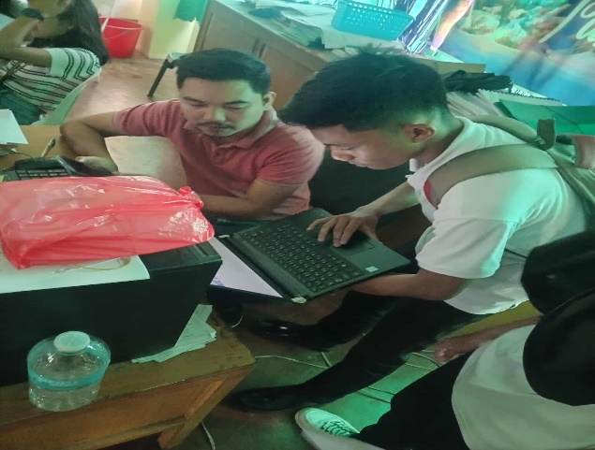
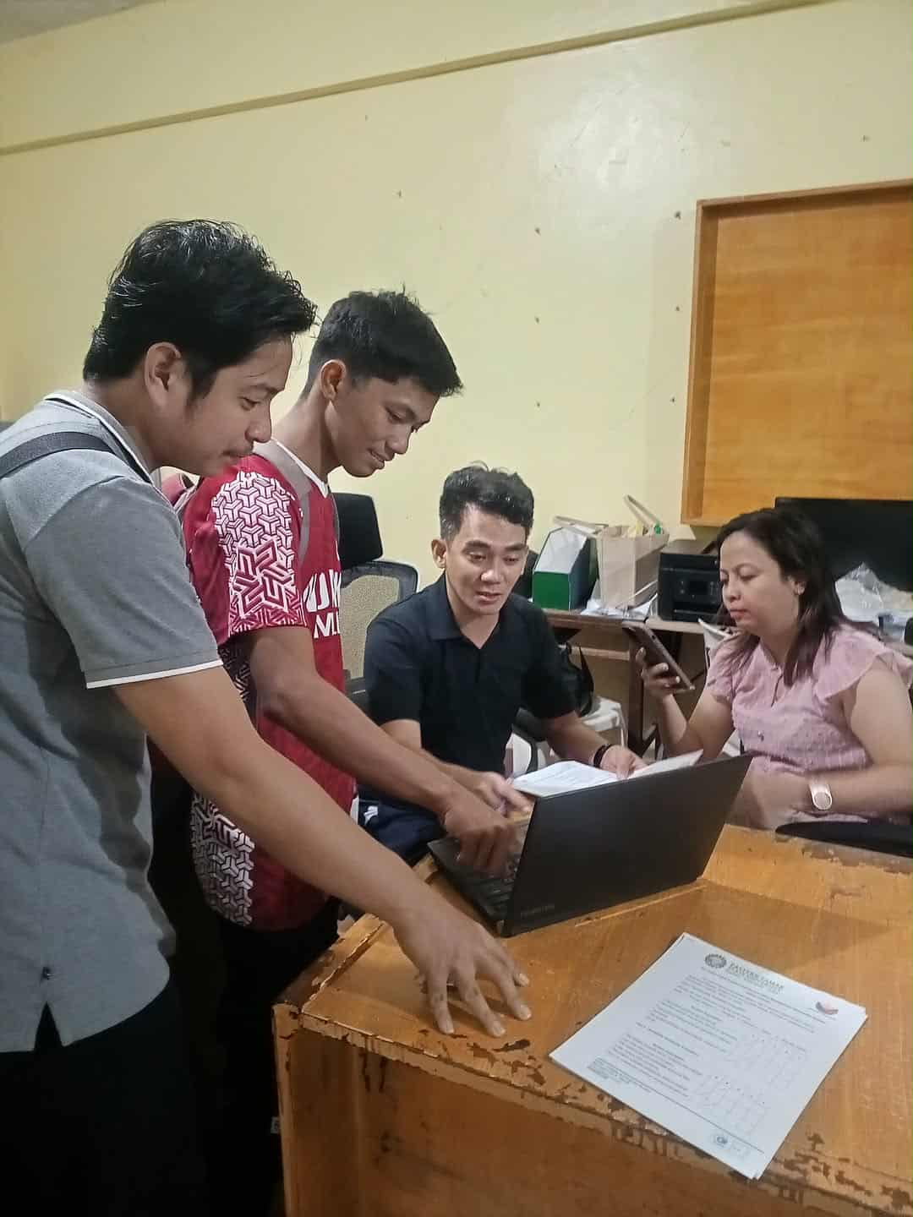
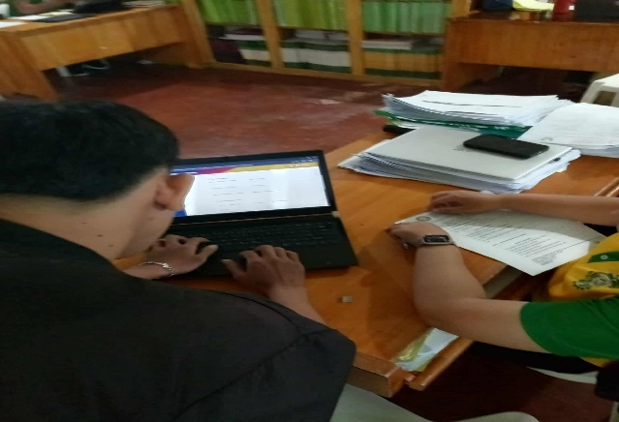
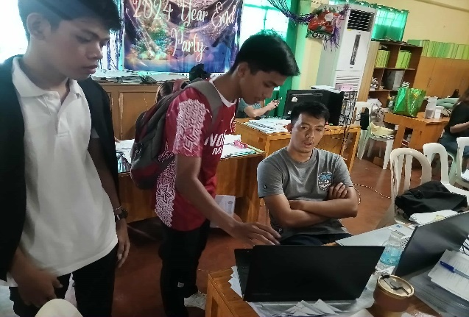
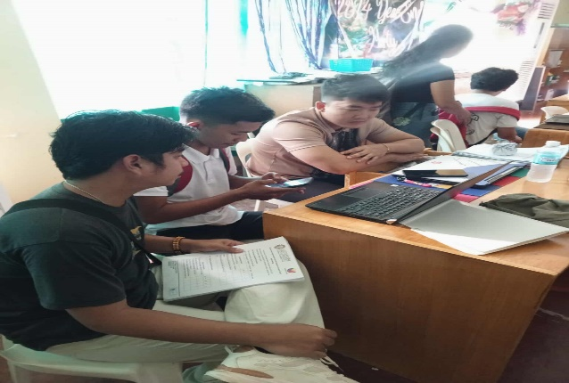
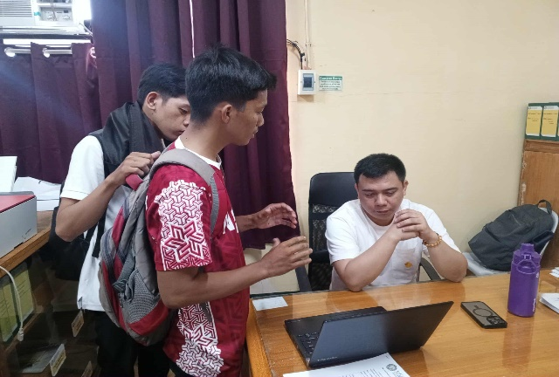
College of Computer Studies Faculty


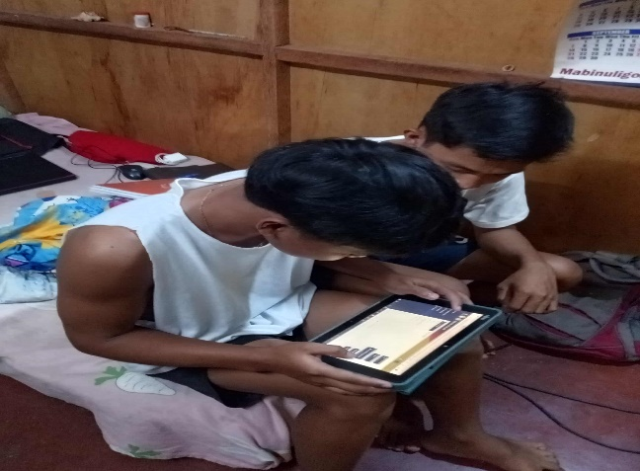
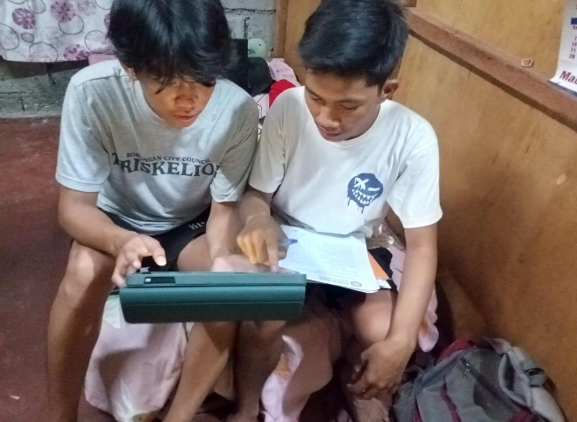
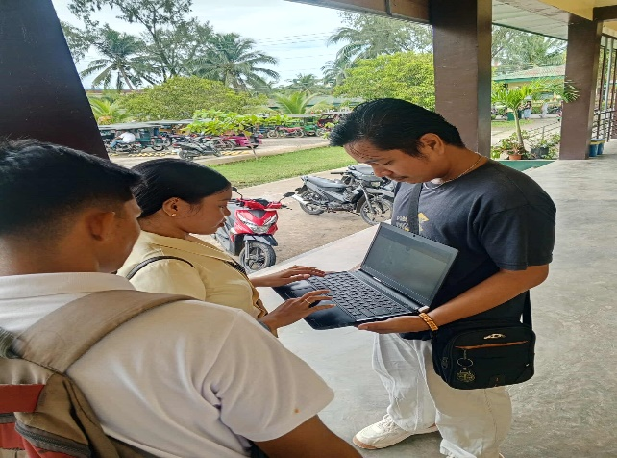
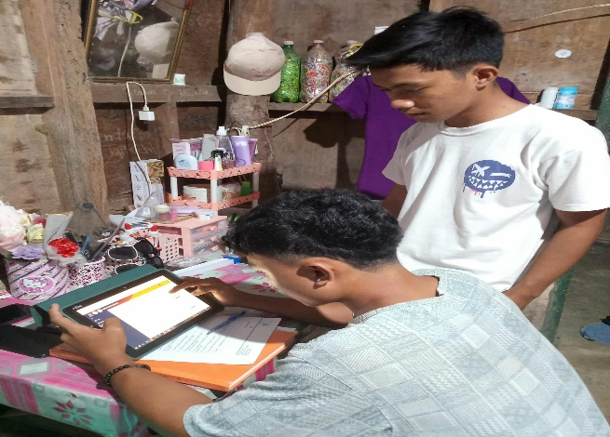

San Julian College students

Appendix D
(Curriculum vitae)



Name: Tirso N Lisaca Jr
Pseudo Name: Tirso
E-mail Address: lisacatirso224@gmail.com
Contact Number: 09352111409
Birth Date: July 29, 2004
Address: Brgy 01 San Julian E Samar
Father's Name: Tirso C, Lisaca Sr.
Mother's Name: Norma N, Lisaca

Educational Background Elementary: San Julian Central Elementary School
School Address: Brgy 01 San Julian E Samar
Year Graduated: 2015-2016
High School: East Visayan Institute (EVI)
Address: Brgy 05 San Julian E Samar
Year Graduated: 2019-2020

College: Eastern Samar State University
Address: Maypangdan Borongan E Samar
College Degree: Bachelor of Science in Information Technology


Name: Benidic Docel G.
Pseudo Name: K4rbonara
E-mail Address: docilbenedict@gmail.com
Contact Number: 09357156408
Birth Date: May 19, 2003
Address: Poblacion 06, Taft E. Samar
Father's Name: Blas Docil
Mother's Name: Maria Docil

Educational Background Elementary: Taft Central Elementary School
School Address: Brgy 4, Taft E. Samar
Year Graduated: 2015 – 2016

High School: Taft National Highschool
Address: Brgy 5, Taft E. Samar
Year Graduated: 2021 – 2022

College: Eastern Samar State University
Address: Maypangdan Borongan City
College Degree: Bachelor of Science in Information Technology



Name: Jake E. Villones
Pseudo Name: Jake
E-mail Address: Jakevillones123@gmail.com

Contact Number: 09458770506
Birth Date: October 1, 2001
Address: Dolores Eastern Samar
Father's Name: Crisostomo B. Villones
Mother's Name: Ma. Jeane E. Villones
Educational Background Elementary: Dolores Central Elementary School
School Address: Brgy 11 Dolores Eastern
Year Graduated: 2013 - 2014

High School: Dolores National High School
Address: Brgy 9 Dolores Eastern Samar
Year Graduated: 2019 - 2020

College: Eastern Samar State University
Address: Maypangdan Borongan Eastern Samar
College Degree: Bachelor of Science in Information Technology

